NZ on track for record Christmas spend
Spending patterns show more people are on the move – both into and out of Auckland – but the bigger picture is simply Christmas: we are buying more this year

AUCKLAND, 20 December 2021 – With just five days left till Christmas, New Zealanders’ spending at retail stores is trending at record levels.

While the easing of Auckland’s Covid-19-induced boundary restrictions last week allowed for more movement of people across the country resulting in higher spending on accommodation in the Bay of Plenty, Waikato and Auckland/Northland regions, the dominant pattern across the nation was the ongoing surge in spending ahead of Christmas Day.

“While New Zealanders are no doubt enjoying more freedom of movement due to the change to Auckland’s boundary settings, the bigger influence on increased spending across the nation was clearly Christmas,” says Worldline’s Head of Data, George Putnam.
“In 2020, a record $4.9B was spent through Worldline at the core retail stores in the six weeks before Christmas – supermarkets, department stores, appliance shops, clothing outlets, toy stores and jewellers. Now, with just five days of pre-Christmas trading left in 2021, we are seeing spending levels are well above last year.”
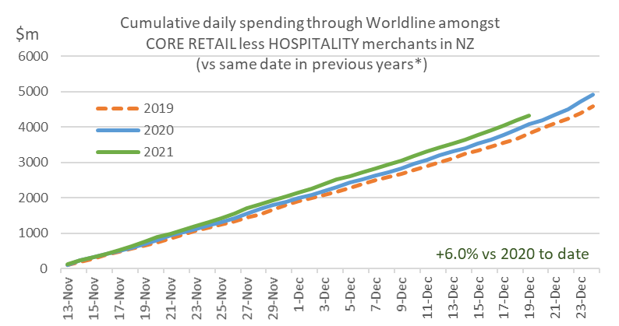
Figure 1: All Cards NZ underlying* spending through Worldline for NZ core retail excluding hospitality merchants, cumulative since 13th November (* Underlying excludes large clients moving to or from Worldline)
At this stage, the fastest annual growth pre-Christmas, taken as the 37 days since 13 November, is in Wanganui (+10%), Taranaki (+9%) and Waikato (+9%). Lowest pre-Christmas spending growth to date has been in Marlborough (+1%), Wellington (+2%), Otago (+2%), Nelson (+2%) and Gisborne (+3%).
The two-year pre-Christmas growth rate is lowest in Otago (+2%), which includes Queenstown.
WORLDLINE All Cards underlying* spending for Core Retail merchants excluding Hospitality 13-Nov to 19-Dec
 | Value | Underlying* | Underlying*
Region | transactions $millions | Annual % change on 2020 | Annual % change on 2019
Auckland/Northland | 1,664.4 | 8% | 15%
Waikato | 340.6 | 9% | 18%
BOP | 291.5 | 5% | 15%
Gisborne | 40.4 | 3% | 11%
Taranaki | 93.3 | 9% | 22%
Hawke's Bay | 146.5 | 6% | 16%
Wanganui | 51.3 | 10% | 20%
Palmerston North | 127.2 | 8% | 19%
Wairarapa | 51.8 | 7% | 20%
Wellington | 416.4 | 2% | 12%
Nelson | 82.3 | 2% | 7%
Marlborough | 50.3 | 1% | 4%
West Coast | 25.7 | 4% | 8%
Canterbury | 498.3 | 7% | 14%
South Canterbury | 68.0 | 4% | 10%
Otago | 206.9 | 2% | 2%
Southland | 94.5 | 4% | 7%
New Zealand | 4,315.5 | 6% | 13%
Figure 2: All Cards NZ annual underlying* spending growth through Worldline between 13-Nov and 19-Dec for regional core retail excluding hospitality merchants (* Underlying excludes large clients moving to or from Worldline)
Looking more closely at patterns since Auckland’s lockdown ended, nationwide spending through Worldline core retail merchants, excluding hospitality, over the five days since the Auckland border easing ($549m) was up 10% on the same days in the previous week.
Notably, spending through Worldline’s payment network at accommodation merchants in Bay of Plenty ($1.6m) jumped 43% in the first five days following the easing of restricted travel across the Auckland boundary, compared to the same five days one week earlier.
“Movement to this region is typical for this time of year but the increased accommodation spending in recent days occurred earlier this year, coinciding with the removal of the Auckland travel restrictions,” says George Putnam.
The Bay of Plenty accommodation spend is expected to increase further in the next few days but is still unlikely to reach the pre-Covid levels of 2019.
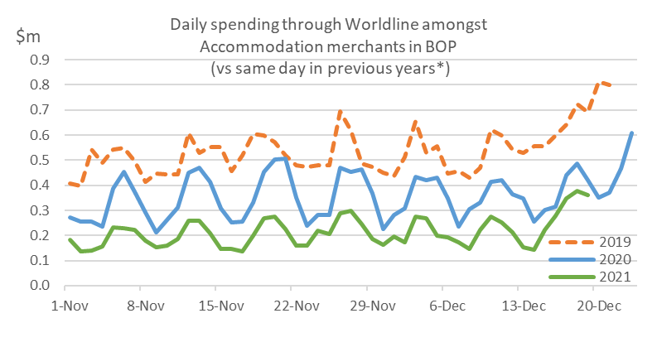
Figure 3: All Cards NZ underlying* annual spending change per day through Worldline Bay of Plenty accommodation merchants to Sunday 19 December 2021 (* Underlying excludes large clients moving to or from Worldline)
A similar early surge was noticeable in Waikato and Auckland/Northland, the latter due in part to more people also travelling to Auckland. Elsewhere, changes in accommodation spending were more typical of the seasonal patterns, with the exception of Gisborne where the value of accommodation transactions did not rise as much as usual in recent days.
Spending amongst Bay of Plenty core retail merchants, excluding hospitality, did increase 8% in the last five days, but this was similar to the same group of merchants elsewhere.
*** ends ***
Note to editors:
These figures reflect general market trends and should not be taken as a proxy for Worldline‘s market share or company earnings. The figures primarily reflect transactions undertaken within stores but also include some ecommerce transactions. The figures exclude transactions through Worldline undertaken by merchants outside the Core Retail sector (as defined by Statistics NZ).

For more information, contact:
Brendan Boughen
T 027 839 6044
E brendan.boughen@paymark.co.nz

ABOUT WORLDLINE IN NEW ZEALAND
We are New Zealand's leading payments innovator. We design, build and deliver payment solutions that help Kiwi business succeed. Whether you’re looking for in store, online or mobile payment solutions or powerful business insights, Worldline is here to help with technology backed by experience. www.paymark.co.nz

About Worldline
Worldline [Euronext: WLN] is the European leader in the payments and transactional services industry and #4 player worldwide. With its global reach and its commitment to innovation, Worldline is the technology partner of choice for merchants, banks and third-party acquirers as well as public transport operators, government agencies and industrial companies in all sectors. Powered by over 20,000 employees in more than 50 countries, Worldline provides its clients with sustainable, trusted and secure solutions across the payment value chain, fostering their business growth wherever they are. Services offered by Worldline in the areas of Merchant Services; Terminals, Solutions & Services; Financial Services and Mobility & e-Transactional Services include domestic and cross-border commercial acquiring, both in-store and online, highly-secure payment transaction processing, a broad portfolio of payment terminals as well as e-ticketing and digital services in the industrial environment. In 2020 Worldline generated a proforma revenue of 4.8 billion euros. worldline.com

PRESS CONTACTs

Hélène Carlander
T +33 (0)7 72 25 96 04
E helene.carlander@worldline.com
Investors Relations
Laurent Marie
T : +33 (0)1 58 01 83 24
E : laurent.marie@worldline.com

Follow us

