A long time between drinks – and haircuts
Worldline data shows spending surging at Auckland hairdressers, as well as cafés and bars, following the move to Traffic Light system for COVID-19 protection

AUCKLAND, 7 December 2021 – Aucklanders rushed to catch up on almost 100 days without haircuts or beauty treatments last week, while the increased freedom that came with the shift to the new Traffic Light COVID protection system on Friday saw patronage of bars and cafés grow by triple percentage figures.

Worldline data released today shows spending amongst beauty and hairdressing merchants surged to a total of $7.2m from Friday to Sunday, up 44% on the same three days last week and up 34% on the same time last year.
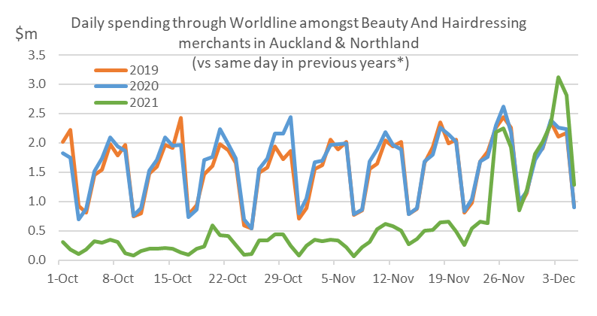
Figure 1: All Cards NZ underlying* daily spending through Worldline for Auckland/Northland beauty and hairdressing merchants (* Underlying excludes large clients moving to or from Worldline)
Spending from Friday to Sunday ($16.9m) was 86% higher amongst cafés and restaurants, relative to the same three days in the previous week and was 180% higher amongst clubs and bars ($3.2m). However, both sets of merchants were still trading around 30-40% below the same period last year.
Meanwhile, whilst spending amongst other core retailers – including grocery and liquor stores – did not surpass the Black Friday sales rush of the previous weekend, overall pre-Christmas spending across the nation continued on a strong track, exceeding pre-Christmas spending in recent years.

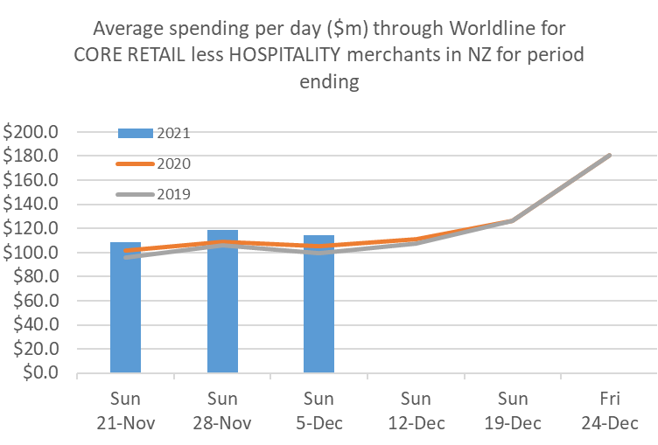
Figure 2: All Cards NZ underlying* spending through Worldline for NZ core retail excluding Hospitality merchants (* Underlying excludes large clients moving to or from Worldline)
Spending in Auckland/Northland was $311m in the seven days to Sunday or $44m per day, 11% up on the same Monday-Sunday period last year, while spending in the rest of the country was $490m or $70m per day, up 7% on last year. Both sets of figures are also higher than in the same seven days in 2019, before Covid-19 reached New Zealand.
Combined, national average spending through Worldline for core retailers, excluding hospitality merchants, was $114m per day last week.
“This spending pattern, in spite of Covid constraints, appears to be following a similar pattern to previous years”, says Worldline’s Head of Data, George Putnam.
“Although spending did dip last week following Black Friday weekend, trends overall appear to be on track to match or more likely surpass pre-Christmas spending in recent years. However, there are some very wide regional and sectoral disparities”.
Spending nationally over the last 21 days is now 8% ahead of 2020 and 13% ahead of 2019. Notably, this total includes spending at supermarkets and liquor stores, a significant part of preparations for Christmas.
The regional spending growth over the 21 days was highest since 2019 pre-Covid levels in Wanganui (+21%), Taranaki (+20%), Palmerston North (+19%) and Wairarapa (+19%). Growth since 2019 was lowest in Otago (+1%), Marlborough (+5%), West Coast (+7%) and Southland (+7%).
(See full table of regional spending below.)

WORLDLINE All Cards underlying* spending for Core Retail merchants excluding Hospitality for 21 days ending Sun 5-Dec-21
 | Value | Underlying* | Underlying*
Region | transactions $millions | Annual % change on 2020 | Annual % change on 2019
Auckland/Northland | 928.0 | 11% | 15%
Waikato | 186.2 | 10% | 17%
BOP | 160.4 | 7% | 15%
Gisborne | 22.1 | 4% | 11%
Taranaki | 51.2 | 11% | 20%
Hawke's Bay | 80.1 | 9% | 14%
Wanganui | 28.4 | 13% | 21%
Palmerston North | 70.4 | 11% | 19%
Wairarapa | 28.5 | 9% | 19%
Wellington | 231.9 | 4% | 12%
Nelson | 45.1 | 4% | 8%
Marlborough | 27.8 | 4% | 5%
West Coast | 14.1 | 5% | 7%
Canterbury | 279.9 | 8% | 14%
South Canterbury | 37.4 | 6% | 9%
Otago | 113.1 | 3% | 1%
Southland | 51.8 | 5% | 7%
New Zealand | 2,392.0 | 8% | 13%
Figure 3: All Cards NZ annual underlying* spending growth through Worldline over 21 days for regional Core Retail excluding Hospitality merchants (* Underlying excludes large clients moving to or from Worldline)
*** ends ***
Note to editors:
These figures reflect general market trends and should not be taken as a proxy for Worldline‘s market share or company earnings. The figures primarily reflect transactions undertaken within stores but also include some ecommerce transactions. The figures exclude transactions through Worldline undertaken by merchants outside the Core Retail sector (as defined by Statistics NZ).

For more information, contact:
Brendan Boughen
T 027 839 6044
E brendan.boughen@paymark.co.nz

ABOUT WORLDLINE IN NEW ZEALAND
We are New Zealand's leading payments innovator. We design, build and deliver payment solutions that help Kiwi business succeed. Whether you’re looking for in store, online or mobile payment solutions or powerful business insights, Worldline is here to help with technology backed by experience. www.paymark.co.nz

About Worldline
Worldline [Euronext: WLN] is the European leader in the payments and transactional services industry and #4 player worldwide. With its global reach and its commitment to innovation, Worldline is the technology partner of choice for merchants, banks and third-party acquirers as well as public transport operators, government agencies and industrial companies in all sectors. Powered by over 20,000 employees in more than 50 countries, Worldline provides its clients with sustainable, trusted and secure solutions across the payment value chain, fostering their business growth wherever they are. Services offered by Worldline in the areas of Merchant Services; Terminals, Solutions & Services; Financial Services and Mobility & e-Transactional Services include domestic and cross-border commercial acquiring, both in-store and online, highly-secure payment transaction processing, a broad portfolio of payment terminals as well as e-ticketing and digital services in the industrial environment. In 2020 Worldline generated a proforma revenue of 4.8 billion euros. worldline.com

PRESS CONTACTs

Hélène Carlander
T +33 (0)7 72 25 96 04
E helene.carlander@worldline.com
Investors Relations
Laurent Marie
T : +33 (0)1 58 01 83 24
E : laurent.marie@worldline.com

Follow us

