Uneven start for retail merchants in 2022
Covid impacts dampen spending in late January after initial strong core retail shopping into the New Year

AUCKLAND, 2 February 2022 – Overall consumer spending in January through retail stores in Worldline’s payments network was up on the same time last year but dipped in the final week of the month due to Covid influences.
Figures released by Worldline today showed $3.06B in total spending in January 2022 through core retail sector stores (excluding Hospitality), a lift of 7.1% on the same month last year and up 12.8% from January 2020. Comparable figures for Hospitality merchants were $0.9B in January 2022, down 5.2% on 2021 and 8.7% on 2020.
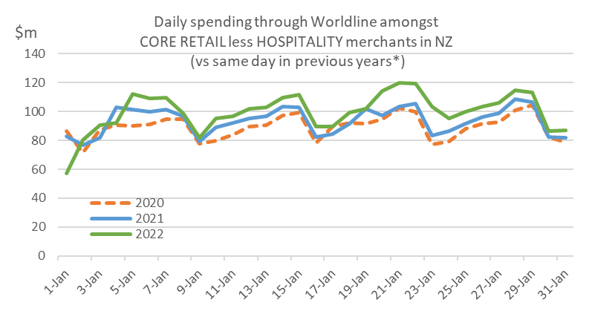
Figure 1: All Cards NZ underlying* spending through Worldline for NZ core retail merchants excluding hospitality in January 2022
(*Underlying excludes large clients moving to or from Worldline)
Notably, there was a marked change in overall spending around Monday, 24 January, when the national shift to the ‘Red’ setting occurred under the Covid-19 Protection Framework, prompted by the spread of the Omicron variant in the community.
Worldline’s Head of Data, George Putnam, says it is useful to consider the data from three categories of merchants over the last three weeks of January as the patterns are quite different.
“There was a surge in spending within the Food & Liquor retail store category between 20 – 24 January, most likely in anticipation of a shift to ‘Red’, but after that annual growth rate for this sector reverted to that of earlier in the month,” he says.
“Then there are the Hospitality merchants who in total recorded, through Worldline, slightly lower spending this year in the two weeks preceding the change to Red but experienced a sharp dip from the 24th. Within the Hospitality sector, Accommodation sector spending was down 16.9% on year-ago levels for the last week of the month, while the Food & Liquor services sector dropped 10.1% for the same period.
“Finally, there are the remaining core retail merchants – the shops selling hardware, clothes, and appliances, etc. – which, again in total through Worldline, recorded growth early in the month. That growth rate slowed in Auckland and Northland on 25 January, and from 28 January in the rest of the country.
“While it may have been the good weather pulling people away from the shops, the shift to the Red traffic light setting was most likely behind this slower end to the month”, says Putnam.
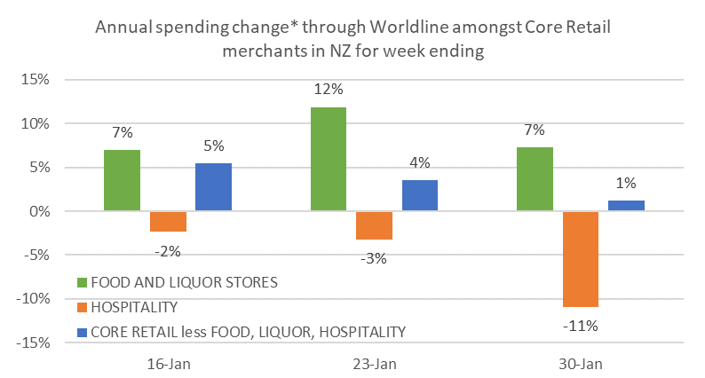
Figure 2: All Cards NZ underlying* annual spending growth through Worldline for NZ core retail merchants in weeks of January 2022 (* Underlying excludes large clients moving to or from Worldline)
Overall, spending within the Core Retail excluding hospitality grouping was still higher during January for most regions, the exception being Gisborne (-0.1%). Annual growth was highest in West Coast (+15.4%).
WORLDLINE All Cards underlying* spending for CORE RETAIL (excluding HOSPITALITY) merchants for January 2022
 | Value | Underlying* | Underlying*
Region | transactions $millions | Annual % change on 2021 | Annual % change on 2020
Auckland/Northland | 1,099 | 5.9% | 11.5%
Waikato | 254 | 10.0% | 17.8%
BOP | 223 | 9.6% | 14.8%
Gisborne | 30 | -0.1% | 7.1%
Taranaki | 72 | 13.4% | 25.4%
Hawke's Bay | 107 | 6.0% | 17.2%
Wanganui | 38 | 11.3% | 19.9%
Palmerston North | 91 | 11.5% | 21.2%
Wairarapa | 40 | 9.0% | 22.8%
Wellington | 290 | 2.6% | 11.4%
Nelson | 66 | 3.8% | 6.4%
Marlborough | 40 | 1.7% | 5.2%
West Coast | 23 | 15.4% | 10.5%
Canterbury | 348 | 9.4% | 16.8%
South Canterbury | 50 | 9.4% | 13.5%
Otago | 166 | 6.9% | 3.0%
Southland | 70 | 14.2% | 7.2%
New Zealand | 3,058 | 7.1% | 12.8%
Figure 3: All Cards NZ annual underlying* spending growth through Worldline in January 2022 for regional core retail excluding Hospitality merchants (* Underlying excludes large clients moving to or from Worldline)
*** ends ***
Note to editors:
These figures reflect general market trends and should not be taken as a proxy for Worldline‘s market share or company earnings. The figures primarily reflect transactions undertaken within stores but also include some ecommerce transactions. The figures exclude transactions through Worldline undertaken by merchants outside the Core Retail sector (as defined by Statistics NZ).

For more information, contact:
Brendan Boughen
T 027 839 6044
E brendan.boughen@paymark.co.nz

ABOUT WORLDLINE IN NEW ZEALAND
We are New Zealand's leading payments innovator. We design, build and deliver payment solutions that help Kiwi business succeed. Whether you’re looking for in store, online or mobile payment solutions or powerful business insights, Worldline is here to help with technology backed by experience. www.paymark.co.nz

About Worldline
Worldline [Euronext: WLN] is the European leader in the payments and transactional services industry and #4 player worldwide. With its global reach and its commitment to innovation, Worldline is the technology partner of choice for merchants, banks and third-party acquirers as well as public transport operators, government agencies and industrial companies in all sectors. Powered by over 20,000 employees in more than 50 countries, Worldline provides its clients with sustainable, trusted and secure solutions across the payment value chain, fostering their business growth wherever they are. Services offered by Worldline in the areas of Merchant Services; Terminals, Solutions & Services; Financial Services and Mobility & e-Transactional Services include domestic and cross-border commercial acquiring, both in-store and online, highly-secure payment transaction processing, a broad portfolio of payment terminals as well as e-ticketing and digital services in the industrial environment. In 2020 Worldline generated a proforma revenue of 4.8 billion euros. worldline.com

PRESS CONTACTs

Hélène Carlander
T +33 (0)7 72 25 96 04
E helene.carlander@worldline.com
Investors Relations
Laurent Marie
T : +33 (0)1 58 01 83 24
E : laurent.marie@worldline.com

Follow us

