Another busy Easter for core retailers, while hospitality sector builds momentum

AUCKLAND, 20 April 2022 – As COVID restrictions further eased across New Zealand, consumer spending over Easter was similar to recent years, while the Hospitality sector continued to build on the momentum seen in March.

Consumer spending through core retail merchants (excluding Hospitality) in Worldline’s payments network reached $652.6m for the seven days up to Easter Monday (18 April). This was 12% up on the same period in 2019, and similar to the growth seen during March 2022.
Meanwhile, spending at Hospitaility merchants for the same period reached $202.8m, down 7% on the Easter week ending Monday 22 April 2019, but an improvement on the average 23% decline seen over the last eight months, following the Delta lockdown that began in August 2021.
This increasing spending at Hospitality merchants continued the momentum of the gradual recovery of this sector seen in Worldline’s data from March 2022, with the gap between pre-COVID spending levels in 2019 narrowing again over Easter.
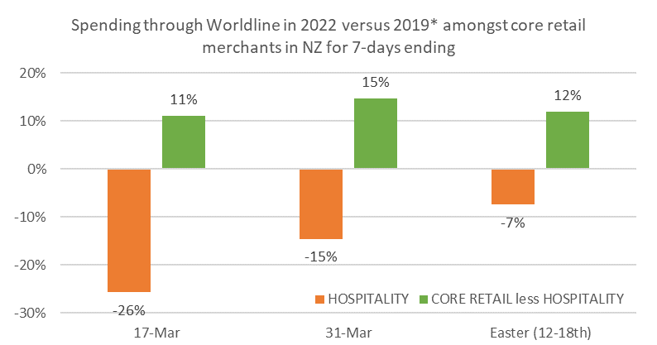
Figure 1: All Cards NZ underlying* spending change for recent 7-day periods since equivalent periods in 2019 through Worldline for core retail merchants (* Underlying excludes large clients moving to or from Worldline)
This year, Saturday was an especially busy shopping day, with core retail spending on 16 April in Auckland / Northland up 10% on the previous Saturday (9 April), rising $6m to $64.7m.
The smaller regions experienced a proportionally larger increase, although it was smaller in dollar terms, as people travelled away from the larger centres for the Easter break. The highest Saturday-to-Saturday jump was 57% ($0.5m) in the West Coast region, followed by 37% ($0.6m) in Wairarapa. Outside Auckland/Northland, the next largest Saturday-to-Saturday jump in dollar terms was in Bay of Plenty, up $3.5m or 32%.
Across the entire four-day Easter long weekend, spending levels this year were similar to those seen last year, but notably were 8% above the pre-COVID Easter of 2019.
The regions recording the highest year-on-year core retail growth rates over the four-day Easter weekend were generally around the lower half of the North Island. Wellington remains the exception within this wider region, with Easter spending slightly down on 2021.
Meanwhile, the highest growth was seen in Taranaki, up 8% on last year and 26% on 2019, while spending over the four days of Easter was below 2019 and 2021 levels in Marlborough and Otago.
WORLDLINE All Cards underlying* spending for CORE RETAIL merchants for Easter weekend (Fri-Mon)
 | Value | Underlying* | Underlying*
Region | transactions $millions | Annual % change on 2021 | Annual % change on 2019
Auckland/Northland | 148.7 | -1% | 7%
Waikato | 34.7 | 4% | 16%
BOP | 35.9 | -1% | 11%
Gisborne | 4.0 | -4% | 7%
Taranaki | 10.1 | 8% | 26%
Hawke's Bay | 15.0 | 3% | 14%
Whanganui | 5.3 | 5% | 18%
Palmerston North | 11.8 | 5% | 19%
Wairarapa | 5.1 | 4% | 22%
Wellington | 39.2 | -2% | 7%
Nelson | 8.1 | -1% | 6%
Marlborough | 5.9 | -8% | -4%
West Coast | 3.7 | 1% | 6%
Canterbury | 44.0 | 3% | 10%
South Canterbury | 6.2 | 0% | 10%
Otago | 26.9 | -3% | -8%
Southland | 10.5 | 1% | 0%
New Zealand | 419.4 | 0% | 8%
Figure 2: All Cards NZ annual underlying* spending growth through Worldline over Easter weekend (Fri-Mon) for regional core retail (* Underlying excludes large clients moving to or from Worldline)
- ENDS -
Note to editors:
These figures reflect general market trends and should not be taken as a proxy for Worldline‘s market share or company earnings. The figures primarily reflect transactions undertaken within stores but also include some ecommerce transactions. The figures exclude transactions through Worldline undertaken by merchants outside the Core Retail sector (as defined by Statistics NZ).

For more information, contact:
Brendan Boughen
T 027 839 6044
E brendan.boughen@paymark.co.nz

ABOUT WORLDLINE IN NEW ZEALAND
We are New Zealand's leading payments innovator. We design, build and deliver payment solutions that help Kiwi business succeed. Whether you’re looking for in store, online or mobile payment solutions or powerful business insights, Worldline is here to help with technology backed by experience. www.paymark.co.nz

About Worldline
Worldline [Euronext: WLN] is the European leader in the payments and transactional services industry and #4 player worldwide. With its global reach and its commitment to innovation, Worldline is the technology partner of choice for merchants, banks and third-party acquirers as well as public transport operators, government agencies and industrial companies in all sectors. Powered by over 20,000 employees in more than 50 countries, Worldline provides its clients with sustainable, trusted and secure solutions across the payment value chain, fostering their business growth wherever they are. Services offered by Worldline in the areas of Merchant Services; Terminals, Solutions & Services; Financial Services and Mobility & e-Transactional Services include domestic and cross-border commercial acquiring, both in-store and online, highly-secure payment transaction processing, a broad portfolio of payment terminals as well as e-ticketing and digital services in the industrial environment. In 2020 Worldline generated a proforma revenue of 4.8 billion euros. worldline.com

PRESS CONTACTs

Hélène Carlander
T +33 (0)7 72 25 96 04
E helene.carlander@worldline.com
Investors Relations
Laurent Marie
T : +33 (0)1 58 01 83 24
E : laurent.marie@worldline.com

Follow us

