Hospitality sector spending takes gradual steps up in March as border rules change

AUCKLAND, 5 April 2022 – As several changes to New Zealand’s border rules came into effect in March, spending in the Hospitality sector rose gradually but steadily across the nation.
Data released by Worldline today shows that spending through Hospitality merchants increased steadily over the last four weeks of March. However, the monthly total of nearly $700m was still down 16.3% on March last year, when lockdowns were not in effect and COVID case numbers were low.

“There remains evidence of tough trading conditions amongst the merchants that transact through Worldline in New Zealand but there are encouraging pockets of recovery, and Hospitality especially is one of these,” says the company’s Head of Data, George Putnam.
Putnam notes that on March 4th, fully vaccinated New Zealanders and others with Immigration eligibility were able to enter the country from anywhere around the world without the need to isolate, then from March 19th, most other travellers could enter New Zealand without the need to enter Managed Isolation and Quarantine (MIQ).
“As international travel rules continue to ease further in the months ahead, the yardstick will be how well businesses are doing relative to pre-COVID levels,” says Putnam.
“Hospitality spending was down on pre-COVID levels by 26% in March, but the gap between 2019 and 2022 narrowed significantly during the month, with Hospitality spending in the last week of the month narrowing to a 15% decline. This is a promising development.”
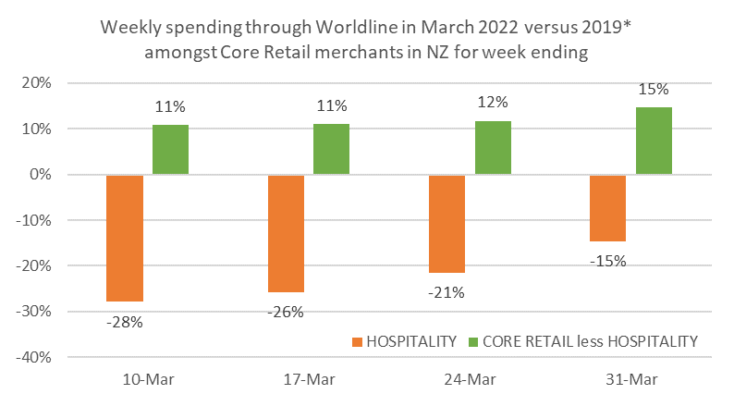
Figure 1: All Cards NZ underlying* spending change by month since 2019 through Worldline for core retail merchants (* Underlying excludes large clients moving to or from Worldline)
Meanwhile, spending in the rest of the core retail sector reached $2.9B in March, which is up 2.5% on last year, and up 10% on pre-COVID levels. However, as Putnam notes, the patterns can be markedly different for groupings of merchants.
“There is a wide mix of merchants within the non-hospitality core retail merchants and a wide range of experiences as well. For example, the group of merchants selling hardware, appliance, furniture etc. experienced 23% more spending relative to March 2019,” he says.
“Likewise, spending is up amongst groups such as pharmacies (+45%) and recreational goods merchants (+3%). However, in contrast, spending is below 2019 levels amongst groups of booksellers (-5%), clothing (-20%) and footwear (-30%) merchants.”
Putnam notes the regional pattern is also mixed.
Outside of the hospitality sector, Otago (-1.9%) recorded spending below pre-COVID levels, the Auckland / Northland, Wellington and Marlborough regions each saw modest three-year growth and the remaining regions grew at or above the national average.
The highest three-year growth was in Taranaki (+25.4%). Of particular note in March, storm-ravaged Gisborne was down 5.1% on last year, but still 10.2% up on March 2019, pre-COVID.
WORLDLINE All Cards underlying* spending for CORE RETAIL less HOSPITALITY merchants for March 2022
 | Value | Underlying* | Underlying*
Region | transactions $millions | Annual % change on 2021 | Annual % change on 2019
Auckland/Northland | 1,062 | 3.9% | 6.7%
Waikato | 232 | 5.3% | 18.0%
BOP | 195 | 3.8% | 14.7%
Gisborne | 27 | -5.1% | 10.2%
Taranaki | 68 | 9.1% | 25.4%
Hawke's Bay | 101 | 2.1% | 15.3%
Wanganui | 37 | 3.8% | 23.6%
Palmerston North | 89 | 4.5% | 20.4%
Wairarapa | 37 | 4.4% | 23.9%
Wellington | 281 | -4.3% | 8.4%
Nelson | 58 | 1.5% | 10.1%
Marlborough | 34 | -3.7% | 4.4%
West Coast | 20 | 4.0% | 12.4%
Canterbury | 345 | 4.2% | 15.1%
South Canterbury | 49 | 2.7% | 15.3%
Otago | 149 | -0.5% | -1.9%
Southland | 69 | 2.1% | 10.2%
New Zealand | 2,898 | 2.5% | 10.1%
Figure 2: All Cards NZ annual underlying* spending growth through Worldline March for regional core retail excluding hospitality merchants (* Underlying excludes large clients moving to or from Worldline)
- ENDS -
Note to editors:
These figures reflect general market trends and should not be taken as a proxy for Worldline‘s market share or company earnings. The figures primarily reflect transactions undertaken within stores but also include some ecommerce transactions. The figures exclude transactions through Worldline undertaken by merchants outside the Core Retail sector (as defined by Statistics NZ).

For more information, contact:
Brendan Boughen
T 027 839 6044
E brendan.boughen@paymark.co.nz

ABOUT WORLDLINE IN NEW ZEALAND
We are New Zealand's leading payments innovator. We design, build and deliver payment solutions that help Kiwi business succeed. Whether you’re looking for in store, online or mobile payment solutions or powerful business insights, Worldline is here to help with technology backed by experience. www.paymark.co.nz

About Worldline
Worldline [Euronext: WLN] is the European leader in the payments and transactional services industry and #4 player worldwide. With its global reach and its commitment to innovation, Worldline is the technology partner of choice for merchants, banks and third-party acquirers as well as public transport operators, government agencies and industrial companies in all sectors. Powered by over 20,000 employees in more than 50 countries, Worldline provides its clients with sustainable, trusted and secure solutions across the payment value chain, fostering their business growth wherever they are. Services offered by Worldline in the areas of Merchant Services; Terminals, Solutions & Services; Financial Services and Mobility & e-Transactional Services include domestic and cross-border commercial acquiring, both in-store and online, highly-secure payment transaction processing, a broad portfolio of payment terminals as well as e-ticketing and digital services in the industrial environment. In 2020 Worldline generated a proforma revenue of 4.8 billion euros. worldline.com

PRESS CONTACTs

Hélène Carlander
T +33 (0)7 72 25 96 04
E helene.carlander@worldline.com
Investors Relations
Laurent Marie
T : +33 (0)1 58 01 83 24
E : laurent.marie@worldline.com

Follow us

