Hospitality sector rebound continues

AUCKLAND, 4 May 2022 – Data released by Worldline today confirms that consumer spending through Hospitality merchants increased significantly in April.

Consumer spending at Hospitality merchants – accommodation, cafes, bars, restaurants, and fast food outlets – in Worldline’s payments network reached $892m in April 2022. While this was down 6.8% on April 2021 and 0.4% on April 2019 before the COVID-19 pandemic, it marks a sharp improvement on the previous eight months, following the national Covid lockdown that began in mid-August last year.

“The increasing relaxation of Covid restrictions in April and the general shift towards more personal responsibility around risks of Covid did appear to prompt consumers to make the most of their new freedoms for autumnal dining opportunities,” says Worldline’s Head of Data, George Putnam.
“As was the case last year during less restrictive periods, the Hospitality spending boost was more noticeable in the North Island regions outside of the two major centres than in the South Island, consistent with the larger population of the North Island moving around.”
Relative to April 2019, spending at Hospitality merchants was up 31% in Wairarapa ($8m) and 27% in Taranaki ($22m), as opposed to small annual declines seen during March. Conversely, Hospitality spending in the South Island ($229m) was still down 10% on April 2019, although this was a marked improvement on the 32% below 2019 levels seen during March 2022.
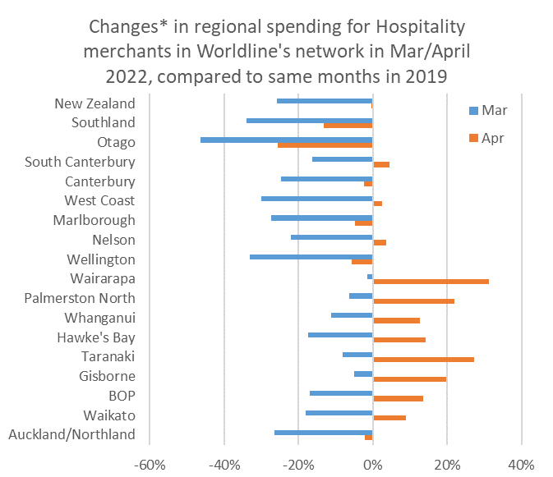
Figure 1: All Cards NZ underlying* spending change since 2019 through Worldline for hospitality merchants (* Underlying excludes large clients moving to or from Worldline)
Meanwhile, spending through Worldline’s payments network amongst the rest of the Core Retail sector was $2.9B in April 2022, up 4.1% on April last year and 15.4% on April 2019. These growth rates are similar to those seen in the previous five months.
“Spending in the rest of the Core Retail sector, which overall is far larger than Hospitality, is maintaining a growth momentum at present, at least in terms of total dollars being spent,” says Putnam.
“Worldline does not track spending on individual products so we cannot comment on whether the increased spend at these stores represents higher prices or a shift in buying for high- and low-priced products. However, it is notable that the average value of a payment transaction has increased since 12-months ago, which is consistent with generally higher prices.”
Putnam says the average value of April transactions through all Core Retail merchants in Worldline’s network (excluding Hospitality) was $52.84, up 8.9% since April last year and 11.0% since April 2019.
“What’s more, in April this year we saw spending at merchants selling discretionary products – such as clothing and footwear, or electrical goods – showing growth patterns very similar to earlier months, suggesting that any inflation-induced cutbacks in spending have been modest so far.”
Around the regions, the highest three-year growth amongst the Core Retail merchants (excluding Hospitality) was seen in Wairarapa (+29.7%), Taranaki (+27.5%) and Whanganui (+23.5%). Spending in Gisborne and Wellington was below year-ago levels, but both were up around 12% on 2019. All regions were trading at above pre-Covid levels for April (although the same cannot be said for all merchants).
WORLDLINE All Cards underlying* spending for CORE RETAIL less HOSPITALITY merchants for April 2022
 | Value | Underlying* | Underlying*
Region | transactions $millions | Annual % change on 2021 | Annual % change on 2019
Auckland/Northland | 1,058 | 3.8% | 13.1%
Waikato | 234 | 9.2% | 22.4%
BOP | 203 | 6.1% | 18.7%
Gisborne | 27 | -2.4% | 12.1%
Taranaki | 68 | 10.4% | 27.5%
Hawke's Bay | 103 | 4.3% | 20.3%
Whanganui | 36 | 5.1% | 23.5%
Palmerston North | 88 | 6.0% | 21.6%
Wairarapa | 38 | 5.4% | 29.7%
Wellington | 274 | -2.2% | 12.4%
Nelson | 58 | 3.1% | 10.8%
Marlborough | 35 | 1.1% | 11.3%
West Coast | 20 | 6.4% | 19.3%
Canterbury | 343 | 6.3% | 21.0%
South Canterbury | 47 | 3.3% | 14.9%
Otago | 155 | 2.0% | 7.4%
Southland | 67 | 3.8% | 12.5%
New Zealand | 2,901 | 4.1% | 15.4%
Figure 2: All Cards NZ annual underlying* spending growth through Worldline April for regional core retail excluding hospitality merchants (* Underlying excludes large clients moving to or from Worldline)
- ENDS -
Note to editors:
These figures reflect general market trends and should not be taken as a proxy for Worldline‘s market share or company earnings. The figures primarily reflect transactions undertaken within stores but also include some ecommerce transactions. The figures exclude transactions through Worldline undertaken by merchants outside the Core Retail sector (as defined by Statistics NZ).

For more information, contact:
Brendan Boughen
T 027 839 6044
E brendan.boughen@paymark.co.nz

ABOUT WORLDLINE IN NEW ZEALAND
We are New Zealand's leading payments innovator. We design, build and deliver payment solutions that help Kiwi business succeed. Whether you’re looking for in store, online or mobile payment solutions or powerful business insights, Worldline is here to help with technology backed by experience. www.paymark.co.nz

About Worldline
Worldline [Euronext: WLN] is the European leader in the payments and transactional services industry and #4 player worldwide. With its global reach and its commitment to innovation, Worldline is the technology partner of choice for merchants, banks and third-party acquirers as well as public transport operators, government agencies and industrial companies in all sectors. Powered by over 20,000 employees in more than 50 countries, Worldline provides its clients with sustainable, trusted and secure solutions across the payment value chain, fostering their business growth wherever they are. Services offered by Worldline in the areas of Merchant Services; Terminals, Solutions & Services; Financial Services and Mobility & e-Transactional Services include domestic and cross-border commercial acquiring, both in-store and online, highly-secure payment transaction processing, a broad portfolio of payment terminals as well as e-ticketing and digital services in the industrial environment. In 2020 Worldline generated a proforma revenue of 4.8 billion euros. worldline.com

PRESS CONTACTs

Hélène Carlander
T +33 (0)7 72 25 96 04
E helene.carlander@worldline.com
Investors Relations
Laurent Marie
T : +33 (0)1 58 01 83 24
E : laurent.marie@worldline.com

Follow us

