



Assessment of the Housing System: with insights from the Hamilton-Waikato Area

Housing Technical Working Group

18 August 2022

Contents

Executive Summary 2

At a Glance - Some Key Facts 4

Background 5

Terminology used in the report 6

Key findings 6

Contributing members of the Housing Technical Working Group: Dominick Stephens (Treasury, Chair), Nick McNabb (MHUD), Chris McDonald (RBNZ), Alan Bentley (MHUD), Matthew Brunton (RBNZ), Enzo Cassino (RBNZ), Andrew Coleman (RBNZ), Ashley Farquharson (RBNZ), Alex Gunn (MHUD), Jonno Ingerson (MHUD), Frances Krsinich (MHUD, Statistics NZ), Hannah Ouellet (Treasury), Chris Parker (Treasury), Tyler Smith (RBNZ).

# Executive Summary

To better understand the drivers of house prices and rents and how this has impacted households Te Tūāpapa Kura Kainga (Ministry of Housing and Urban Development), Te Pūtea Matua (Reserve Bank of New Zealand) and Te Tai Ōhanga (The Treasury), through the Housing Technical Working Group, looked at the housing and urban development system in Hamilton-Waikato to build a more comprehensive picture of supply and demand and how these have interacted over time.

It is commonly asserted that a lack of dwelling supply relative to population has been a key driver of rising house prices in recent decades. But physical supply and demand should affect rents as well as prices, and over the past twenty years house prices have risen far more than rents. Our key conclusion is that a combination of a global decline in interest rates, the tax system, and restrictions on the supply land for urban use have led to a large change in the ratio of prices to rents, and are the main cause of higher house prices in Hamilton-Waikato, as well as other parts of Aotearoa New Zealand, over the past 20 years.

To understand the drivers of rents and house prices it is important to separate the supply of land from the supply of dwellings. We find that regulations and other constraints to urban intensification (building up) and expansion (building out), particularly in the main urban areas, have restricted land supply with implications for house prices and rents.

In the context of restrictions to land supply, the key driver of house prices over the last twenty years has been the global decline in interest rates that significantly reduced the cost of debt servicing and increased home buyers’ ability to pay. The resulting increase in demand inevitably caused an initial lift in prices. If land supply had been more responsive, then over time that initial price rise would have incentivised a larger housing supply response, causing prices to retreat and rents to fall below their initial levels relative to income. This did not fully happen, because land supply has been restricted.

Due to restrictions to land supply, much of the global decline in interest rates was instead capitalised into, or captured by, higher land prices. As land prices rose alongside house prices, there was less change in the incentive to build new houses, and less of a supply response. Consequently, the initial price rise caused by lower interest rates persisted, and the longer-run retreat in prices and decline in rents did not materialise.

Evidence supporting our conclusions includes the fact that prices rose much further than rents, that the price of land rose much further than the cost of constructing new dwellings, and direct indications of restricted land supply.

Restrictions to land supply also influence how the tax system and other factors affect house prices relative to rents. The more restricted the supply of land, the more that changes to the tax system will be captured as changes in the value of land, rather than affecting incentives to build more homes and reduce rents. Hence the tax system has played a role in the passthrough from lower interest rates to higher land prices. Similarly, when land supply is restricted, changes to construction costs or building standards are more likely to affect land values than housing supply or rents.

We still regard the supply of dwellings as extremely important for housing costs and the wider housing system. The supply of dwellings relative to demand is a less prominent driver of house prices, but an important determinant of rents. Until recently rents in Hamilton Waikato had moved broadly in line with, and at times slower than, incomes over a long period. Trends at a national level were similar. But since 2015, rents have increased sharply across the Hamilton Waikato region as population has grown faster than the supply of dwellings. The worsening availability and affordability of rentals has increased financial stress and homelessness.

The increase in rents since 2015 is likely to have had a larger negative impact for the wellbeing of society’s most vulnerable members than the large increase in house prices. This further emphasises the importance of our conclusion that, had land supply been more flexible, the large decline in interest rates would have resulted in rents and house prices being lower.

While we regard falling interest rates in the context of unresponsive land supply as the main driver of rising house prices over the past twenty years, it does not explain house prices in all places and all times. Costs of construction, land development and infrastructure have also increased over time, including to support other objectives like improved water quality or climate adaptation. Also in many regional centres house prices have spent periods of time below the cost of constructing new dwellings. Under these conditions increasing demand will cause prices to rise until new homes are priced competitively compared to existing ones.

One further and crucial caveat is that our analysis explains outcomes in the housing market where land and housing is valued as an asset as well as a home. For Māori, all land holds significant cultural and non market value . Land held under Te Ture Whenua Māori, which makes up of 5% of land in Aotearoa New Zealand, can be subject to significant additional constraints through fragmented ownership and access to finance. For this reason, the housing market drivers outlined in this paper will not necessarily explain outcomes for land owned by Māori. Aspects of the Māori Housing system will be a focus of future work.

Reforms to increase land supply (including the National Policy Statement on Urban Development and The Resource Management (Enabling Housing Supply and Other Matters) Act) may moderate land and house prices further, but this is dependent on other factors such as local government support, the provision of infrastructure and decisions by major landowners including mana whenua. This will play out over a longer timeframe.

While there are significant potential gains from improving the responsiveness of land supply to changes in demand, many constraints could be difficult to fully address, and others exist for good reasons. Further reforms to improve the responsiveness of land supply, including through the Resource Management Act reforms, need to be supported by an improved understanding of the interactions between housing and other national, regional or local objectives, all of which support thriving communities. Priorities around climate change, emissions reductions, food production, maintenance of heritage/character, and the limits around funding and financing of infrastructure and urban development all have the potential to limit land supply or make development more expensive.

Better assessment and monitoring metrics will help us manage these interactions and identify where and how land supply can be more responsive while also consistent with other objectives, such as the Government Policy Statement on Housing and Urban Development. Developing better indicators of land supply responsiveness is a key next focus of the Housing Technical Working Group.

There is no simple and complete solution to solving the housing crisis. The Housing Technical Working Group, with support from other stakeholders, will work together to get a better understanding of the relative impacts of policies on housing outcomes and the other priorities for New Zealanders.

# At a Glance - Some Key Facts

Due to restrictions on the supply of land, the global decline in interest rates over the past twenty years was capitalised into land values, explaining most of the rise in house prices.

If land supply had been more flexible, falling interest rates would have sparked more of a housing supply response, meaning rents and prices would have risen by less.

For the Waikato Region, between March 2002 and June 2021:

* House prices increased by 372% and rents by 114%.
* Incomes increased by 98% over the same period, while national construction costs increased by 142%.
* Section prices have increased by 405% (and 658% in Hamilton City).
* Deposit affordability has declined sharply, with the required deposit increasing significantly relative to income.
* Mortgage affordability – the cost to service a mortgage – had improved due to the decline in long term interest rates, although the very recent increase in mortgage rates has largely reversed this.
* Rental affordability improved from around 2007 through to 2014, but since then an increase in people per dwelling has put pressure on the supply and demand for housing causing the recent decline in rental affordability.
* The relative affordability of Hamilton Waikato housing compared to Auckland increased demand from movers, first home buyers and investors, contributing to population and price growth.
* A number of metrics indicate that land supply has not been responsive to increased demand, consistent with the strong growth in section prices and the increase in the house price to rent ratio.

# Background

The high price of housing, including rents, is one of the most important issues facing New Zealanders today.[1] In 2020, New Zealand had the highest housing cost to disposable income ratio in the OECD.[2] However, access to affordable housing is not a new issue, it is a persistent long-term challenge that has far reaching consequences on social, cultural and economic outcomes. Reductions in affordability can exacerbate inequality, homelessness, and child poverty, generate financial stability risks, and redistribute wealth. Insufficient responses to Māori housing issues have had an intergenerational impact on Māori communities. It is therefore important that the Government’s response to the housing crisis is effective with government agencies having the best possible understanding of the housing market and the housing and urban development system within which it sits.

The housing market is complex and influenced by many factors. In 2021 many changes were made to New Zealand’s housing system. During 2020 and 2021, there was a rapid increase in house prices. This was different to expectations that the market would cool due to the impacts of COVID-19. Given that this rapid increase occurred during a period of low population growth and strong construction activity, it challenged traditional understandings of the housing market. In 2021, the Government put additional investment into housing and infrastructure, Māori housing, and made changes to tax and zoning policies. In March 2021, the Reserve Bank reinstated Loan-to-Value Ratio restrictions at pre-COVID levels, and further tightened restrictions later in the year. The Minister of Finance also gave a direction to the Reserve Bank to have regard to the effect of financial policy on house price sustainability. In addition to the Government’s and the Reserve Bank’s actions in 2021, many existing housing policies, programmes and long-term reforms remain underway.

Given that there is a lot going on in the housing market, the Reserve Bank, Treasury and the Ministry of Housing and Urban Development wanted to ensure we had a common and evidence-based understanding of the housing market. We undertook this assessment to develop a deeper understanding of the demand and supply drivers of housing, and how these drivers interact to affect house prices and rents. We are also interested in the impact of recent and ongoing policies on the housing market. Insights will be used to help inform our approach to supporting the Government’s housing objectives that were set out in the Government Policy Statement on Housing and Urban Development (GPS-HUD),[3] released in September 2021.

The three agencies looked at the Hamilton-Waikato area to ground our assessment of New Zealand’s housing market. We took a place-based approach to capture insights that were likely to be relevant across New Zealand. To support our conclusions about the national housing market, we also used national level data. The Hamilton-Waikato area – principally the Future Proof area of Hamilton City, Waipa District and Waikato District – was selected because it is a major urban area with fewer natural constraints or market disruptions than other major centres.

As leads for the housing and urban development, economic, financial and monetary systems, the three agencies led this assessment to test how our analytical and theoretical frameworks performed in the Hamilton-Waikato area and nationally. This report is an observational analysis of how the housing market functions and does not put forward specific policy advice or points of action.

An important caveat to our analysis is that it focuses on the outcomes in the housing market, where land and housing is valued as an asset as well as a home. Our analysis will not reflect outcomes for Māori where land has significant cultural value as well as market value, and where additional constraints and responsibilities can limit how land is used. Future work of the Housing Technical Working Group will look at how aspects of the Māori housing system interact with the housing market, with an initial focus on supporting reforms to financing on whenua Māori.

# Terminology used in the report

Land supply is a term that will be used throughout the report. While the overall supply of land in a country is ultimately is fixed, the extent to which is can be used for urban uses, including housing is not. In this report, the supply of land refers to:

* new urban land, typically on the outer limits of cities;
* redevelopment opportunities on existing urban sites; and
* intensification opportunities on existing housing sites.

It is also important to note that urban land may be used for housing, commercial, industrial, infrastructure or community purposes. While the predominant focus of this report is the supply of land for housing, land is also needed for other urban uses to enable communities to thrive.

The supply of land for urban use is not just about land use regulation, land also needs to be serviced by infrastructure. In cities, the quality of transport networks can be a key determinant of land value and the volume of redevelopment and intensification opportunities, and therefore land supply.

Restricted land supply means that there are rules, regulations or constraints that reduce the supply of developable land (serviced by infrastructure). Abundant land supply means that there are no restrictions or constraints to land supply.

# Key findings

1. Rising prices and rents have had a significant impact on wellbeing, home ownership rates, wealth inequality, homelessness and child poverty. These outcomes disproportionately affect low-income earners, Māori and Pacifica people and young people.

Low-income earners, Māori and Pacific peoples and young people are more likely to rent the homes they live in, and Māori and Pacific peoples are overrepresented on the Public Housing Register. On average across New Zealand, rents have risen in proportion to incomes over recent decades. However, in some parts of the country, including the Hamilton/Waikato area, a shortfall in housing supply drove rents up faster than incomes between 2014 and 2019. This could have a long-lasting effect on wellbeing for some of New Zealand’s most vulnerable people. Some New Zealanders will rent for life and compared to other groups will likely have higher lifetime housing costs relative to their income.

The biggest change in housing affordability has been experienced by aspiring first home buyers struggling to raise a house deposit. Rising house prices over the past twenty years have caused a dramatic rise in the deposit required to get a mortgage compared to average incomes. Consequently, many people have been forced to delay their entry into homeownership and others have been locked out of the housing market altogether, exposing them to high rental costs.

In contrast to aspiring first home buyers and other renters, people with sufficient capital to muster a deposit have benefitted from mortgage rates trending lower over time. Despite rising house prices, mortgage affordability has generally been maintained in the sense that mortgage payments on a given house have increased at a similar pace to incomes over the past twenty years. This is the key reason that some New Zealanders have been willing and able to pay such high prices for houses, but it has come at the cost of increasing the barrier for others to home ownership. Furthermore, over the past twenty years existing homeowners have benefitted from a rise in the value of their main asset. This has amounted to a redistribution of wealth from non-owners to owners.

#### Analysis of the Hamilton-Waikato Area

House prices in the Hamilton and Waikato area have increased much faster than incomes over the past 20 years. However, mortgage rates have approximately halved. The net effect is that mortgage costs relative to income have decreased since 2000. Figure 1 shows that mortgage affordability has improved over the past 20 years, but has recently dipped due to a lift in mortgage rates. This means recent buyers may find it more difficult to service a mortgage compared to when they purchased the home.

Figure Mortgage affordability

Change in mortgage interest prices and incomes since March 2001

|  |  |  |
| --- | --- | --- |
| Hamilton City | Waikato region | New Zealand |
|  |  |  |

Note: Higher affordability index means becoming more affordable. Source: Te Tūāpapa Kura Kāinga Ministry of Housing and Urban Development estimates, Stats NZ, Tenancy Bonds, and CoreLogic.

Deposit affordability measures the ratio of house prices to incomes. It can be thought of as the cost of raising the deposit necessary to get a mortgage on a typical New Zealand house, relative to incomes. Figure 2 shows that deposit affordability has fallen to historic lows in Hamilton, Waikato and across New Zealand, as house prices have increased. Hamilton has a younger population and a lower homeownership rate than the rest of the country, so deposit affordability is particularly relevant.

Figure Deposit affordability

Change in property prices and incomes since March 2001

|  |  |  |  |  |
| --- | --- | --- | --- | --- |
| Hamilton City | Waikato region | New Zealand | | |
|  |  | |  |

Note: Higher affordability index means becoming more affordable. Source: Te Tūāpapa Kura Kāinga Ministry of Housing and Urban Development estimates, Stats NZ, Tenancy Bonds, and CoreLogic.

National rental affordability has remained relatively stable over the past 20 years. However, median rents have increased slightly more than median incomes in Waikato over the past 6 years, leading to a drop in rental affordability. This is shown in Figure 3 below. The increase in rents is likely a result of population growth outpacing new dwelling supply in Waikato from 2014 to 2019 (see Figure 6). Over this time, there was also an increase in people per dwelling from 2.4 to 2.6 in the Waikato region, and from 2.8 to 3.0 in Hamilton City, indicating that a shortage of housing has emerged.

Figure Rental affordability

Change in rent and income since March 2001

|  |  |  |
| --- | --- | --- |
| Hamilton City | Waikato region | New Zealand |
|  |  |  |

Note: Higher affordability index means becoming more affordable. Source: Te Tūāpapa Kura Kāinga Ministry of Housing and Urban Development estimates, Stats NZ, Tenancy Bonds, and CoreLogic.

The recent decline in rental affordability has had significant impacts on wellbeing. Worsening affordability has contributed to increased household crowding and individuals and whanau seeking emergency and public housing. In December 2021 there were 2,036 households on the Public Housing Register across Hamilton, Wāipa and Waikato districts, compared to 693 in December 2018. Compared to the rest of New Zealand, Hamilton has significantly more people (per capita) on the public housing register, and more families living in motels (see Figure A1).

For mana whenua in the Waikato region, this worsening affordability occurs in the context of historic loss of land through confiscation and war – or raupatu. For this reason, Māori own less land, fewer own their homes and have less intergenerational wealth. Because Māori make up a larger proportion of renters and aspirant first home buyers they have been disproportionately affected by recent declines in affordability.[4]

1. A common view amongst economists and policymakers has been that rising house prices are a consequence of a lack of dwelling supply. The conclusion reached by the Housing Technical Working Group is that while the housing shortage has contributed to New Zealand’s housing crisis by affecting rents and overcrowding, it has not been the major driver of house prices over the past 20 years.

New Zealand policymakers and economists have often linked the rise of house prices to either shortages of dwellings or increases in construction costs. This reflects traditional economic theory, which holds that house prices should reflect the cost of constructing a dwelling plus the cost of vacant land, and that the price vacant land at the edge of city should reflect its next-best use, often farming. Any large increase in house prices should, over time, provoke an increase in housing supply until prices are driven back to the cost of construction plus land. Under this traditional model, large persistent increases in house prices are explained by either increases in the cost of constructing dwellings, or by a failure of the construction sector to mount an adequate supply response to any increase in demand.

However, the facts of the Waikato and New Zealand house price booms are not consistent with this explanation.

#### Analysis of the Hamilton-Waikato area

Shortages of dwelling supply should affect both house prices and rents, as the two forms of tenure are substitutes. But in fact, over the past twenty years (between March 2002 and June 2021), house prices have risen 372% while the increase in rents has been much smaller at 114%, and has been similar to income growth (Figure 4).

Over the same period, the national cost of building dwellings increased 142% based on the CPI purchase of new housing class (see Figure A2). Therefore, rising construction costs can at best explain only a proportion of the total increase. The remainder is associated with an increase in the price of sections.

In the Hamilton-Waikato area the sharp increase in section prices aligns with recent movements in house prices (Figure 5). Where land supply is restricted, land is priced at its highest and best use as housing, therefore we expect section prices and house prices to track closely together.

Figure Growth in house prices rents and income across the Waikato Region

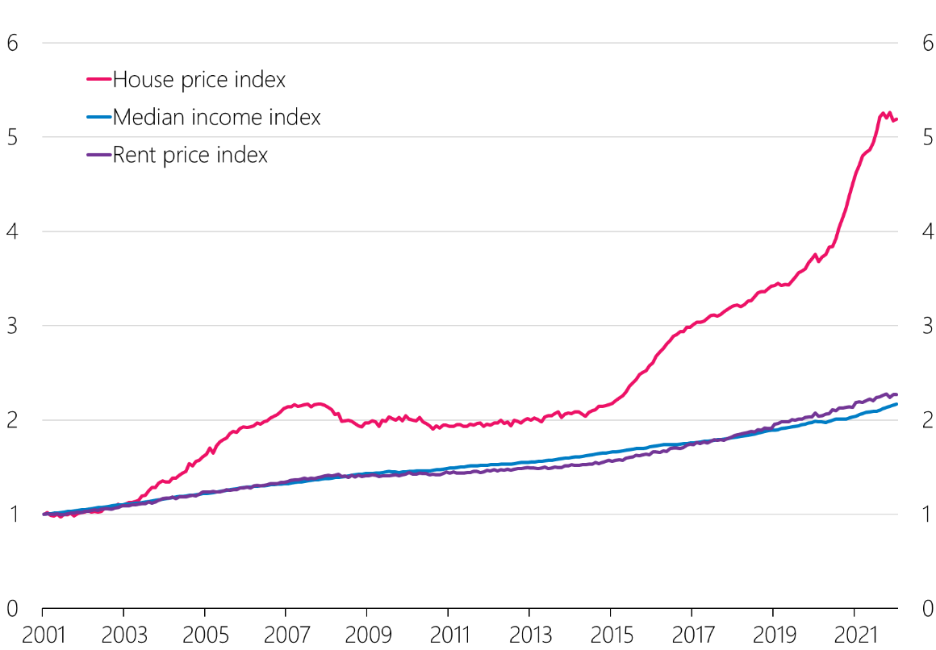

Source: Stats NZ, REINZ, HUD estimates.

Figure Median Sales Price for Residential Vacant Land  
(rated up to Hamilton Median Section size of 0.068 Hectares)

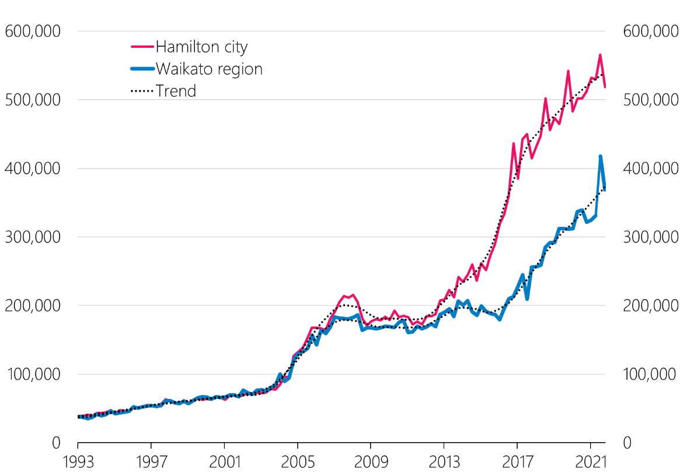

Source: HUD calculations based on CoreLogic data.

There has been no consistent link between supply shortages and house prices in Hamilton-Waikato over recent decades. Dwelling supply outpaced population growth from 2004 to 2007, a period of very rapid house price inflation. House prices also increased quickly when Hamilton-Waikato experienced a large undersupply of housing relative to population growth from 2014 to 2019, a period when net immigration to New Zealand was elevated and as people from Auckland moved to the Waikato region (see Figure 8). However, population growth in Hamilton-Waikato fell sharply soon after the onset of Covid-19 and residential construction activity accelerated further, yet over 2020 and 2021 house prices rose even more rapidly than over the previous five years.

Figure Population growth versus housing supply in the Waikato region



Note: ‘Change in the supply of houses’ is a 12-month rolling average of residential building consents. ‘Population growth’ is working-aged population growth from the Household Labour Force Survey (HLFS). This is divided by people per dwelling which is the ratio of the working-aged population over the number of electricity connections. Source: Stats NZ, Electricity Authority, RBNZ estimates.

1. In our assessment, the main driver of house prices in New Zealand over the past 20 years has been a global decline in interest rates, in the context of restricted land supply.

House prices rising much faster than rents over the past twenty years has resulted in a dramatic increase in the price/rent ratio, or equivalently, a dramatic decline in rental yields (annual rent divided by the property’s value). This is a clue that financial factors have played a role in determining house prices in New Zealand.

In any housing market, rental yields should bear some relationship to the returns on offer in other markets. For example, if rental yields were much higher than interest rates, private landlords would seek to borrow cheaply to buy high-yielding investment properties, and some tenants would seek to become owner occupiers. This would increase demand for houses and the resulting price rise would drive price/rent ratios up, and rental yields down. This would continue until rental yields fell into equilibrium with interest rates, considering factors like risk aversion and taxes.

Our User Cost analysis shows that both at the national level and for the Hamilton/Waikato area, the decline in rental yield over the past twenty years is consistent with the large decline in mortgage rates that occurred over the same period (see below).

However, it is less clear why this necessary decline in rental yields was brought about by a large persistent rise in prices, rather than by a decline in rents. As the next section explains, this is due to the nature of land supply in New Zealand. Traditional models featuring abundant land supply predict that a fall in interest rates will eventually bring about increased supply and a decline in rents. But when land supply is highly restricted, theory predicts that interest rate changes will affect house prices rather than rents. Hence our overall conclusion is that a decline in interest rates in the context of restricted land supply is the key cause of the large increase in New Zealand house prices over the past twenty years.

#### Analysis of the Hamilton-Waikato area

As noted above across the Waikato Region house prices have risen 372% between March 2002 and June 2021. By comparison rents and incomes are up 114% and 98% respectively, with CPI inflation of 49%. This suggests financial factors, in particular interest rates, have had the greatest impact on prices over the past 20 years.

To see how financial and other factors flow through to buyers’ decisions the Group estimated the user cost value of housing in Hamilton. This is the value of a house for owner-occupiers or private investors given: rental income (or savings from not paying rent); cost of maintaining a property (including local council rates); opportunity cost of other investments; mortgage interest rates; inflation; and taxes including capital gains and the denial of interest deductibility.

Figure 7A shows that changes in estimates of the user cost value of housing (in this case equivalent to a discounted cash flow of housing) provide a good explanation for the trend in house prices over the past 20 years. Since the Global Financial Crisis, house prices and user cost values of housing have increased steadily as long-term interest rates declined. This is also shown in Figure 7B by the estimated neutral discount rate.

Figure A User cost estimates of Hamilton house prices



Source: CoreLogic, RBNZ estimates.

Figure 7B User cost estimates of Hamilton house prices



Source: RBNZ estimates.

Decomposing drivers of user cost estimates could be a useful tool to determine the main drivers of house prices. Figure 8 shows the decline in long-term interest rates has had the greatest effect on house prices since 2016, followed by rising real rents and rising rents due to general inflation.

Figure Drivers of house prices in Hamilton since 2016 using user cost modelling (percentage change)

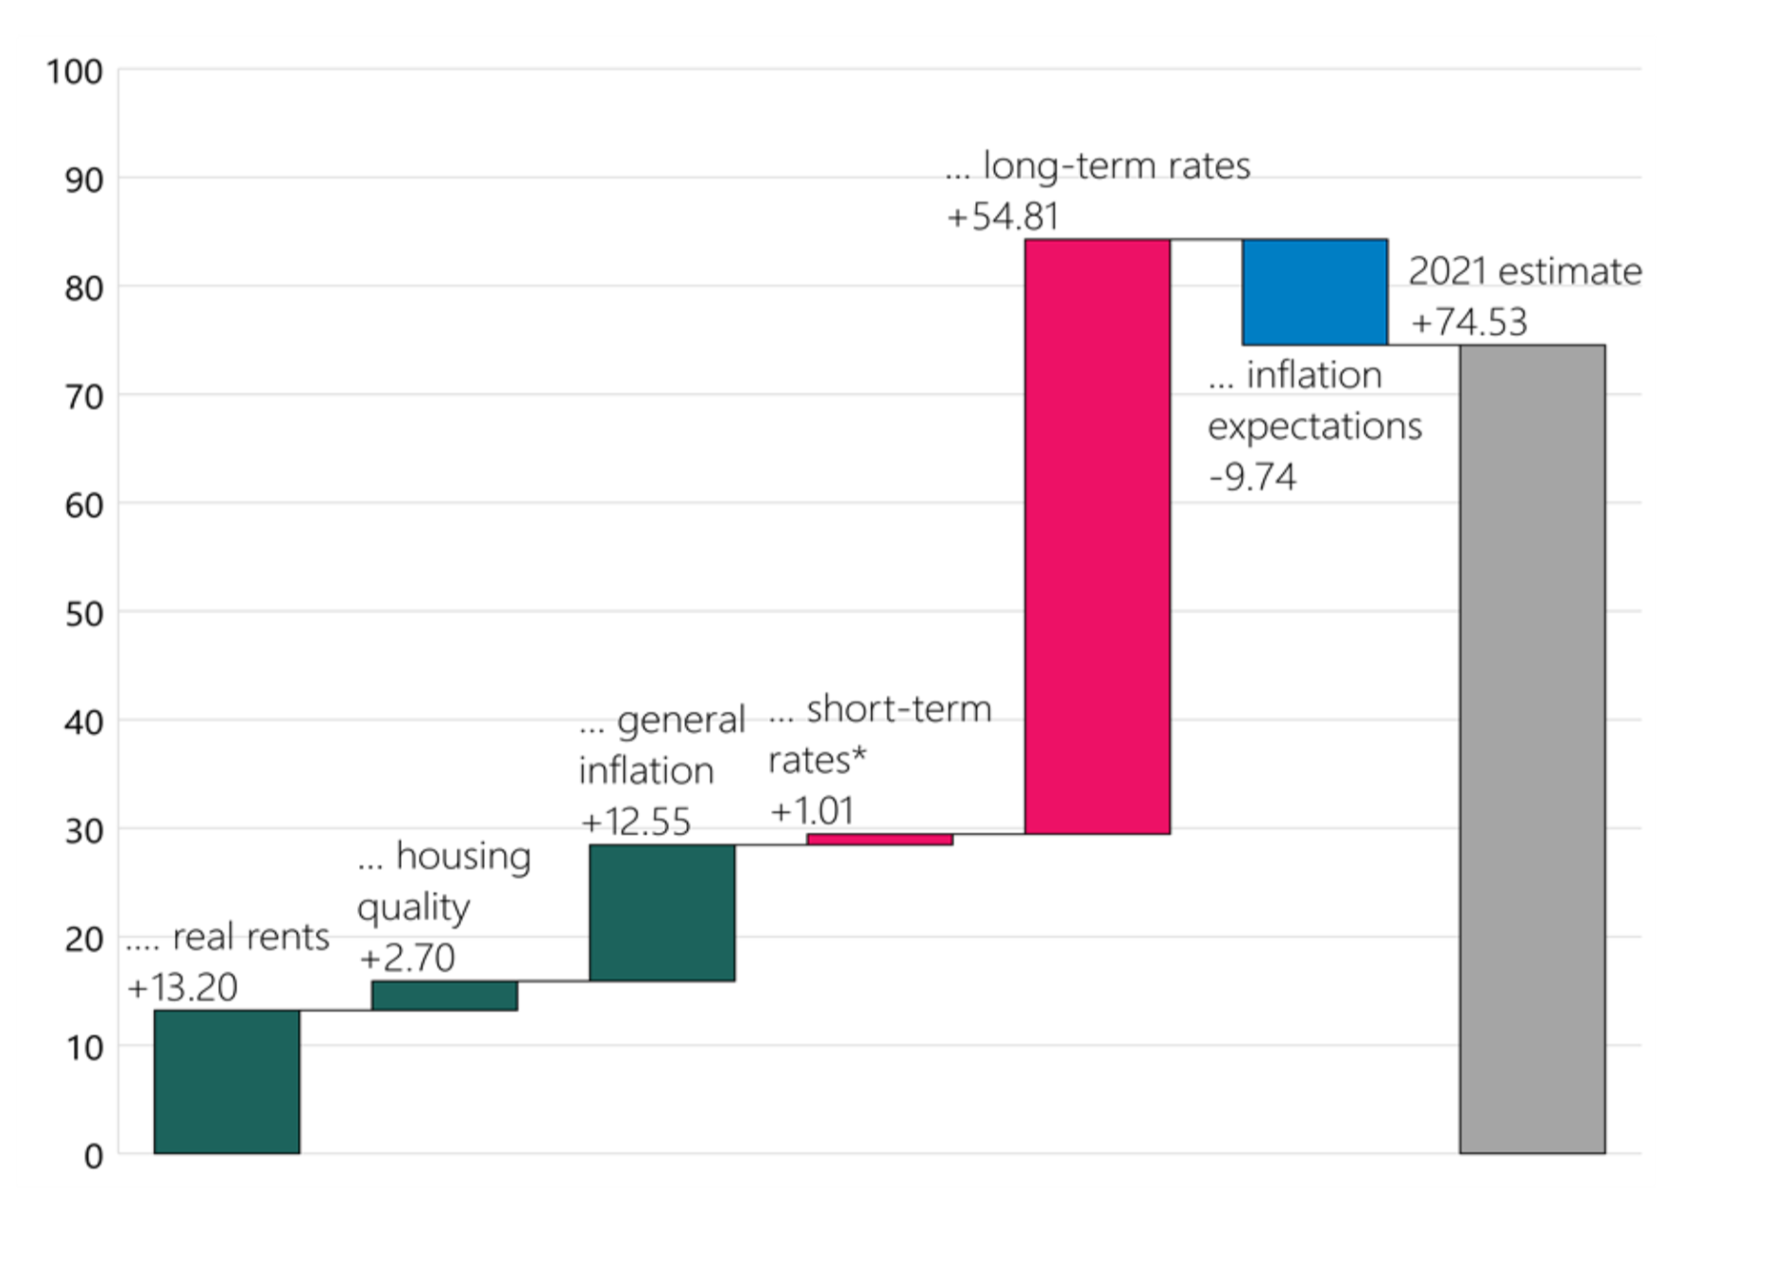

Note: The contribution of short-term rates reflects the change in the difference between long-term and short-term interest rates. The contribution from the change in housing quality is inferred from the difference in rent growth between rental bond data and Stats NZ Rental Price Index. Source: Stats NZ, CoreLogic, RBNZ estimates.

1. A housing market experiencing restricted effective land supply behaves differently to traditional models. Restricted land supply can explain the New Zealand experience.

For the purposes of illustration, this section describes how housing markets will work in two extreme cases: completely abundant land supply, and completely restricted land supply. In reality, New Zealand land markets lie somewhere on a spectrum between these two extremes, as discussed in section 5.

#### Completely Abundant Land Supply

When land supply is completely abundant, house prices will reflect the cost of building new dwellings – construction costs plus land prices. The price of land at a city’s edge will reflect its next best use such as farming, plus the cost of providing suitable infrastructure. Inner city urban land will reflect what people are willing to pay to live closer to jobs and amenities, compared to living at the city’s edge.

If land supply is abundant, then if house prices rise above the cost of construction plus land, new construction will be incentivised, housing supply will increase, and house prices will moderate. Consequently, changes in construction costs would be reflected in changes to house prices.

Under abundant land supply, a decline in interest rates might cause house prices to rise initially, but this would provoke an increase in the supply of dwellings, reducing both rents and house prices. In the long run, rents would adjust to ensure rental yields reflected the financial backdrop. Similarly, taxes on housing would eventually affect rents, not house prices.

#### Completely Restricted Land Supply

When land supply is completely restricted, the price of land is free to diverge from its next-best use, such as its value as a farm on the edge of a city. Rents, however, will be anchored by tenants’ willingness and ability to pay, given factors including household incomes and supply-demand balance. House prices will reflect the net present value of this rental income to a potential investor (or the value of switching away from rent to an owner-occupier). As land is artificially scarce, it would be priced at its highest and best use as housing, less the cost of constructing the building.

Therefore, when land supply is completely restricted any change in construction costs will simply increase or decrease land values, without affecting incentives to supply new dwellings or rents.

Similarly, any change in interest rates will be captured as a change in land values. A drop in interest rates would cause house prices to rise, but since land values would also rise there would be no change in incentives to build, and therefore no change in rents.

Finally, when land supply is completely restricted, tax changes would affect land values, but would not affect housing supply or rent.

Table Long-run impacts on house prices, depending on characteristics of land market

|  |  |  |
| --- | --- | --- |
|  | Completely Abundant Land Supply | Completely Restrictive Land Supply |
| Construction cost increase | House prices and rents increase. Land prices unchanged. | Land prices decrease. House prices and rents unchanged. |
| Introduction of capital gains tax or a tax on house owners | Rents increase due to supply reduction. Land prices and house prices unchanged. | Land prices decrease, house prices decrease, no change in supply, rents unchanged. |
| Permanent interest rate decline | Rental yields fall via a reduction in rents due to increased supply, house prices unchanged, land prices unchanged. | Rental yields fall via an increase in house prices and land prices. No change in supply, rents unchanged. |
| Large increase in population | No long-run change in rents or prices due to supply response. | Some increase in rents and prices as no change in supply. |

1. New Zealand’s land supply lies between abundant and restricted, and some cities have more abundant land supply than others.

The rapid rise in prices compared to rents seen in the Hamilton-Waikato housing market over the past twenty years, and of the New Zealand market at large, is inconsistent with completely abundant land supply. The behaviour of these housing markets is indicative of some degree of restriction or constraint on the supply of land. But neither is the availability of land completely restricted. For example, rising house prices do appear to generate a dwelling supply response.

While neither completely abundant or restricted land supply exists in practice, our analysis suggests that land supply in the Hamilton-Waikato area lies closer to the more restricted extreme than is commonly understood. The same is likely to be true for much of New Zealand.

#### Analysis of the Hamilton-Waikato Area

The Group has looked at four key indicators of urban land market performance. While no indicator provides a precise measure of the cost of land supply restrictions, the three indicators with recent evidence for Hamilton-Waikato suggest that land supply has been restricted. These indicators are useful for monitoring how responsive land supply is to demand, and for understanding the impact of local and central government interventions.

##### Rural-Urban Land Price Differential

When land supply is abundant, rural and urban land prices at the city’s fringe should be similar in value (net of development costs). Taking account of costs of development, Hamilton-Waikato had a rural-urban price differential of $227 per m2, based on 2017 prices (see Figure A3). This indicates that within the city there is a shortage of opportunities to redevelop brownfield land, and at the fringe there is a shortage of urban land supply. Since 2017 this price differential has most likely increased.

##### Upzoning Premiums

When land supply is abundant, land prices at any given location should remain similar in value after restrictions are removed. A study in Auckland found that large scale upzoning increased the price of underdeveloped properties relative to properties that were already intensively developed and properties that were not upzoned [5] This indicates that developers were (and likely still are) prevented from redeveloping sites to match demand for housing in some locations. This analysis has not been conducted in the Waikato area, but we would expect similar results.

##### House Price to Construction Cost Ratio

When land supply is abundant, house prices should broadly equate to the cost of constructing a new dwelling plus land and infrastructure. Based on research from the United States, where in many housing markets land supply is abundant, the cost of construction makes up around two thirds of the cost. This means the price of a home should be no more than 1.5 times the cost of construction. In Hamilton-Waikato, house prices generally outstrip construction costs. In 2016 the house price to cost ratio was estimated at 2.23 and has risen over time (see Figure A4)

##### Extensive vs Intensive Land Values

When land supply is abundant, there should be no systemic difference between the value of land under dwellings and vacant land. In Hamilton-Waikato the value of land under a dwelling was 2.8 to 5.4 times higher than the price of land that is not developed due to, for example, land use constraints and other physical and economic constraints. Land use regulations may have represented up to 28% of a dwelling’s price in 2015, a premium of up to $128,634 for the average dwelling.[6] These regulations are often a function of the broader urban planning system.

##### Different Constraints to Land Supply

Completely abundant land supply does not exist in practice as there are frictions and constraints that cannot be removed, may be expensive to remove, or may be net beneficial to society. To some degree the indicators reviewed above will reflect these frictions, other constraints or the effects of meeting other objectives. However, there are many things we can do to make effective land supply more abundant. We have identified three general categories of constraints to residential development:

Geographic and natural constraints: Highly productive soils, deep peat soils, rivers and high-risk flood zones from wetlands. Around 65% of land in the Waikato is used for farming or forestry, 27% is indigenous vegetation, and 1% is urban.[7] Compared to other major centres, the Waikato has fewer natural constraints. Sites of significance to Māori can also be a constraint on development and unable to be mitigated.

Less or non-controllable constraints: Extensive fragmentation of land ownership limits development options and past investment in infrastructure such as the Main and Eastern Trunk Lines and the Waikato Expressway create physical barriers and path dependence for future development.

More controllable constraints: including choices around regulation and investment. For example Waikato’s Regional Policy Statement and the NPS-UD are relatively permissive to urban expansion and intensification. The new medium-density rules are expected to add 3,000 to 12,000 dwellings in Hamilton.[8] However, much of the proposed future land supply does not have infrastructure committed. For this reason, it is not yet planned and cannot be developed.

Our conclusions are in line with recent work by Te Waihanga – the New Zealand Infrastructure Commission – that looked at the role that urban planning policies and infrastructure have played in slowing the responsiveness of housing supply and contributing to higher prices. A key difference in approach is that our analysis has identified the important role played by declining interest rates in the last 20 years, while Te Waihanga looked over a much longer time-period including past periods of low interest rates. Our view is that the combination of restrictions to land supply and the decline in interest rates have caused the price/rent ratio to increase over the past twenty years.

1. The tax system has also contributed to high house prices, given restrictions to land supply.

A neutral tax system is one that treats different economic activities equally. New Zealand’s tax system is not neutral. There are a range of tax distortions that affect house prices, land prices, rents and construction costs in New Zealand, and these have affected the Hamilton/Waikato area as much as other regions. The most important distortions are:

* Imputed rent (the rent owner occupiers effectively pay themselves) is not taxed, whereas other forms of income earned on investments are taxed.
* Capital gains are not often taxed, whereas other forms of income are.
* GST is charged as a lump sum when a house is built, and is charged on maintenance costs and rates, but is not charged on the flow of housing services consumed (rents or imputed rents).

The first distortion increases the incentive to purchase housing relative to other forms of consumption, creating an incentive for people to live in bigger or better houses than otherwise.

Both the first and the second distortions also increase the investment value of housing relative to other investments. Devoting resources to owner occupied housing yields untaxed shelter in perpetuity as well as untaxed capital gain, whereas saving money in the bank or investing in one’s education will yield a taxed stream of future income. Similarly, investing in rental housing yields tax-free capital gain for those who hold the property for long enough. Our analysis shows that these tax distortions have caused a higher price to rent ratio in New Zealand than under a more neutral tax system. In theory, whether prices or rents are affected depends on land supply. In a world of abundant land supply, these tax incentives for housing would lead to greater housing supply and therefore lower rents. Conversely, under completely restricted land supply, tax incentives would be capitalised into the value of urban land and would have little effect on housing supply. In practice, we assess New Zealand as being closer to restricted land supply than abundant, and therefore we conclude that these income tax distortions are likely to have driven house prices higher rather than increasing supply and reducing rents.

The corollary is that future changes to the income tax incentives around housing investment are more likely to affect urban land prices and house prices, rather than affecting housing supply or rents.

Charging GST at the time of construction increases the cost of building new houses. As noted in section 4, how construction costs affect house prices depends on land supply, with a fairly limited role for construction costs under conditions of restricted land supply. However, the overall role of GST extends well beyond this direct impact on construction costs, and includes a complex array of interactions stemming from the fact that GST is not charged on rents but is charged on other goods, and that GST is charged on only some land transactions. Assessing the overall impact of New Zealand’s GST on house prices is a possible area for future research.

#### Tax Distortion in Hamilton House Prices

The Group compared the impact of tax distortions on different house buyers. This was done with the user cost value of housing approach shown in Figure 7, comparing the estimated house value for each buyer type (e.g. the price they would be willing to pay) given current tax settings and more ‘neutral’ tax settings.

There are a number of assumptions made in such an exercise. Importantly, we assume that the impact of tax was on house prices rather than rents. This reflects a world of completely restricted land supply, so should be viewed as an upper bound on the impact of tax distortions on house prices.[9]

The tax system is complex in practice and tax settings need to take into account other factors like the ability to operationalise tax policies. Therefore, it may not be feasible to impose truly ‘neutral’ tax settings. The purpose of this exercise is simply to understand the extent to which tax distortions may be a factor in house prices, where land supply is restricted.

The distortions we focus on are: (i) the lack of tax on real capital gains, (ii) the lack of tax on ‘imputed’ rent for owner-occupiers, (iii) the impact of tax on nominal interest for alternative investments (rather than real interest), and (iv) the impact of not being able to deduct real mortgage interest.

We assess these distortions over four time periods to provide a range of estimates given different interest and inflation rates. These show that tax distortions are relatively small in 2002 when interest rates were much higher. By 2021, the impact of tax distortions had grown significantly. This is largely due to the interaction between tax settings, interest rates and inflation. In a low interest rate environment, tax distortions are significantly amplified.

Table Impacts of tax distortions on house values for each buyer type

|  |  |  |  |  |
| --- | --- | --- | --- | --- |
| Estimates with current tax settings  (Estimates with ‘neutral’ tax settings) | | | | |
| Date  Inflation rate  Interest rate* | Q2 2002  π = 1.8%  i= 5.6% | Q2 2011  π = 2.5%  i= 5.4% | Q2 2016  π = 2.1%  i= 4.1% | Q2 2021  π = 2.0%  i= 3.5% |
| Landlord  Equity financed | $169,031  ($114,495) | $289,709  ($185,365) | $438,582  ($261,808) | $680,901  ($379,377) |
| Landlord  60% debt** | $164,869  ($112,175) | $276,188  ($179,021) | $435,601  ($261,950) | $431,979  ($400,966) |
| Owner-occupier  Equity financed | $189,161  ($89,753) | $278,309  ($141,369) | $367,980  ($185,213) | $516,949  ($255,797) |
| Owner-occupier  80% debt | $170,501  ($135,703) | $270,154  ($217,032) | $431,129  ($330,242) | $741,250  ($531,450) |

* The inflation rate is the expected inflation over the longest available period, based on Aon Hewitt and Reserve Bank surveys on inflation expectations. The interest rate is the expected return on term deposits over the long-term, which is derived using the Reserve Bank mean estimate for the neutral OCR.

** For leveraged landlords we remove nominal interest deductions for Q2 2021 to reflect the announced tax changes around interest deductibility. This is assuming that the investor will purchase an existing property, as new builds are exempt for 20 years.

1. Regional housing markets are connected, and key housing issues are national in scale rather than local.

The cost of housing can have a significant impact on regional migration. The strong growth and high level of house prices in Auckland and other main centres has increased internal migration to regional centres. In many regional centres, experiencing growth for the first time in decades, supply has not responded, leading to sharp increases in prices, rents and housing stress for existing residents.

When there is a material shift in the overall benefits from living in one city compared to another, people are incentivised to relocate to the city that makes them better off. Benefits of a city include high wages and access to amenities; costs of a city include congestion (i.e., traffic) and high house prices or rents. Therefore, actions to improve land supply and housing affordability in one place may be offset by migration from places with higher housing costs.

##### Analysis of the Hamilton-Waikato Area

Demand for housing in the Hamilton-Waikato area has been heavily influenced by the Auckland housing market, illustrating that New Zealand’s regional housing markets are connected and that key housing issues are national in scale rather than local.

Figure 8 shows that Auckland has been the main source of net internal migration into the Waikato Region, while the rest of New Zealand did not contribute much.

Figure 8 Internal migration to Hamilton and Waikato

|  |  |
| --- | --- |
| **Waikato region** | **Hamilton city** |
|  |  |
| **Waikato district** | **Waipa district** |
|  |  |

Source: Stats NZ.

The increase in house prices and rents across the Waikato region lagged the rise in Auckland house prices by a couple of years. The population flow between Auckland and the Waikato Region contributed to this, but it is not sufficient to explain the rise in house prices in the Waikato. It simply outlines that housing markets are connected.

##### Owner Occupiers

The house price gap between Hamilton and Auckland is strongly correlated with the percentage of homeowners selling up in Auckland and moving to Hamilton. The price gap widened rapidly from 2010 to 2015 (Figure A5). During this period, the proportion of house movers from Auckland also increased, from 8% in 2010 to 19% in 2015 (Figure A6). The price gap closed slightly between 2015 and 2019, and during this time the percentage of Auckland movers also dropped.

##### First Home Buyers and Investors

The increased price difference with Auckland appears to have also influenced first home buyers and investors to move to or invest in Hamilton City and the Waikato District (Figure A7). The upward trend in first home buyers in Hamilton City and the Waikato District is consistent with migration from Auckland.

##### Renters

We have not found a relationship between the rent price gap and renters moving from Auckland to the Waikato or vice versa. One possible explanation is that the cost to benefit ratio between the two cities remained similar for renters. This means that the difference between rents, amenities and wages may have remained similar between cities so there was no incentive for movement in either direction, unlike first home buyers and movers.

1. The recent and ongoing increases in mortgage interest rates are likely to dampen house prices.

Our key conclusion is that, in the context of restricted land supply, interest rates are a key driver of house prices. It follows that the recent sharp rise in mortgage rates is the main cause of the recent decline in house prices, and are likely to dampen house prices further.

Because rents are more clearly related to the local balance of supply and demand for dwellings than house prices, we expect a moderation in rent price inflation at a national level. Since 2020, population growth has been very low and construction activity has accelerated. This combination is diminishing the housing shortage that built up last decade, and in time this partial alleviation of the housing shortage is expected to reduce the rate of rent inflation.

The change in supply/demand balance is also expected to have some dampening effect on house prices. In our framework, house prices are influenced by their rental value. If rent growth falls, the value to both private investors and owner occupiers is lower than otherwise. However, in our assessment the impact of the changing balance of supply and demand for dwellings will be much smaller than the impact of rising interest rates, so far as house prices are concerned.

Recent policy changes such the removal of tax deductibility will also reduce the financial benefits of property ownership over the medium term.

In the long-run, reforms to increase land supply (i.e., Resource Management Act reforms, NPS-UD, and Medium Density Residential Standards) will likely moderate land and house prices. This is supported by the Cost-Benefit Analysis for the Medium Density Residential Standards.[10] However, house price moderation from long-term reforms is highly dependent on factors which are not covered in detail in this analysis, such as local council support and the provision of infrastructure for growth.

Even with reforms to improve land supply, future changes in interest rates will still likely impact house prices, albeit to a less extent as land supply improves. This means financial factors will continue to influence purchase affordability and wealth distribution in the long run.

1. Based on how the housing market currently functions, we have identified key areas of opportunity that would support the Government’s housing objectives.

Land supply needs to be more responsive to demand. This is the focus of policies and reforms including the Resource Management Act reforms, NPS-UD, the Urban Growth Agenda and for development on iwi land through MAIHI Ka Ora – the National Māori Housing Strategy. To succeed, these interventions depend on local council support and ensuring that infrastructure can be funded and financed.

To enable more responsive land supply policymakers and planners should make explicit the interactions between housing and other priority areas including food production, climate adaptation, emissions reductions, and maintaining heritage/character, and ensure decisions are well evidenced. In many instances, other objectives could limit land available for development, or increase the cost of developing it. Assessing the efficacy of land-use restrictions and balancing these against the need for more affordable housing is vital. Developing better assessment and monitoring metrics will help us to manage these interactions and to identify synergistic opportunities when making decisions.

Deposit affordability for first home buyers will remain a challenge in the medium term, and there may be different ways to overcome the deposit barrier for borrowers who can otherwise service a mortgage.

Policymakers may wish to revisit the question of taxation as it relates to housing. Historically, there has been a concern that removing tax distortions that favour housing could reduce new housing supply or lead to higher rents. However, as many New Zealand land markets are currently at the more restricted end of the spectrum, it is more likely that tax changes would affect house prices rather than rents or supply. However, it will be important to understand how the impact of tax interventions will change over time if land supply is made more abundant.

As regional housing markets are connected, solutions should be national in scale.

If land supply becomes significantly more abundant, price-setting dynamics will change. Therefore, how Government and Reserve Bank interventions impact the housing market will also change. It is important to continue researching how restricted New Zealand land markets are currently, and how that is changing over time.

1. There is no simple and complete solution to solving the housing crisis. This year the three agencies plan to get a better understanding of the relative impacts of policies on housing outcomes and the interactions with other priorities.

The three agencies are interested in how housing drivers interact with each other and with recent policy changes. A key challenge will be making sense of the relative impact of future policies and how key choices are being made to help improve wellbeing outcomes for New Zealanders. We plan on investigating topics including the drivers of rents; indicators of land supply responsiveness; and access to finance in the development market including on iwi land.

Restricted land supply is a key issue in the housing market, so we plan on developing land performance metrics to better understand and help improve the supply of developable land in key urban areas. However, our problem is not simply one of making land supply more abundant, but doing so in the context of Māori aspirations and our Treaty obligations, geographic limits, climate change considerations, status-quo bias, existing and planned infrastructure, and significant constraints to the funding and financing of growth as well as other barriers.

1. Ipsos (2021), “The Ipsos New Zealand Issues Monitor: An Ipsos Survey - October 2021”.
2. OECD (2020), “How's Life? 2020: Measuring Well-being”. OECD Publishing, Paris.
3. [hud.govt.nz/urban-development/government-policy-statement-gps/](https://www.hud.govt.nz/urban-development/government-policy-statement-gps/)
4. Thom R R M, and Grimes A, “[Land loss and the intergenerational transmission of wellbeing: The experience of iwi in Aotearoa New Zealand](https://reader.elsevier.com/reader/sd/pii/S0277953622001101?token=610B9B61313CA5BBF4C5D2B88AA25176655A00D9B9C3B43FA1FEF851F0E3ACA42AFE9A0B55CB9652E5FEC866A21AF168&originRegion=us-east-1&originCreation=20220621214623)”, Social Science & Medicine 296 (2022).
5. Ryan Greenaway-McGrevy, Gail Pacheco, Kade Sorensen, “The effect of upzoning on house prices and redevelopment premiums in Auckland, New Zealand”, Urban Studies (August 2020)
6. This is an upper limit estimate noting that difference could also be due to other frictions such as land fragmentation
7. Waikato Regional Council., Land and Soll Monitoring Report, <https://subsite.waikatoregion.govt.nz/environment/land-and-soil/land-and-soil-monitoring/land1-report-card/>
8. PWC and Sense Partners, Cost-Benefit Analysis of proposed Medium Density Residential Standards., <https://environment.govt.nz/assets/publications/Cost-benefit-analysis-of-proposed-MDRS-Jan-22.pdf>
9. Another key assumption is that landlords will retain property over 10 years and, therefore, are not taxed on capital gains. This exercise also focuses on the tax impacts on purchasing a completed property. As such, tax impacts on the development and construction stages of supplying housing are not considered. We also assume that the alternative investment is a term-deposit.
10. PWC and Sense Partners, Cost-Benefit Analysis of proposed Medium Density Residential Standards., <https://environment.govt.nz/assets/publications/Cost-benefit-analysis-of-proposed-MDRS-Jan-22.pdf>