Some retail sectors show bright spots of growth amidst another tough month for NZ merchants
AUCKLAND, 3 August 2022 – Consumer spending figures released by Worldline NZ today show July was another tough month for merchants across New Zealand, but several retail sectors are showing encouraging signs of growth.

Consumer spending through Core Retail merchants (excluding Hospitality) in Worldline NZ’s payments network across New Zealand was $2.84B in July 2022, down 0.3% on July last year.
A combination of rising interest rates, higher food and fuel prices, and wet weather are the likely factors behind this drop, says Worldline NZ’s Head of Data, George Putnam.

“While having five Sundays in July this year had a dampening effect on annual growth along with the widespread wet weather, spending was mostly flat or negative amongst many merchant groups. However, as we have seen in recent months, there are some merchant groups experiencing growth, albeit for apparently different reasons,” he says.
Putnam says the merchant groups where spending is improving – but still below pre-Covid levels – includes Hotels and Motels, and Footwear merchants, as well as non-retail merchants such as Taxis, Flight Booking companies and Movie Theatres.
“These patterns are consistent with a gradual return to more socialising,” he says.
“Elsewhere, there is still a rising value of spending (relative to 12 months earlier) amongst merchants selling Fuel or Food, such as convenience stores and takeaway merchants, but not restaurants and cafés, where increased spending is likely due to higher prices.”
Worldline NZ data also shows the merchant groups that either remain or have recently moved above year-ago and pre-Covid levels include Pet Shops, Bookshops and Chemists (amongst the retail sector) and non-retailers such as Beauty and Hairdressing, Veterinary Services and Dry-cleaners.
“While the exact reasons for these increases in consumer spending in these sectors are not revealed in Worldline NZ’s data, it is certainly encouraging to see these bright spots amidst what has been another tough month for Kiwi merchants,” says Putnam.
At the regional level, consumer spending at Core Retailers (excluding Hospitality) was below year-ago levels in the large regions of Auckland/Northland (-0.9%) and Wellington (-1.9%), while the largest percentage annual declines were in Gisborne (-5.0%) and Marlborough (-4.3%).
The annual growth rate was highest in Taranaki (+3.0%) and Waikato (+2.2%), but notably, spending remains above pre-Covid levels in all regions.
Putnam says a noteworthy spark of spending activity was seen within the Otago region in early July, where the arrival of Australian tourists during their school holidays was a likely factor driving this. (See Figure 1 below.)
“However, spending over the NZ school holiday period in mid-July was lower, and likely to have disappointed merchants in that region following the positive start to the month.”
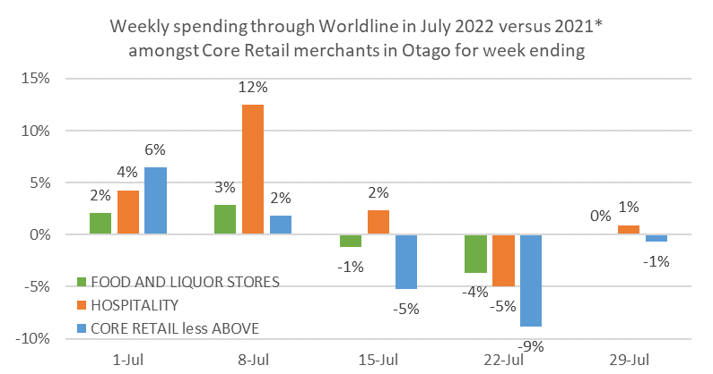
Figure 1: All Cards underlying* weekly spending through Worldline for Core Retail merchants for 7 days ending Friday during July in Otago (* Underlying excludes large clients moving to or from Worldline)

WORLDLINE All Cards underlying* spending for CORE RETAIL less HOSPITALITY merchants for July 2022
 | Value | Underlying* | Underlying*
Region | transactions $millions | Annual % change on 2021 | Annual % change on 2019
Auckland/Northland | 1,051 | -0.9% | 12.7%
Waikato | 224 | 2.2% | 21.1%
BOP | 190 | 0.7% | 18.2%
Gisborne | 26 | -5.0% | 6.1%
Taranaki | 66 | 3.0% | 26.5%
Hawke's Bay | 98 | 1.5% | 21.7%
Wanganui | 36 | -2.3% | 18.9%
Palmerston North | 85 | -0.9% | 20.4%
Wairarapa | 35 | 0.3% | 25.1%
Wellington | 272 | -1.9% | 9.9%
Nelson | 54 | -0.6% | 12.0%
Marlborough | 33 | -4.3% | 12.2%
West Coast | 18 | -1.7% | 17.8%
Canterbury | 340 | 1.3% | 20.5%
South Canterbury | 47 | -0.3% | 16.5%
Otago | 158 | -0.3% | 11.9%
Southland | 65 | 0.9% | 15.5%
New Zealand | 2,843 | -0.3% | 15.1%
Figure 2: All Cards NZ annual underlying* spending growth through Worldline July for regional core retail excluding hospitality merchants (* Underlying excludes large clients moving to or from Worldline)
- ENDS -
Note to editors:
These figures reflect general market trends and should not be taken as a proxy for Worldline‘s market share or company earnings. The figures primarily reflect transactions undertaken within stores but also include some ecommerce transactions. The figures exclude transactions through Worldline undertaken by merchants outside the Core Retail sector (as defined by Statistics NZ).

For more information, contact:
Brendan Boughen
T 027 839 6044
E brendan.boughen@paymark.co.nz

ABOUT WORLDLINE IN NEW ZEALAND
We are New Zealand's leading payments innovator. We design, build and deliver payment solutions that help Kiwi business succeed. Whether you’re looking for in store, online or mobile payment solutions or powerful business insights, Worldline is here to help with technology backed by experience. www.paymark.co.nz

About Worldline
Worldline [Euronext: WLN] is the European leader in the payments and transactional services industry and #4 player worldwide. With its global reach and its commitment to innovation, Worldline is the technology partner of choice for merchants, banks and third-party acquirers as well as public transport operators, government agencies and industrial companies in all sectors. Powered by over 20,000 employees in more than 50 countries, Worldline provides its clients with sustainable, trusted and secure solutions across the payment value chain, fostering their business growth wherever they are. Services offered by Worldline in the areas of Merchant Services; Terminals, Solutions & Services; Financial Services and Mobility & e-Transactional Services include domestic and cross-border commercial acquiring, both in-store and online, highly-secure payment transaction processing, a broad portfolio of payment terminals as well as e-ticketing and digital services in the industrial environment. In 2020 Worldline generated a proforma revenue of 4.8 billion euros. worldline.com

PRESS CONTACTs

Hélène Carlander
T +33 (0)7 72 25 96 04
E helene.carlander@worldline.com
Investors Relations
Laurent Marie
T : +33 (0)1 58 01 83 24
E : laurent.marie@worldline.com

Follow us

