Consumer spending not as weak as feared
AUCKLAND, 5 October 2022 – While recent consumer confidence surveys have forecast a drop in consumer spending, figures released by Worldline NZ today show that spending growth is actually continuing, albeit barely above the inflation rate.

Consumer spending through Worldline NZ’s payments network amongst Core Retail merchants (excluding Hospitality) was $2.92B in September 2022, up 16% on September 2021.
However, as this year-to-year comparative increase is relative to a time when merchants in New Zealand’s regions were operating at varying levels of COVID-19 lockdowns, Worldline’s Head of Data, George Putnam notes that it says very little about the current growth momentum and that longer-term data patterns are more insightful.
“As we saw last month, a large year-on-year jump in spending at this point in 2022 is primarily due to COVID-19 conditions at the same time in 2021, so we need to turn to 2019 as the pre-COVID baseline for any comparisons,” he says.
“A better measure of the trend at present is to look at the quarterly results since 2019. These confirm that spending growth is occurring, at least in nominal terms.”
Putnam says Worldline NZ’s consumer spending data for the latest September quarter were 14.6% above the pre-COVID levels of September quarter 2019, while the inflation rate over the same period was slightly less.
“We can see spending in the quarter ending September 2022 was 14.6% above that of three years earlier and the growth rate had increased from the three-year rate of 13.6% in the quarter ending in June 2022,” he says.
“However, spending growth is only just keeping up with rising prices. The September CPI is yet to be released but average prices are estimated to have risen by around 13% since September 2019, which implies we are spending in real terms around 1% more now compared to three years ago.
“In spite of that meagre real growth rate, we have seen several reports [1] in recent months that say consumer confidence is very low, so it is a pleasant surprise to see nominal retail spending still increasing – a case of the retail sector being not as bad as feared.”
Regionally, spending through Core Retail merchants (excluding Hospitality) remains above 2019 levels in all regions, with rankings similar to last month. The 2019-2022 growth rate was highest in Taranaki (31.3%), Hawke’s Bay (25.3%) and Wairarapa (25.3%) and lowest in Gisborne (4.2%) and Wellington (9.1%).
WORLDLINE All Cards underlying* spending for CORE RETAIL less HOSPITALITY merchants for September 2022
 | Value | Underlying* | Underlying*
Region | transactions $millions | Annual % change on 2021 | Annual % change on 2019
Auckland/Northland | 1,079 | 42.0% | 14.2%
Waikato | 233 | 6.2% | 25.5%
BOP | 194 | 3.7% | 20.3%
Gisborne | 25 | -8.8% | 4.2%
Taranaki | 67 | 6.8% | 31.3%
Hawke's Bay | 102 | 5.2% | 25.3%
Whanganui | 37 | 3.7% | 24.2%
Palmerston North | 88 | 5.7% | 24.9%
Wairarapa | 36 | 0.7% | 25.3%
Wellington | 275 | -1.0% | 9.1%
Nelson | 57 | 0.8% | 15.1%
Marlborough | 35 | 3.1% | 19.7%
West Coast | 19 | 5.8% | 22.3%
Canterbury | 353 | 6.3% | 24.2%
South Canterbury | 50 | 2.7% | 19.4%
Otago | 159 | 11.5% | 15.4%
Southland | 69 | 7.9% | 19.4%
New Zealand | 2,922 | 15.6% | 17.3%
Figure 1: All Cards NZ annual underlying* spending growth through Worldline September for regional core retail excluding Hospitality merchants (* Underlying excludes large clients moving to or from Worldline)
The most significant changes in three-year growth rates between the June and September quarters was accelerated spending in Otago and Southland but decelerated spending amongst the mid-to-lower North Island regions of Wellington, Wairarapa, Whanganui and Gisborne.
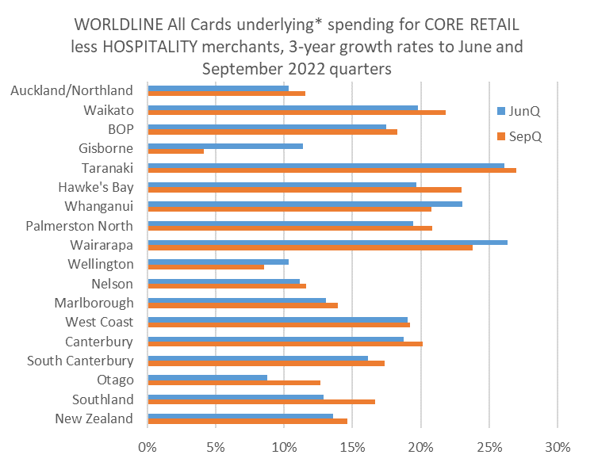
Figure 2: All Cards NZ annual underlying* 3-year spending growth through Worldline for September and June 2022 quarters for regional core retail excluding Hospitality merchants (* Underlying excludes large clients moving to or from Worldline)

[1] Reports include the ANZ-Roy Morgan Consumer Confidence report, September 2022 (https://www.anz.co.nz/content/dam/anzconz/documents/economics-and-market-research/2022/ANZ-ConsumerConfidence-20220930.pdf), BCG New Zealand Consumer Sentiment Series, July 2022 (https://www.bcg.com/publications/2022/new-zealand-consumer-sentiment-report-series), Westpac McDermott Miller Consumer Confidence Index, June 2022 (https://www.westpac.co.nz/assets/Business/tools-rates-fees/documents/economic-updates/2022/Bulletins/Q2-Consumer-conf-Jun-2022-Westpac-NZ.pdf)
- ENDS -
Note to editors:
These figures reflect general market trends and should not be taken as a proxy for Worldline‘s market share or company earnings. The figures primarily reflect transactions undertaken within stores but also include some ecommerce transactions. The figures exclude transactions through Worldline undertaken by merchants outside the Core Retail sector (as defined by Statistics NZ).

For more information, contact:
Brendan Boughen
T 027 839 6044
E brendan.boughen@paymark.co.nz

ABOUT WORLDLINE IN NEW ZEALAND
We are New Zealand's leading payments innovator. We design, build and deliver payment solutions that help Kiwi business succeed. Whether you’re looking for in store, online or mobile payment solutions or powerful business insights, Worldline is here to help with technology backed by experience. www.paymark.co.nz

About Worldline
Worldline [Euronext: WLN] is the European leader in the payments and transactional services industry and #4 player worldwide. With its global reach and its commitment to innovation, Worldline is the technology partner of choice for merchants, banks and third-party acquirers as well as public transport operators, government agencies and industrial companies in all sectors. Powered by over 20,000 employees in more than 50 countries, Worldline provides its clients with sustainable, trusted and secure solutions across the payment value chain, fostering their business growth wherever they are. Services offered by Worldline in the areas of Merchant Services; Terminals, Solutions & Services; Financial Services and Mobility & e-Transactional Services include domestic and cross-border commercial acquiring, both in-store and online, highly-secure payment transaction processing, a broad portfolio of payment terminals as well as e-ticketing and digital services in the industrial environment. In 2020 Worldline generated a proforma revenue of 4.8 billion euros. worldline.com

PRESS CONTACTs

Hélène Carlander
T +33 (0)7 72 25 96 04
E helene.carlander@worldline.com
Investors Relations
Laurent Marie
T : +33 (0)1 58 01 83 24
E : laurent.marie@worldline.com

Follow us

