EMBARGOED TO: FRIDAY, NOVEMBER 4, 2022 12PM NZT

PRESS RELEASE: Friday, 4 November 2022

Announcing the finalists in the Research IP Fund Manager of the Year Awards 2022 on 16th November.
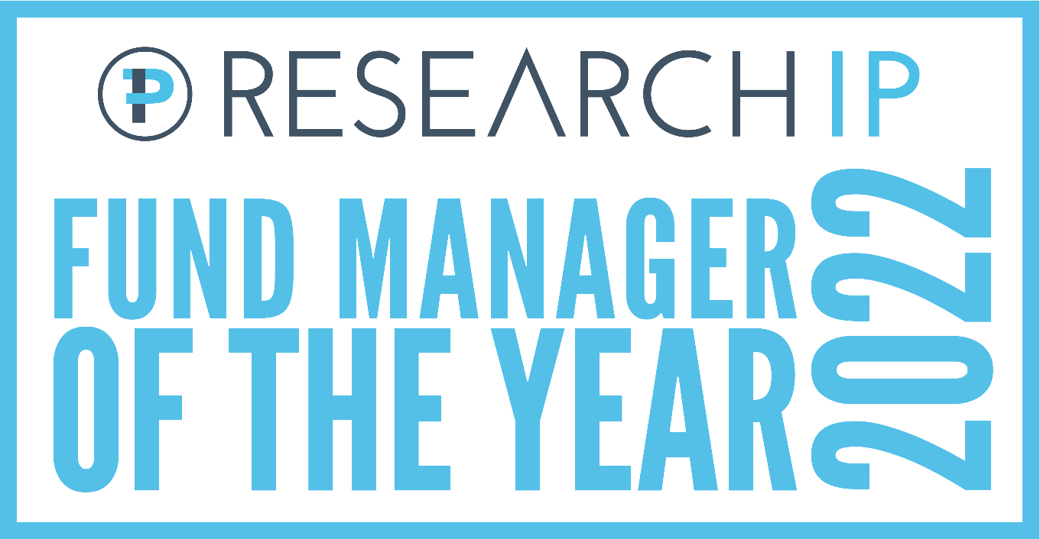
The Research IP Fund Manager of the Year Awards are back in 2022, to round out the year that was, and recognise the best fund managers in the country.
Research IP has powered awards in New Zealand since 2015 and proudly sits behind the eponymous awards. The use of managed funds has continued to grow in New Zealand despite the difficult backdrop of the transition from QE to QT (Quantitative Easing to Quantitative Tightening), higher inflation and escalating interest rates. The awards will play a role by identifying the top-performing money managers, with categories such as Fund Manager of the Year, Boutique Manager of the Year, KiwiSaver Manager of the Year and Responsible Investment Manager of the Year.
The Research IP Awards also recognise the expertise of advisers in the wealth management equation, with the Adviser Choice awards for the best fund managers in four different categories including KiwiSaver.
Advisers can have their say in the Adviser Choice Awards.
In a change for 2022, Retail investors can now have their say about who their favourite fund manager is, with the introduction of the Investor Choice award.
With new direct-to-consumer platform Flint Wealth launching in January 2022, joining Sharesies, InvestNow, and Hatch (the latter two being acquired by Apex Partners and FNZ respectively in 2022), retail investors are becoming more savvy and have the ability to manage their wealth directly. Accordingly, this affords an avenue for retail or KiwiSaver investors to have their say. There is still time to vote.
Investors to have their say in the Investor Choice Awards.
Darren Howlin, Managing Director of Research IP, said: “We are super excited to host the 2022 Awards in person, we believe our awards recognise the hard work of fund managers, bringing together the best of the investment management industry. We plan to announce the winners at 6pm NZT on Wednesday, 16 November. The 2022 in person awards will come packed with insights from fund managers, the risks to their portfolios, who are the TWAT’s (Tuesday, Wednesday and Thursday in the office) and importantly walking the talk on ESG and carbon footprints. There are some fascinating takeaways.”

Announcing the Finalists

Global Fixed Interest Fund of the Year
- Bentham Global Income NZD
- Daintree Core Income Trust
- Fisher Income
Australasian Fixed Interest Fund of the Year
- Clarity Fixed Income
- Harbour Enhanced Cash
- QuayStreet Fixed Interest

Global Property & Infrastructure Fund of the Year
- ClearBridge RARE Infrastructure Value Unhedged
- Fisher Property & Infrastructure
- Maple-Brown Abbott Global Listed Infrastructure

Australasian Property Fund of the Year
- Alceon Australian Property
- Octagon Listed Property
- Smartshares Aus Property
Alternatives Fund of the Year
- Janus Henderson Global Natural Resources
- Salt Carbon
- Salt Long Short
Global Equities Fund of the Year
- BetaShares S&P 500 Equal Weight ETF
- QuayStreet International Equity
- Smartshares US 500

Australian Equities Fund of the Year
- Airlie Australian Share
- Perpetual Smaller Companies
- Smartshares Australian Top 20
Australasian Equities Fund of the Year
- Clarity TAHITO Te Tai o Rehua
- Devon Alpha
- Harbour Australasian Equity Income

New Zealand Equities Fund of the Year
- Nikko AM Core Equity
- Octagon New Zealand Equities
- QuayStreet New Zealand Equity

Diversified Fund of the Year
- Milford Australian Absolute Growth PIE
- Perpetual Diversified Real Return
- Schroder Real Return
Responsible Investment Manager of the Year
- Alphinity Investment Management
- BT Funds Management (NZ)/Westpac
- Harbour Asset Management
- Pathfinder Asset Management
Other major Awards will be announced live on the night
Adviser Choice – Equities
Adviser Choice – Fixed Interest
Adviser Choice – Property & Infrastructure
Adviser Choice – KiwiSaver
Investor Choice
and
Longevity Award
KiwiSaver Manager of the Year
Boutique Manager of the Year
Fund Manager of the Year

Research IP is a leading provider of investment research, tools and technology. The inaugural 2019 Research IP awards were a huge success after previously powering the NZX’s FundSource Awards for four years. With extensive access to data insights and an open universe of funds to choose from, Research IP is experienced in undertaking the requisite research to award the very best.
ends
About Research IP Pty Ltd
Research IP has been providing clients with investment governance, financial product research and investment technology solutions since 2015. By leveraging the skills of our team of specialists, Research IP is able to provide innovative and tailored financial services solutions to clients. We are a specialist investment research provider which is used and trusted by charities, not-for-profit organisations, family offices, & financial advisers for investment, Superannuation and other Pension schemes throughout the Asia Pacific region.
Our experience has been gained in well over 20 years of roles across different facets of the industry, so we understand the key drivers and challenges for people trusted with the management of investments.
Client focused outcomes are underpinned by the belief that the role of business model innovation and accelerating technological change opens up new possibilities, to put client interests at the centre of the financial services industry focus. We have strong philosophical alignment with John Hagel’s work on the possibilities for “Disruption by Trusted Advisors” and John Kay's views in "Other People's Money: Masters of the Universe or Servants of the People".
Some of the consulting services we provide to financial advisers, charities, not-for-profit organisations and other investors include:
- Financial service licence reviews
- Platform and Financial Adviser Software reviews
- Fee negotiations for better client outcomes
- Investment committee terms of reference / charter
- Investment committee skills assessment
- Investment policy development
- Investment committee implementation review
- Chair or independent investment committee member
- Investment manager review
- Investment manager / adviser selection
- Quarterly reporting and commentary
- Sustainability and ESG policy development
- Sustainability and ESG investment selection / implementation of strategies.

© 2022 Research IP Pty Ltd. All rights reserved.
Media Contact:
Darren Howlin, +61 423 607 233 or Darren@Research-IP.com

