Consumer spending nudges above year-ago levels as final Christmas shopping week starts strongly
AUCKLAND, 19 December 2022 – Consumer spending maintained its high levels in the second to last full week of pre-Christmas shopping, nudging above spending over the same time last year and surging ahead of pre-Covid levels.

Consumer spending through Core Retail merchants in Worldline NZ’s payments network (excluding Hospitality) was $881m in the week ending Saturday 17 December 2022, which was up just 1.9% on the week ending December 17th in 2021 but up 14.6% on the same week in 2019.
The final week of Christmas shopping has also started strongly, with spending recorded on Sunday 18th December 2022 reaching 12.1% higher than the previous Sunday (11th December 2022).
Worldline NZ’s Chief Sales Officer, Bruce Proffit, says consumer spending is very likely to increase even further in the days ahead, considering comparative spending patterns from previous years and yesterday’s positive start to the last seven days of Christmas shopping.
“Spending does normally increase week-to-week in the run up to Christmas, and while we saw an 8.3% jump last week, this was around typical levels,” he says.
“However, within that total were some big jumps in week-to-week spending at Recreational Goods retailers (up 28.7%), Clothing and Footwear shops (up 21.9%) and a more moderate jump within the Hardware / Appliances / Furniture sector (up 4.7%).”
“All this suggests spending is on track to jump around 40% this week, as last-minute gift purchases and stocking up on Christmas food climbs to its usual frenzied peak on Friday and Saturday.”
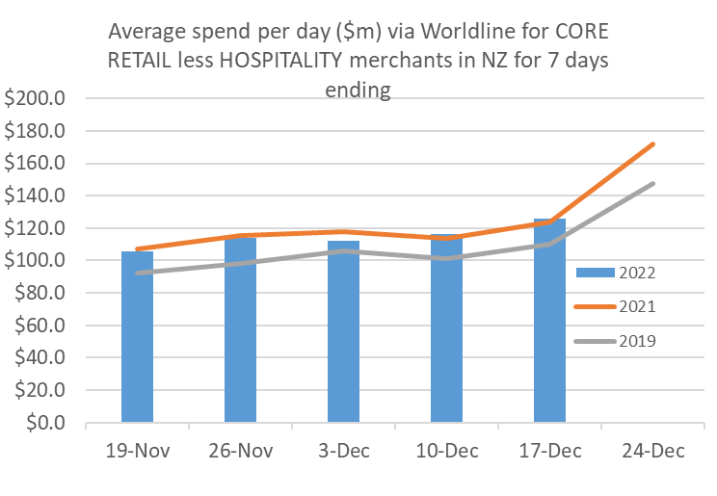
Figure 1: All Cards NZ underlying* spending (average per day) through Worldline for core retail excluding hospitality merchants in weeks leading up to Christmas Day (* Underlying excludes large clients moving to or from Worldline)
Annual regional spending (Core Retail less Hospitality) was highest in Marlborough (10.6%), West Coast (10.5%) and Otago (8.7%). Spending was below 2021 levels for the same 7 days in Auckland/Northland (-0.8%), Gisborne (-0.8%) and Bay of Plenty (-2.5%).
WORLDLINE All Cards underlying* spending for CORE RETAIL less HOSPITALITY merchants for 7 days ending 17-Dec-2022
 | Value | Underlying* | Underlying*
Region | transactions $millions | Annual % change on 2021 | Annual % change on 2019
Auckland/Northland | 326.0 | -0.8% | 11.7%
Waikato | 70.9 | 0.6% | 21.2%
BOP | 57.3 | -2.5% | 12.3%
Gisborne | 7.7 | -0.8% | 9.7%
Taranaki | 20.3 | 5.0% | 28.1%
Hawke's Bay | 31.4 | 4.9% | 21.4%
Whanganui | 10.9 | 5.9% | 26.6%
Palmerston North | 27.1 | 4.8% | 24.8%
Wairarapa | 10.7 | 2.2% | 22.2%
Wellington | 83.0 | 0.6% | 8.7%
Nelson | 17.3 | 2.2% | 7.5%
Marlborough | 11.2 | 10.6% | 11.9%
West Coast | 5.8 | 10.5% | 27.3%
Canterbury | 104.7 | 6.1% | 20.0%
South Canterbury | 15.0 | 8.0% | 20.8%
Otago | 46.2 | 8.7% | 13.0%
Southland | 21.0 | 8.1% | 16.9%
New Zealand | 881.3 | 1.9% | 14.6%
Figure 2: All Cards NZ annual underlying* spending growth through Worldline last week for regional core retail excluding hospitality merchants (* Underlying excludes large clients moving to or from Worldline)
Meanwhile, spending through Hospitality merchants (Restaurants, Cafés, Fast Foods, Pubs, Clubs, Bars, Taverns and Accommodation) in Worldline NZ’s payments network remained strong over the week ending December 17th, totaling $254m nationwide.
Notably, spending at Hospitality merchants on Saturday 17th December through Worldline’s payments was $46m. This is 10.4% above the busiest day for Hospitality in 2021 (Saturday 18th December), but 0.5% below the peak day of 2019 (Saturday 21st December).
“While spending amongst the Hospitality sector is expected to remain at high levels in the last few days ahead of Christmas, it is likely that last Saturday (17 December 2022) marked the peak day this year for wining and dining,” says Proffit.
Annual regional Hospitality spending for the week was highest in West Coast (up 46.8% on 11-17th December 2021 and up 34.8% on 11-17th December 2019).
Hospitality spending was higher than last year in all regions but was mixed relative to pre-Covid levels (11-17th December 2019), including being down in Marlborough (-1.7%), Wellington (-4.7%) and Otago (-8.6%) and up only modestly in Auckland/Northland (+1.1%) and Southland (+1.6%).
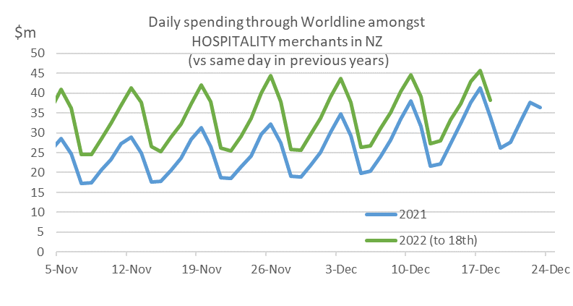
Figure 3: All Cards NZ underlying* spending through Worldline for hospitality merchants in recent days and the comparable days last year (* Underlying excludes large clients moving to or from Worldline)

WORLDLINE All Cards underlying* spending for HOSPITALITY merchants for 7 days ending 17-Dec-2022
 | Value | Underlying* | Underlying*
Region | transactions $millions | Annual % change on 2021 | Annual % change on 2019
Auckland/Northland | 96.9 | 22.2% | 1.1%
Waikato | 17.7 | 17.5% | 10.3%
BOP | 20.0 | 20.2% | 10.2%
Gisborne | 2.2 | 12.3% | 17.8%
Taranaki | 5.9 | 20.6% | 27.7%
Hawke's Bay | 7.5 | 24.1% | 22.3%
Whanganui | 2.7 | 24.7% | 19.3%
Palmerston North | 6.8 | 13.2% | 24.5%
Wairarapa | 1.9 | 4.0% | 20.8%
Wellington | 24.9 | 6.6% | -4.7%
Nelson | 5.2 | 31.8% | 15.9%
Marlborough | 3.8 | 17.1% | -1.7%
West Coast | 1.9 | 46.8% | 34.8%
Canterbury | 27.6 | 13.8% | 6.0%
South Canterbury | 3.5 | 14.1% | 10.3%
Otago | 17.0 | 44.1% | -8.6%
Southland | 7.8 | 40.9% | 1.6%
New Zealand | 253.6 | 20.3% | 4.2%
Figure 4: All Cards NZ annual underlying* spending growth through Worldline last week for regional hospitality merchants (* Underlying excludes large clients moving to or from Worldline)
- ENDS -
Note to editors:
These figures reflect general market trends and should not be taken as a proxy for Worldline‘s market share or company earnings. The figures primarily reflect transactions undertaken within stores but also include some ecommerce transactions. The figures exclude transactions through Worldline undertaken by merchants outside the Core Retail sector (as defined by Statistics NZ).

For more information, contact:
Brendan Boughen
T 027 839 6044
E brendan.boughen@paymark.co.nz

ABOUT WORLDLINE IN NEW ZEALAND
We are New Zealand's leading payments innovator. We design, build and deliver payment solutions that help Kiwi business succeed. Whether you’re looking for in store, online or mobile payment solutions or powerful business insights, Worldline is here to help with technology backed by experience. www.paymark.co.nz

About Worldline
Worldline [Euronext: WLN] is the European leader in the payments and transactional services industry and #4 player worldwide. With its global reach and its commitment to innovation, Worldline is the technology partner of choice for merchants, banks and third-party acquirers as well as public transport operators, government agencies and industrial companies in all sectors. Powered by over 20,000 employees in more than 50 countries, Worldline provides its clients with sustainable, trusted and secure solutions across the payment value chain, fostering their business growth wherever they are. Services offered by Worldline in the areas of Merchant Services; Terminals, Solutions & Services; Financial Services and Mobility & e-Transactional Services include domestic and cross-border commercial acquiring, both in-store and online, highly-secure payment transaction processing, a broad portfolio of payment terminals as well as e-ticketing and digital services in the industrial environment. In 2020 Worldline generated a proforma revenue of 4.8 billion euros. worldline.com

PRESS CONTACTs

Hélène Carlander
T +33 (0)7 72 25 96 04
E helene.carlander@worldline.com
Investors Relations
Laurent Marie
T : +33 (0)1 58 01 83 24
E : laurent.marie@worldline.com

Follow us

