Consumers spent less on goods but more on hospitality in November and the most recent week
AUCKLAND, 7 December 2022 – In the early stages of the pre-Christmas shopping season, spending data show Kiwi consumers outlaid less money on goods but more on hospitality – wining, dining and accommodation – in November, suggesting there was still reason to celebrate, even amidst tougher economic times.

Consumer spending through Core Retail merchants in Worldline NZ’s payments network (excluding Hospitality) reached $3.18B in the full month of November 2022, which was up just 0.9% on November 2021 but up 11.0% on the pre-Covid month of November 2019.
Within this national total for November, spending through Food and Liquor stores was up on the same month last year (+3.3%), while spending in other merchant sectors was down (-2.2%) – this latter pattern being consistent with lower comparative spending recorded during the seven-day sales period that included Black Friday (20-26 November).
The focus now for most merchants is the usual build-up in consumer spending as Christmas Day approaches, the most recent week ending Saturday 3rd December being only the fourth full week of shopping before Christmas Day.
For Hospitality merchants, the news is relatively positive. In the week ending 3rd December, spending through Hospitality merchants in Worldline’s payments network averaged $33.6m per day, up 34.7% on the same seven days in 2021, albeit the average was only marginally above pre-Covid levels of 2019.
This high annual growth rate was due to spending at Accommodation merchants almost doubling (+94.3%) and spending at Cafés, Bars, and Restaurants jumping 29.3%. Historic data show these merchants in the Hospitality sector can also expect a spending boost in the run up to Christmas.
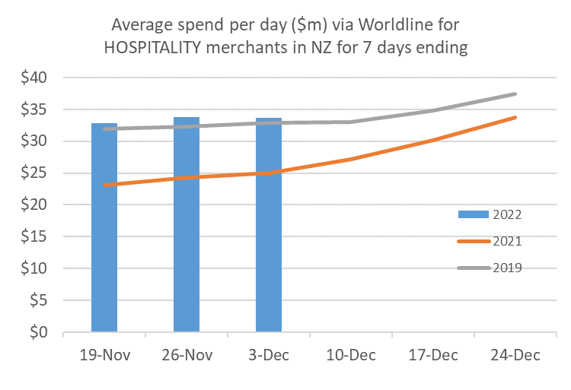
Figure 1: All Cards NZ underlying* spending (average per day) through Worldline for Hospitality merchants in weeks leading up to Christmas Day (* Underlying excludes large clients moving to or from Worldline)
Amongst the wider shopping sector, the average daily spend across the Core Retail sector (excluding Hospitality) of $111.9m per day in the week ending 3rd December was down 5.0% on the same seven days last year (ending Friday 3 December). The average spend was also below that of the previous week – which has included Black Friday – but the focus will remain on the usual busy shopping weeks ahead.
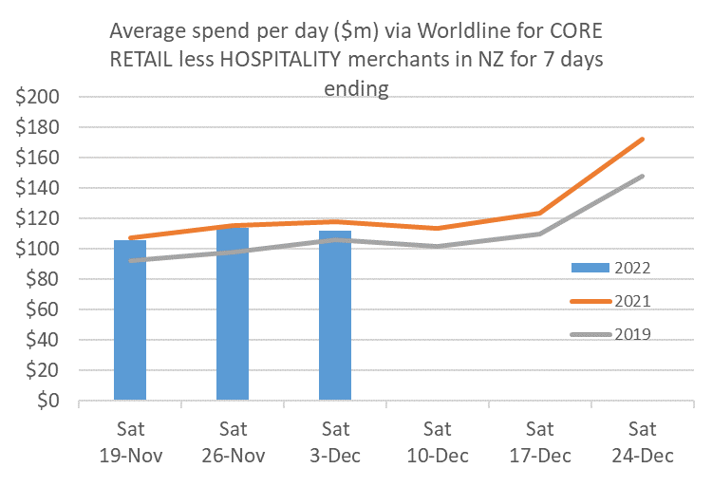
Figure 2: All Cards NZ underlying* spending (average per day) through Worldline for core retail excluding hospitality merchants in weeks leading up to Christmas Day (* Underlying excludes large clients moving to or from Worldline)
Meanwhile, going back to the monthly figures, regional spending growth between November 2021 and November 2022 through Core Retail merchants (excluding Hospitality) was highest in Southland (7.3%), West Coast (6.5%) and Otago (6.4%) and lowest in Wellington (-3.0%).
WORLDLINE All Cards underlying* spending for CORE RETAIL less HOSPITALITY merchants for November 2022
 | Value | Underlying* | Underlying*
Region | transactions $millions | Annual % change on 2021 | Annual % change on 2019
Auckland/Northland | 1,174 | 0.2% | 7.3%
Waikato | 251 | 0.1% | 15.8%
BOP | 213 | -1.6% | 11.1%
Gisborne | 28 | -0.6% | 7.2%
Taranaki | 71 | 1.3% | 23.8%
Hawke's Bay | 115 | 5.6% | 18.3%
Whanganui | 38 | -1.6% | 19.8%
Palmerston North | 95 | 0.6% | 18.0%
Wairarapa | 40 | 1.3% | 19.2%
Wellington | 303 | -3.0% | 7.9%
Nelson | 63 | 0.3% | 9.0%
Marlborough | 39 | 4.9% | 10.1%
West Coast | 22 | 6.5% | 15.3%
Canterbury | 385 | 3.3% | 17.5%
South Canterbury | 54 | 4.9% | 16.2%
Otago | 165 | 6.4% | 8.2%
Southland | 75 | 7.3% | 13.7%
New Zealand | 3,181 | 0.9% | 11.0%
Figure 3: All Cards NZ annual underlying* spending growth through Worldline November for regional core retail excluding Hospitality merchants (* Underlying excludes large clients moving to or from Worldline)
- ENDS -

Note to editors:
These figures reflect general market trends and should not be taken as a proxy for Worldline‘s market share or company earnings. The figures primarily reflect transactions undertaken within stores but also include some ecommerce transactions. The figures exclude transactions through Worldline undertaken by merchants outside the Core Retail sector (as defined by Statistics NZ).

For more information, contact:
Brendan Boughen
T 027 839 6044
E brendan.boughen@paymark.co.nz

ABOUT WORLDLINE IN NEW ZEALAND
We are New Zealand's leading payments innovator. We design, build and deliver payment solutions that help Kiwi business succeed. Whether you’re looking for in store, online or mobile payment solutions or powerful business insights, Worldline is here to help with technology backed by experience. www.worldline.co.nz

About Worldline
Worldline [Euronext: WLN] is the European leader in the payments and transactional services industry and #4 player worldwide. With its global reach and its commitment to innovation, Worldline is the technology partner of choice for merchants, banks and third-party acquirers as well as public transport operators, government agencies and industrial companies in all sectors. Powered by over 20,000 employees in more than 50 countries, Worldline provides its clients with sustainable, trusted and secure solutions across the payment value chain, fostering their business growth wherever they are. Services offered by Worldline in the areas of Merchant Services; Terminals, Solutions & Services; Financial Services and Mobility & e-Transactional Services include domestic and cross-border commercial acquiring, both in-store and online, highly-secure payment transaction processing, a broad portfolio of payment terminals as well as e-ticketing and digital services in the industrial environment. In 2020 Worldline generated a proforma revenue of 4.8 billion euros. worldline.com

PRESS CONTACTs

Hélène Carlander
T +33 (0)7 72 25 96 04
E helene.carlander@worldline.com
Investors Relations
Laurent Marie
T : +33 (0)1 58 01 83 24
E : laurent.marie@worldline.com

Follow us

