Pre-Christmas spending is up, but patterns are mixed across sectors and regions
AUCKLAND, 14 December 2022 – New figures released by Worldline NZ today show consumer spending in the third week before Christmas Day was higher than the same time last year, but spending patterns were mixed across merchant sectors and regions.

Consumer spending through Core Retail merchants in Worldline NZ’s payments network (excluding Hospitality) reached nearly $814m in the week ending Saturday 10 December 2022, which is up 2.3% on the week ending 10 December in 2021 and up 14.7% on the week ending 10 December in 2019.
Within this national total for last week, spending through Food and Liquor stores was up 6.5% on last year, up 7.1% amongst Clothing and Footwear merchants and up 4.8% amongst Department stores.
However, spending amongst the large Hardware / Appliances / Furniture group of merchants was down 10.8% on last year, while spending amongst Recreational goods retailers was down 11.5%.
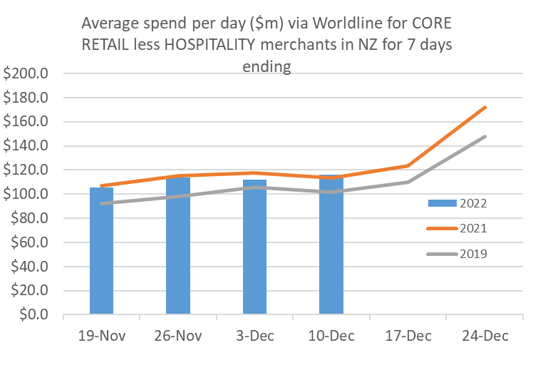
Figure 1: All Cards NZ underlying* spending (average per day) through Worldline for core retail excluding hospitality merchants in weeks leading up to Christmas Day (* Underlying excludes large clients moving to or from Worldline)
Worldline NZ’s Chief of Sales, Bruce Proffit says these numbers reflect a similar pattern of spending as was seen over the recent Black Friday sales period, suggesting that while consumers are still spending freely, there is some holding off on purchases of big-ticket items this side of Christmas.
“The challenging economic environment is undoubtedly still exerting a strong influence on consumer spending choices this year, but as can be seen from trends of previous years, the tills of merchants across the Core Retail sector will be ringing more over the next fortnight. Whether spending levels persist at rates similar to those of the past week remains to be seen.”
Regional spending for the week ending 10 December meanwhile was highest in West Coast (15.3%), Nelson (10.2%) and Marlborough (10.1%). Spending was below 2021 levels for the same seven days in Auckland/Northland (-1.9%), Taranaki (-3.2%) and Gisborne (-4.4%).
WORLDLINE All Cards underlying* spending for CORE RETAIL less HOSPITALITY merchants for 7 days ending 10-Dec-2022
 | Value | Underlying* | Underlying*
Region | transactions $millions | Annual % change on 2021 | Annual % change on 2019
Auckland/Northland | 300.5 | -1.9% | 10.9%
Waikato | 65.8 | 2.9% | 21.2%
BOP | 55.8 | 2.7% | 18.4%
Gisborne | 7.1 | -4.4% | 8.6%
Taranaki | 16.9 | -3.2% | 16.7%
Hawke's Bay | 29.3 | 3.9% | 20.7%
Whanganui | 10.3 | 6.9% | 30.0%
Palmerston North | 24.9 | 6.7% | 22.7%
Wairarapa | 10.0 | 4.3% | 22.4%
Wellington | 78.2 | 3.8% | 12.3%
Nelson | 16.4 | 10.2% | 14.0%
Marlborough | 10.2 | 10.1% | 16.7%
West Coast | 5.5 | 15.3% | 29.7%
Canterbury | 95.8 | 6.7% | 19.1%
South Canterbury | 13.8 | 7.0% | 16.9%
Otago | 41.5 | 8.4% | 11.2%
Southland | 18.9 | 6.5% | 17.7%
New Zealand | 813.9 | 2.3% | 14.7%
Figure 2: All Cards NZ annual underlying* spending growth through Worldline last week for regional core retail excluding hospitality merchants (* Underlying excludes large clients moving to or from Worldline)
- ENDS -

Note to editors:
These figures reflect general market trends and should not be taken as a proxy for Worldline‘s market share or company earnings. The figures primarily reflect transactions undertaken within stores but also include some ecommerce transactions. The figures exclude transactions through Worldline undertaken by merchants outside the Core Retail sector (as defined by Statistics NZ).

For more information, contact:
Brendan Boughen
T 027 839 6044
E brendan.boughen@paymark.co.nz

ABOUT WORLDLINE IN NEW ZEALAND
We are New Zealand's leading payments innovator. We design, build and deliver payment solutions that help Kiwi business succeed. Whether you’re looking for in store, online or mobile payment solutions or powerful business insights, Worldline is here to help with technology backed by experience. www.worldline.co.nz

About Worldline
Worldline [Euronext: WLN] is the European leader in the payments and transactional services industry and #4 player worldwide. With its global reach and its commitment to innovation, Worldline is the technology partner of choice for merchants, banks and third-party acquirers as well as public transport operators, government agencies and industrial companies in all sectors. Powered by over 20,000 employees in more than 50 countries, Worldline provides its clients with sustainable, trusted and secure solutions across the payment value chain, fostering their business growth wherever they are. Services offered by Worldline in the areas of Merchant Services; Terminals, Solutions & Services; Financial Services and Mobility & e-Transactional Services include domestic and cross-border commercial acquiring, both in-store and online, highly-secure payment transaction processing, a broad portfolio of payment terminals as well as e-ticketing and digital services in the industrial environment. In 2020 Worldline generated a proforma revenue of 4.8 billion euros. worldline.com

PRESS CONTACTs

Hélène Carlander
T +33 (0)7 72 25 96 04
E helene.carlander@worldline.com
Investors Relations
Laurent Marie
T : +33 (0)1 58 01 83 24
E : laurent.marie@worldline.com

Follow us

