MEDIA RELEASE

**New Zealand small business sales growth slows, wages up**

*Data reveals November small business wages growth close to all-time high*

**Wellington — 15 December, 2022 —** [Xero](https://www.xero.com/), the global small business platform, today released its [Xero Small Business Index](http://xero.com/xerosbi) for November 2022, revealing weakening annual sales growth for New Zealand’s small business sector.

Sales grew 2.3 percent year-on-year (y/y), down from 10.0 percent y/y in October and the lowest since September 2021.

Xero Country Manager, Bridget Snelling, says this slowdown in sales is consistent with the Reserve Bank’s recent comments about slowing growth.

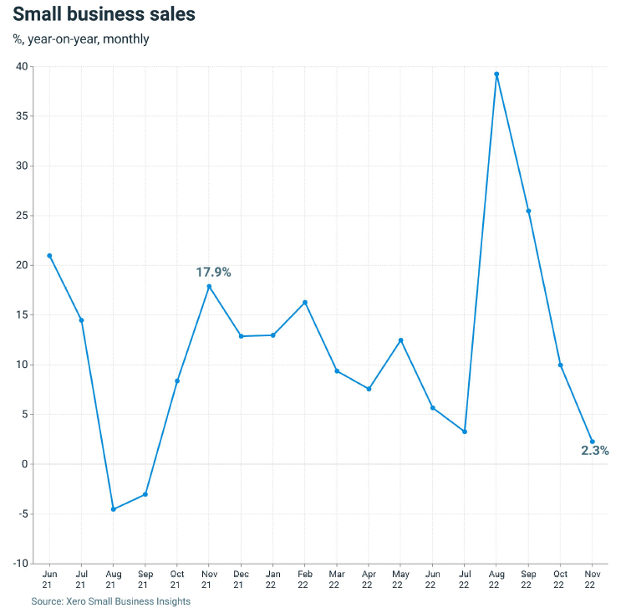

“The rising official cash rate and subsequent changes to interest rates are seeing households become understandably more financially conscious,” says Snelling.

“Unfortunately, this directly impacts the small business economy, which is seeing a downturn in sales. This is particularly challenging as we enter summer as now is the time where many businesses bolster their accounts to survive the quieter holiday months.”

Across industries, hospitality sales were up 38.1 percent y/y in November 2021. This is heavily impacted by the low 2021 November result due to Auckland still having some trading restrictions in place on this sector.

Manufacturing (+2.2% y/y) and construction (+2.0% y/y) also rose, while retail trade (-4.2% y/y), professional services (-2.2% y/y), rental, hiring and real estate (-1.6% y/y), and agriculture (-1.3% y/y) saw sales fall.

**Growing wages put pressure on small businesses**

While sales weakened, wages grew 6.6 percent y/y in November 2022, the second consecutive month of acceleration as wage growth nears the previous record high of 6.7 percent y/y (June 2022).

The return to faster wages growth is evident across all regions and industries, with industry results ranging from +5.9 percent y/y in retail trade to +7.4 percent y/y in construction. By region, the range was +6.3 percent y/y in Auckland up to +6.9 percent y/y in Otago and Canterbury.

“While it’s true we want to see growing wages for small business employees, the current pace of wage rises is putting pressure on small business owners,” says Snelling.

**Strong small business job growth**

Furthermore, the increase in wages growth reflects the very tight state of the labour market, with the official Aotearoa unemployment rate at 3.3 percent in the September quarter.

Small business jobs rose 5.4 percent y/y in November, with the biggest gains in professional services (+8.4% y/y), hospitality (+6.7% y/y), manufacturing (+6.4% y/y) and rental, hiring and real estate (+6.3% y/y).

“While slower than the 8.1 percent y/y growth recorded in the previous two months, this result highlights small businesses are continuing to attract staff, often from larger businesses. Having the right talent will help small businesses in the challenging months ahead,” says Snelling.

**Index up in November**

The New Zealand Small Business Index, part of Xero Small Business Insights, rose three points in November to 139 points.

“While the Small Business Index is currently around record highs, this is largely due to strong jobs and wages results rather than a strong sales performance,” says Snelling.

“The environment remains challenging for small businesses as they try to retain scarce staff in a macro-environment of slowing growth, persistent wages pressure and market expectations for further rises in interest rates.

“As we head into the Christmas and summer season, our message to Kiwis is this: shop local where you can.

“For businesses, now could be the time to review your suppliers and see if there's a local Kiwi business to consider in the New Year. And as always, be sure to pay invoices on time and be diligent to follow up when your invoices aren't paid.”

For further information on the Xero Small Business Insights November 2022 metrics, please refer to the[XSBI New Zealand update](https://www.xero.com/content/dam/xero/pdfs/xsbi/nz-update-nov-2022.pdf). To find out more about how the Xero Small Business Index is constructed, see the [methodology](https://www.xero.com/content/dam/xero/images/xsbi/xsbi-methodology-doc.pdf).

**ENDS**

**Media Contact**Amelia Lewis

Xero Communications

[amelia.lewis@xero.com](mailto:amelia.lewis@xero.com)

**About Xero**

[Xero](https://www.xero.com/) is a global small business platform with 3.5 million subscribers which includes a core accounting solution, payroll, workforce management, expenses and projects. Xero also has an extensive ecosystem of connected apps and connections to banks and other financial institutions helping small businesses access a range of solutions from within Xero’s open platform to help them run their business and manage their finances. For three consecutive years (2020-2022) Xero was included in the Bloomberg Gender-Equality Index. In 2021, Xero was included in the Dow Jones Sustainability Index (DJSI), powered by the S&P Global Corporate Sustainability Assessment. Xero is a [FIFA Women’s Football partner](https://www.xero.com/nz/xero-fifa-womens-football/) under FIFA’s new commercial structure.

**Note to the editor**

Previous iterations of the XSBI data have listed snapshots of data from the time it was captured. Some of these historical data points change as bookkeepers and accountants finalise their clients’ accounts, which can impact the specifics of the percentages.