Damp start to the year for consumer spending
AUCKLAND, 3 February 2023 – The stormy weather events that occurred across New Zealand in January led to a drop in consumer spending in several regions at those times and may have dampened spending more generally over the month – but a weakening pattern suggests wider economic factors are also at play, according to data released today by Worldline NZ.

Consumer spending data recorded in January 2023 through Core Retail merchants in Worldline NZ’s payments network (excluding Hospitality) reached $3.04B, which is down just 0.7% on January 2022 but up 15.9% on January 2019.

Worldline NZ’s Chief Sales Officer, Bruce Proffit, says consumer spending patterns were generally weak over the full month of January 2023, with annual spending growth up (+1.6%) in the first seven days and down (-0.7%) in the last seven days of the month.
“While spending was higher in the first week of January compared to the same week last year, this was not consistent across all regions – and notably, the mixed regional pattern that persisted into the last week of January showed a drop in the three largest regions,” he says.
“The stormy weather that occurred at each end of the month – cyclone Hale and then the deluges across the upper North Island and especially in Auckland – is undoubtedly one factor, but the general nature of the dampened spending also suggests a trend towards wider restraint by consumers,” says Proffit.
The monthly regional figures show annual spending declines were highest – in percentage terms – in Bay of Plenty (-4.2%), Wairarapa (-3.6%), Gisborne (-3.4%) and Wellington (-3.2%). Spending growth was highest in Otago (+8.2%), Southland (+6.9%) and West Coast (+6.7%).
WORLDLINE All Cards underlying* spending for CORE RETAIL less HOSPITALITY merchants for January 2023
 | Value | Underlying* | Underlying*
Region | transactions $millions | Annual % change on 2021 | Annual % change on 2019
Auckland/Northland | 1,075 | -2.2% | 11.8%
Waikato | 250 | -1.6% | 17.2%
BOP | 214 | -4.2% | 13.9%
Gisborne | 27 | -3.4% | 6.4%
Taranaki | 71 | -1.4% | 28.8%
Hawke's Bay | 110 | 0.4% | 22.2%
Whanganui | 39 | 1.1% | 31.5%
Palmerston North | 94 | 2.7% | 31.6%
Wairarapa | 39 | -3.6% | 27.0%
Wellington | 280 | -3.2% | 14.9%
Nelson | 68 | 1.8% | 11.8%
Marlborough | 41 | 4.4% | 15.1%
West Coast | 24 | 6.7% | 28.1%
Canterbury | 352 | 1.2% | 22.1%
South Canterbury | 51 | 2.7% | 22.6%
Otago | 180 | 8.2% | 17.5%
Southland | 75 | 6.9% | 21.4%
New Zealand | 3,036 | -0.7% | 15.9%
Figure 1: All Cards NZ underlying* spending through Worldline in January 2023 for core retail excluding hospitality merchants around (* Underlying excludes large clients moving to or from Worldline)
The direct consumer spending effects of the two major storms in January – cyclone Hale on 10-11th and the record-breaking rainfall event on 27th January in the upper North Island – were most noticeable in Gisborne and Auckland / Northland respectively.
Spending in Gisborne on Wednesday 11th January ($0.8 million) was down 16.3% on Wednesday 12th January 2022. This decline was apparent for three days, with Tuesday to Thursday spending ($2.5m) down 13.5% on 2022 in that region.
Spending in Auckland / Northland on Friday 27th January ($33.9 million) was down 20.5% on Friday 28th January 2022, but was back to near or above 2022 levels over the remaining days of the month.
The Hospitality spending effect of the wet weather has been longer lasting in Auckland/Northland. Annual Hospitality spending growth in Auckland/Northland went from averaging 22% growth in the seven days before Friday, 27th January (daily average $12.8m) to averaging 10% growth since that day (daily average $11.3m).
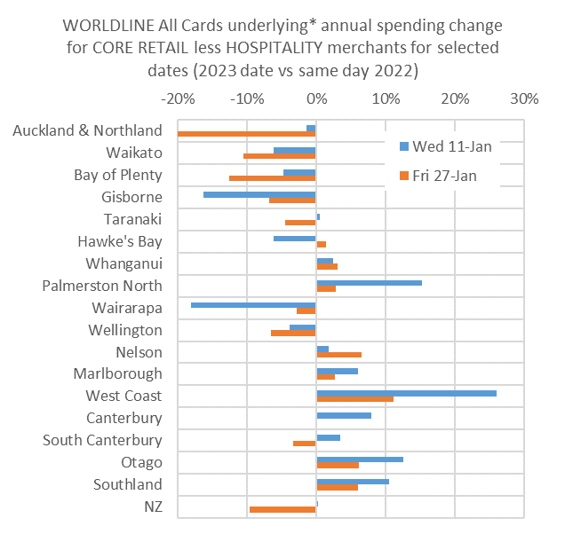
Figure 2: All Cards NZ annual underlying* spending growth through Worldline on selected days by regions for Core Retail excluding hospitality merchants (* Underlying excludes large clients moving to or from Worldline)
- ENDS -
Note to editors:
These figures reflect general market trends and should not be taken as a proxy for Worldline‘s market share or company earnings. The figures primarily reflect transactions undertaken within stores but also include some ecommerce transactions. The figures exclude transactions through Worldline undertaken by merchants outside the Core Retail sector (as defined by Statistics NZ).

For more information, contact:
Brendan Boughen
T 027 839 6044
E brendan.boughen.external@worldline.com

ABOUT WORLDLINE IN NEW ZEALAND
We are New Zealand's leading payments innovator. We design, build and deliver payment solutions that help Kiwi business succeed. Whether you’re looking for in store, online or mobile payment solutions or powerful business insights, Worldline is here to help with technology backed by experience. www.worldline.co.nz

About Worldline
Worldline [Euronext: WLN] is the European leader in the payments and transactional services industry and #4 player worldwide. With its global reach and its commitment to innovation, Worldline is the technology partner of choice for merchants, banks and third-party acquirers as well as public transport operators, government agencies and industrial companies in all sectors. Powered by over 20,000 employees in more than 50 countries, Worldline provides its clients with sustainable, trusted and secure solutions across the payment value chain, fostering their business growth wherever they are. Services offered by Worldline in the areas of Merchant Services; Terminals, Solutions & Services; Financial Services and Mobility & e-Transactional Services include domestic and cross-border commercial acquiring, both in-store and online, highly-secure payment transaction processing, a broad portfolio of payment terminals as well as e-ticketing and digital services in the industrial environment. In 2020 Worldline generated a proforma revenue of 4.8 billion euros. worldline.com

PRESS CONTACTs

Hélène Carlander
T +33 (0)7 72 25 96 04
E helene.carlander@worldline.com
Investors Relations
Laurent Marie
T : +33 (0)1 58 01 83 24
E : laurent.marie@worldline.com

Follow us

