Holidays and general belt tightening lead to slow spending growth in April
AUCKLAND, 3 May 2023 – With April 2023 marking the first full year since Covid restrictions in New Zealand were dropped, consumer spending figures reveal that the annual growth rate is indeed low and weakened even further towards the end of the month.

Consumer spending in April 2023 through Core Retail merchants (excluding Hospitality) in Worldline NZ’s payments network reached $3.012B, which is up just 3.8% on April 2022, and up 19.8% on the same month in 2019.
Worldline NZ’s Chief Sales Officer, Bruce Proffit, says the drop from 8.3% annual growth in March 2023 to 3.8% in April largely reflects the shift to less constrictive retail trading conditions in late March 2022 after Covid restrictions were eased nationally.
“Annual growth rates have been high in recent months because spending had been restricted by Covid 12 months earlier. This was not the case in April 2023,” says Proffit.
“Not surprisingly, the annual growth rate declined while the four-year growth rate from pre-Covid conditions remained around 19-20%, revealing the unimpaired annual growth rate to be low.”
Proffit also says that while a combination of holidays and five Sundays meant April 2023 was never going to be a strong trading month, the decline in annual growth towards the end of the month suggests that consumer belt tightening was a key factor, especially at merchants selling big ticket items.
“We can see that annual spending growth in the last five days of April after Anzac Day was a mere 0.7%. The average annual change for a large merchant group including Hardware, Furniture, Homeware and Electrical goods was -13%,” says Proffit.
Meanwhile, for the month in total, annual Core Retail (excluding Hospitality) spending growth was highest in Otago (+8.9%) and lowest in Wairarapa (+0.9%).
WORLDLINE All Cards underlying* spending for CORE RETAIL less HOSPITALITY merchants for April 2023
 | Value | Underlying* | Underlying*
Region | transactions $millions | Annual % change on 2022 | Annual % change on 2019
Auckland/Northland | 1,093 | 3.3% | 16.8%
Waikato | 243 | 4.1% | 27.5%
BOP | 206 | 1.8% | 20.8%
Gisborne | 26 | 1.5% | 13.4%
Taranaki | 69 | 1.9% | 29.9%
Hawke's Bay | 110 | 5.5% | 26.9%
Whanganui | 39 | 6.4% | 31.4%
Palmerston North | 92 | 4.6% | 27.2%
Wairarapa | 38 | 0.9% | 30.9%
Wellington | 282 | 2.6% | 15.4%
Nelson | 60 | 4.2% | 15.4%
Marlborough | 38 | 6.1% | 18.2%
West Coast | 22 | 5.3% | 25.6%
Canterbury | 356 | 3.7% | 25.4%
South Canterbury | 51 | 8.4% | 24.5%
Otago | 169 | 8.9% | 16.9%
Southland | 72 | 7.4% | 20.7%
New Zealand | 3,012 | 3.8% | 19.8%
Figure 1: All Cards NZ underlying* spending through Worldline in April 2023 for core retail excluding hospitality merchants (* Underlying excludes large clients moving to or from Worldline)
Looking back at the Easter weekend spending, Proffit says Core Retail merchants in Worldline NZ’s payments network averaged $129.8 million per day in the five days of Easter 2023, which was 7.4% up on Easter last year (14-18 April 2022).
“Easter has quite a different spending pattern than other times of the year, given the restrictions on trading and the tendency for people to travel – a reason to also include the Hospitality sector within the figures reported,” he says.
“The difference in daily trading can be shown by comparing spending on Thursday to Monday over Easter with the same days seven days earlier. It shows the pronounced spending on Easter Thursday and Saturday but also shows that spending does decline in total over Easter on a nationwide basis,” says Proffit.
“The decline is most noticeable in the large centres, while smaller centres can gain in spending over Easter, as was the case in West Coast this year.”
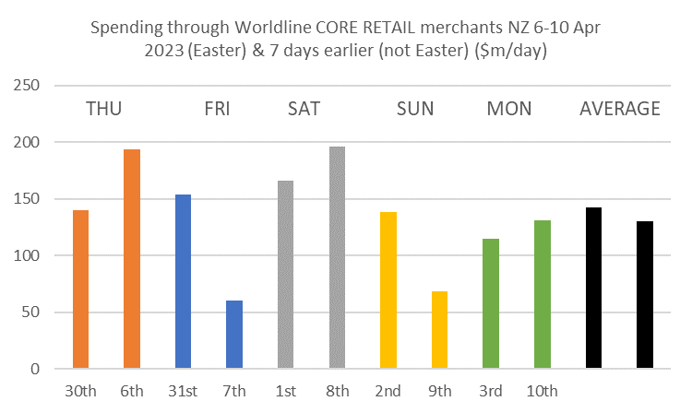
Figure 2: All Cards NZ underlying* spending through Worldline Core Retail merchants in Easter 2023 (6-10 April) compared with 30-Mar to 3-Apr 2023 (not a holiday) (* Underlying excludes large clients moving to or from Worldline)
Spending growth for Easter, compared with 30 March to 3 April 2023, was up in West Coast (+13.0%), Bay of Plenty (+3.9%) and Wairarapa (+0.3%) while the large declines between ‘weekends’ occurred in the three largest regions of Auckland/Northland (-12.8%), Canterbury (-14.8%) and Wellington (-13.7%).
WORLDLINE All Cards underlying* spending for CORE RETAIL merchants for Easter 2023 versus same days 7 days prior
 | Value | Underlying*
Region | transactions $millions | Annual % change on week earlier
Auckland/Northland | 230.3 | -12.8%
Waikato | 53.8 | -3.2%
BOP | 51.1 | 3.9%
Gisborne | 5.3 | -10.3%
Taranaki | 15.2 | -2.5%
Hawke's Bay | 23.4 | -2.7%
Whanganui | 8.4 | -3.4%
Palmerston North | 19.3 | -8.8%
Wairarapa | 7.8 | 0.3%
Wellington | 58.0 | -13.7%
Nelson | 12.6 | -11.2%
Marlborough | 9.6 | 2.1%
West Coast | 5.6 | 13.0%
Canterbury | 71.2 | -14.8%
South Canterbury | 10.4 | -7.5%
Otago | 42.1 | -1.4%
Southland | 17.2 | -5.9%
New Zealand | 648.8 | -8.8%

Figure 3: All Cards NZ underlying* spending through Worldline for Core Retail merchants in Easter 2023 (6-10 April) compared with 30-Mar to 3-Apr 2023 (not a holiday) (* Underlying excludes large clients moving to or from Worldline)
- ENDS -
Note to editors:
These figures reflect general market trends and should not be taken as a proxy for Worldline‘s market share or company earnings. The figures primarily reflect transactions undertaken within stores but also include some ecommerce transactions. The figures exclude transactions through Worldline undertaken by merchants outside the Core Retail sector (as defined by Statistics NZ).

For more information, contact:
Brendan Boughen
T 027 839 6044
E brendan.boughen.external@worldline.com

ABOUT WORLDLINE IN NEW ZEALAND
We are New Zealand's leading payments innovator. We design, build and deliver payment solutions that help Kiwi business succeed. Whether you’re looking for in store, online or mobile payment solutions or powerful business insights, Worldline is here to help with technology backed by experience. www.worldline.co.nz

About Worldline (GLOBAL)
Worldline [Euronext: WLN] helps businesses of all shapes and sizes to accelerate their growth journey – quickly, simply, and securely. With advanced payments technology, local expertise and solutions customised for hundreds of markets and industries, Worldline powers the growth of over one million businesses around the world. Worldline generated a 4.4 billion euros revenue in 2022. www.worldline.com
Follow us

