Consumer spending and retailers’ hopes
lift in final run up to Christmas

AUCKLAND, 22 December 2023 – Consumer spending increased in the third full week of December, lifting both the month-to-date annual growth rate and the hopes of retailers, as expectations rise for Friday and Saturday to be the busiest shopping days of the year.

Worldline NZ reported today that consumer spending processed through all Core Retail merchants (excluding Hospitality) in its payments network during the first 21 days of December reached $2.653B, which is up +2.9% on 1-21 December 2022 and up +17.7% on the same days in 2019.
Chief Sales Officer for Worldline NZ, Bruce Proffit, says the third seven days of December (15-21 Dec) repeated the pattern of the previous week, with spending data showing both the traditional uptick in the approach to Christmas Day and an increase in the running annual month-to-date growth rate.
“Both of these indicators will be welcome news for Kiwi retail merchants, who will be looking forward to a boost to sales at the end of what’s been a challenging year,” says Proffit.
Proffit says spending for the combined three weeks (1-21 December) was up (+7.1%) amongst Food & Liquor merchants and down (-2.9%) across the remaining Core Retail merchants (excluding Hospitality).
Within the Core Retail group, sectors experiencing annual growth include Recreational Goods (+1.7%) and Chemists (+5.2%), while spending at Clothing/Footwear stores (-8.2%) and the large Hardware & Furniture grouping (-0.6%) remain down on last year.
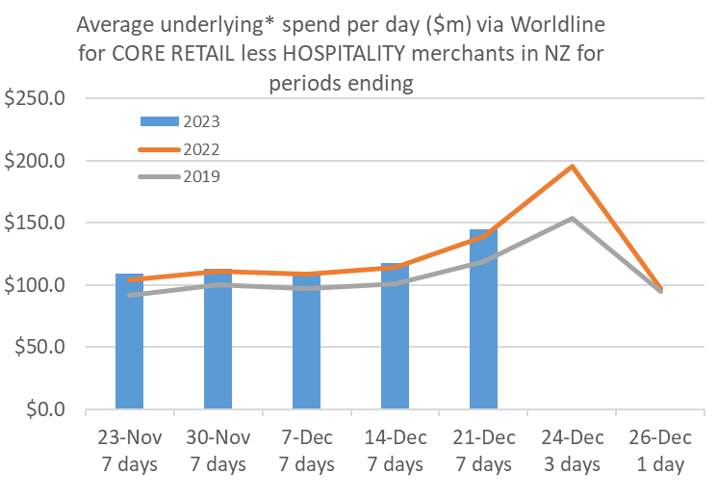
Figure 1: All Cards NZ average daily underlying* spending through Worldline for Core Retail excluding Hospitality in the leadup to Christmas Day (* Underlying excludes large clients moving to or from Worldline)
“Looking closer at the daily pattern, we can see the spending build-up to Christmas Day is following a similar pattern to that of 2017, when Christmas Day was last on a Monday,” says Proffit.
“This suggests Friday and Saturday (22 and 23 December) will be the busiest shopping days of the year, although Sunday should also be busy thanks to the usual last-minute shoppers.”
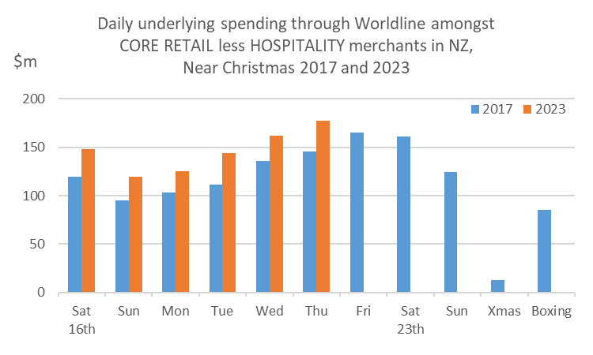
Figure 2: All Cards NZ daily underlying* spending through Worldline for Core Retail excluding Hospitality around Christmas Day (* Underlying excludes large clients moving to or from Worldline)
Regionally, overall spending through Core Retail merchants in the first 21 days of December was up strongest in Whanganui (+10.5%) and Otago (+6.9%). Spending remains lower than last year in Southland (-3.4%) and Taranaki (-0.5%).
WORLDLINE All Cards underlying* spending for CORE RETAIL less HOSPITALITY merchants for 1-21st Dec 2023
 | Value | Underlying* | Underlying*
Region | transactions $millions | Annual % change on 2022 | Annual % change on 2019
Auckland/Northland | 993.5 | 1.7% | 12.2%
Waikato | 223.5 | 4.1% | 26.6%
BOP | 183.2 | 2.5% | 18.7%
Gisborne | 24.2 | 2.7% | 7.6%
Taranaki | 62.6 | -0.5% | 28.7%
Hawke's Bay | 98.9 | 3.6% | 27.7%
Whanganui | 36.6 | 10.5% | 41.1%
Palmerston North | 83.9 | 3.3% | 26.4%
Wairarapa | 33.1 | 3.5% | 26.4%
Wellington | 232.0 | 3.7% | 15.3%
Nelson | 55.4 | 4.7% | 16.5%
Marlborough | 35.3 | 4.5% | 19.1%
West Coast | 18.6 | 4.6% | 33.0%
Canterbury | 320.7 | 3.0% | 20.8%
South Canterbury | 45.8 | 2.4% | 21.4%
Otago | 145.7 | 6.9% | 19.0%
Southland | 60.3 | -3.4% | 11.6%
New Zealand | 2,653.5 | 2.9% | 17.7%
Figure 3: Recent All Cards NZ underlying* spending growth through Worldline for regional Core Retail excluding Hospitality merchants, versus the same dates in previous years (* Underlying excludes large clients moving to or from Worldline)
- ENDS -
Note to editors:
These figures reflect general market trends and should not be taken as a proxy for Worldline‘s market share or company earnings. The figures primarily reflect transactions undertaken within stores but also include some ecommerce transactions. The figures exclude transactions through Worldline undertaken by merchants outside the Core Retail sector (as defined by Statistics NZ).
For more information, contact:
Brendan Boughen
T 027 839 6044
E brendan.boughen.external@worldline.com

ABOUT WORLDLINE IN NEW ZEALAND
We are New Zealand's leading payments innovator. We design, build and deliver payment solutions that help Kiwi business succeed. Whether you’re looking for in store, online or mobile payment solutions or powerful business insights, Worldline is here to help with technology backed by experience. www.worldline.co.nz

About Worldline
Worldline [Euronext: WLN] helps businesses of all shapes and sizes to accelerate their growth journey – quickly, simply, and securely. With advanced payments technology, local expertise and solutions customised for hundreds of markets and industries, Worldline powers the growth of over one million businesses around the world. Worldline generated 4.4 billion euros revenue in 2022. worldline.com
Read our 2022 Integrated Report
Worldline’s corporate purpose (“raison d’être”) is to design and operate leading digital payment and transactional solutions that enable sustainable economic growth and reinforce trust and security in our societies. Worldline makes them environmentally friendly, widely accessible, and supports social transformation.
Press Contact
Hélène Carlander
T +33 7 72 25 96 04
E helene.carlander@worldline.com
Follow us

