Pre-Christmas spending build up begins, but patterns are mixed across retail sectors
AUCKLAND, 8 December 2023 – Consumer spending patterns were mixed in the first full week of December, with pre-Christmas shopping up for Food & Liquor, but down across most other retail sectors.

Consumer spending processed through all Core Retail merchants (excluding Hospitality) in Worldline NZ’s payments network during the first seven days of December reached $785m, which is up 1.4% on the first seven days of December 2022 and up 13.9% on 2019.
Worldline NZ’s Chief Sales Officer, Bruce Proffit, says the December build-up to Christmas has begun similarly to last year, although the experience at the sector level differs.
“The pattern of recent months continues with spending at Food & Liquor stores up and spending elsewhere generally running below 2022 levels,” says Proffit.
He notes that spending in the first seven days of December was up 6.7% amongst Food & Liquor merchants, but down 6.5% across the remaining Core Retail merchants (excluding Hospitality).
Proffit says a closer look at the retail sectors shows annual spending growth so far in December ranged from a positive pattern for Bookshops (+1.7%), Toy/Gaming stores (+2.4%) and Chemists (+8.2%) to negative patterns for Clothing/Footwear stores (-9.2%) and a large grouping of Hardware & Furniture merchants (-6.9%).
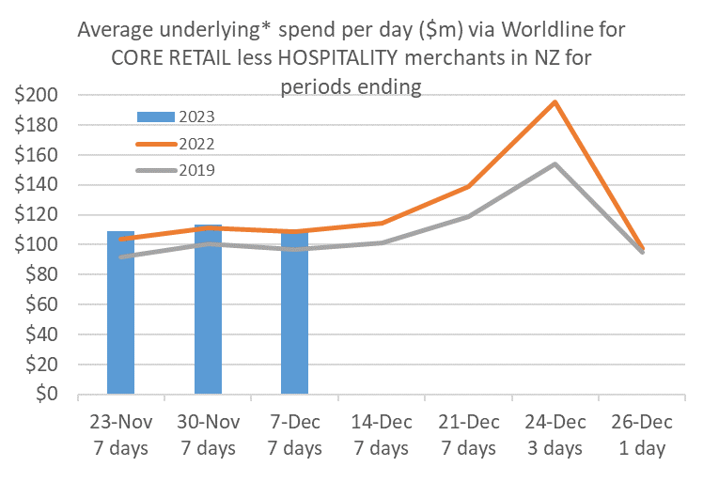
Figure 1: All Cards NZ average daily underlying* spending through Worldline for core retail excluding Hospitality in the leadup to Christmas Day (* Underlying excludes large clients moving to or from Worldline)
In considering how consumer spending may unfold for merchants in the coming weeks, Proffit says although these early figures reflect the longer-term trend of softer spending growth seen in 2023, retailers should still be in for some busy weeks ahead.
“The typical seasonal pattern will see spending tick up a little in the next seven days and again the week after, before a final frenzy over the last three days before Christmas Day,” he says.
“Christmas Eve this year falls on a Sunday so the peak day is likely to be Friday or Saturday – either way, both will no doubt be busy.”
From a regional perspective, spending in the first seven days of December was up strongest in Whanganui (+9.5%) and Otago (+7.4%). Spending was lower than last year in Auckland/Northland (-0.1%) Hawke’s Bay (-1.2%), Gisborne (-1.3%), Southland (-2.0%), Taranaki (-2.8%) and Bay of Plenty (-2.9%).
WORLDLINE All Cards underlying* spending for CORE RETAIL less HOSPITALITY and FOOD/LIQUOR merchants for 1-7th Dec 2023
 | Value | Underlying* | Underlying*
Region | transactions $millions | Annual % change on 2022 | Annual % change on 2019
Auckland/Northland | 293.2 | -0.1% | 7.6%
Waikato | 65.6 | 0.8% | 22.3%
BOP | 53.9 | -2.9% | 15.2%
Gisborne | 7.0 | -1.3% | 6.6%
Taranaki | 18.3 | -2.8% | 23.5%
Hawke's Bay | 29.0 | -1.2% | 19.8%
Whanganui | 11.1 | 9.5% | 40.4%
Palmerston North | 24.9 | 2.7% | 22.9%
Wairarapa | 10.0 | 1.9% | 22.9%
Wellington | 70.7 | 3.9% | 15.7%
Nelson | 16.1 | 1.9% | 14.7%
Marlborough | 10.2 | 1.8% | 16.2%
West Coast | 5.6 | 2.8% | 32.0%
Canterbury | 95.3 | 3.2% | 17.2%
South Canterbury | 13.4 | 1.0% | 13.8%
Otago | 43.1 | 7.4% | 14.8%
Southland | 17.9 | -2.0% | 11.1%
New Zealand | 785.6 | 1.4% | 13.9%
Figure 2: Recent All Cards NZ underlying* spending growth through Worldline for regional core retail excluding hospitality merchants, versus the same dates in previous years (* Underlying excludes large clients moving to or from Worldline)
Looking back to November, the monthly spending total through Worldline’s payments network at Core Retail merchants (excluding Hospitality) was $3.212B, which is up 3.4% on November 2022. The annual growth rate was below that averaged in the first nine months of 2023 (+4.6%).
“Black Friday spending certainly provided the usual boost for retailers at the end of the month, but the overall trends for November continued to reflect the generally weaker growth we’ve seen over the preceding months,” says Proffit.
The fastest monthly growth rate was in Whanganui (8.1%) and West Coast (8.0%) while spending declined in Southland (-2.4%) and Gisborne (-1.9%). Spending nationally was up amongst Food & Liquor merchants (+8.0%) but lower amongst the remaining Core Retail merchants (excluding Hospitality) (-3.1%).

WORLDLINE All Cards underlying* spending for CORE RETAIL less HOSPITALITY merchants for November 2023
 | Value | Underlying* | Underlying*
Region | transactions $millions | Annual % change on 2022 | Annual % change on 2019
Auckland/Northland | 1,214 | 3.6% | 10.1%
Waikato | 264 | 5.2% | 21.4%
BOP | 216 | 0.9% | 12.2%
Gisborne | 28 | -1.9% | 4.1%
Taranaki | 75 | 5.7% | 29.8%
Hawke's Bay | 118 | 3.1% | 20.9%
Whanganui | 42 | 8.1% | 29.0%
Palmerston North | 97 | 1.6% | 19.2%
Wairarapa | 40 | 0.7% | 19.1%
Wellington | 286 | 2.9% | 11.8%
Nelson | 66 | 4.5% | 13.7%
Marlborough | 41 | 5.8% | 16.4%
West Coast | 24 | 8.0% | 24.6%
Canterbury | 397 | 3.3% | 21.0%
South Canterbury | 55 | 3.6% | 20.1%
Otago | 175 | 5.8% | 14.7%
Southland | 73 | -2.4% | 10.3%
New Zealand | 3,212 | 3.4% | 14.5%
Figure 3: All Cards NZ underlying* spending through Worldline in November 2023 for Core Retail (excluding Hospitality) merchants
(* Underlying excludes large clients moving to or from Worldline)
- ENDS -
Note to editors:
These figures reflect general market trends and should not be taken as a proxy for Worldline‘s market share or company earnings. The figures primarily reflect transactions undertaken within stores but also include some ecommerce transactions. The figures exclude transactions through Worldline undertaken by merchants outside the Core Retail sector (as defined by Statistics NZ).
For more information, contact:
Brendan Boughen
T 027 839 6044
E brendan.boughen.external@worldline.com

ABOUT WORLDLINE IN NEW ZEALAND
We are New Zealand's leading payments innovator. We design, build and deliver payment solutions that help Kiwi business succeed. Whether you’re looking for in store, online or mobile payment solutions or powerful business insights, Worldline is here to help with technology backed by experience. www.worldline.co.nz

About Worldline
Worldline [Euronext: WLN] helps businesses of all shapes and sizes to accelerate their growth journey – quickly, simply, and securely. With advanced payments technology, local expertise and solutions customised for hundreds of markets and industries, Worldline powers the growth of over one million businesses around the world. Worldline generated 4.4 billion euros revenue in 2022. worldline.com
Read our 2022 Integrated Report
Worldline’s corporate purpose (“raison d’être”) is to design and operate leading digital payment and transactional solutions that enable sustainable economic growth and reinforce trust and security in our societies. Worldline makes them environmentally friendly, widely accessible, and supports social transformation.
Press Contact
Hélène Carlander
T +33 7 72 25 96 04
E helene.carlander@worldline.com
Follow us

