Second week of Christmas shopping season brings more cheer for retailers

Hospitality sector also sees boost in business as peak party season approaches
AUCKLAND, 15 December 2023 – Consumer spending increased in the second full week of December bringing some much-needed cheer to merchants within both the Core Retail and Hospitality sectors, as month-to-date spending jumped ahead of last year.

Consumer spending processed through all Core Retail merchants (excluding Hospitality) in Worldline NZ’s payments network during the first 14 days of December reached $1.625B, which is up +2.3% on the first 14 days of December 2022 and up +15.2% on 2019.
Worldline NZ’s Chief Sales Officer, Bruce Proffit, says the second seven days of December (8-14 Dec) showed the traditional uptick in consumer spending and, promisingly, lifted the running annual month-to-date growth rate from +1.4% last week to +2.3% now.
“This is not a large annual growth rate, especially when compared with price inflation. However, annual spending growth was positive for the week amongst Recreational Goods merchants and amongst the large Hardware & Furniture sector,” says Proffit.
Proffit says spending for the combined two weeks (1-14 December) was up (+6.6%) amongst Food & Liquor merchants and down (-4.1%) across the remaining Core Retail merchants (excluding Hospitality). Other sectors experiencing annual growth include Recreational Goods (+1.1%) and Chemists (+4.4%), while spending at Clothing/Footwear stores remains down on last year (-8.7%).
“The better week was not sufficient to push the Hardware & Furniture merchants into the black month-to-date (-2.7%) but this sector still has its biggest trading days of the year to come,” he says.
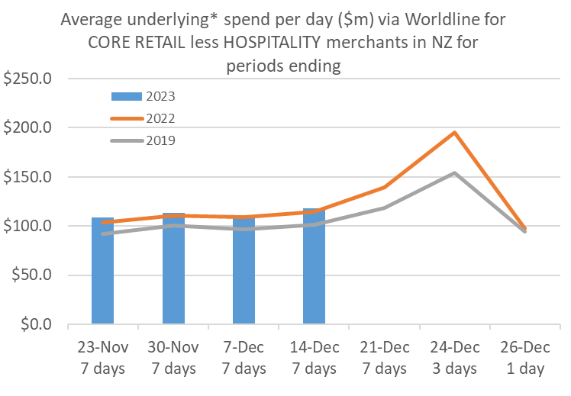
Figure 1: All Cards NZ average daily underlying* spending through Worldline for Core Retail excluding Hospitality in the leadup to Christmas Day (* Underlying excludes large clients moving to or from Worldline)
Proffit says the Christmas leadup is also producing the traditional extra spending at Food & Beverage Services merchants in the Hospitality sector, with spending recorded through Worldline NZ’s network at the likes of restaurants, cafes, fast foods, bars, and clubs reaching $431m in the first 14 days of December, up +0.4% on last year.
“Patterns differ amongst these various types of Hospitality sector offerings but, overall, spending is on track for ‘peak party season’ this Saturday (16 December), when spending in this sector is traditionally busiest for the year,” says Proffit.
WORLDLINE All Cards underlying* spending for FOOD & BEVERAGE SERVICES merchants for 1-14th Dec 2023
 | Value | Underlying* | Underlying*
Region | transactions $millions | Annual % change on 2022 | Annual % change on 2019
Auckland/Northland | 179.4 | 3.6% | 5.2%
Waikato | 31.0 | -0.6% | 15.6%
BOP | 32.4 | -1.7% | 18.2%
Gisborne | 4.0 | 1.1% | 24.7%
Taranaki | 9.4 | -1.1% | 27.4%
Hawke's Bay | 12.7 | 3.7% | 25.3%
Whanganui | 4.5 | 7.2% | 24.1%
Palmerston North | 11.9 | -0.6% | 22.5%
Wairarapa | 3.4 | 1.4% | 31.9%
Wellington | 38.9 | -11.8% | -9.2%
Nelson | 8.0 | -1.1% | 20.9%
Marlborough | 5.2 | -1.6% | -3.8%
West Coast | 2.3 | 19.4% | 63.9%
Canterbury | 45.5 | -1.3% | 4.5%
South Canterbury | 5.7 | -4.3% | 10.6%
Otago | 25.7 | 5.4% | 2.1%
Southland | 11.0 | 1.2% | 15.4%
New Zealand | 431.2 | 0.4% | 7.5%
Figure 2: Recent All Cards NZ underlying* spending growth through Worldline for regional Food and Beverage Services merchants, versus the same dates in previous years (* Underlying excludes large clients moving to or from Worldline)
Regionally, overall spending through Core Retail merchants in the first 14 days of December was up strongest in Whanganui (+8.9%) and Otago (+6.1%). Spending was lower than last year in Southland (-4.1%) and Taranaki (-1.2%).
WORLDLINE All Cards underlying* spending for CORE RETAIL less HOSPITALITY merchants for 1-14th Dec 2023
 | Value | Underlying* | Underlying*
Region | transactions $millions | Annual % change on 2022 | Annual % change on 2019
Auckland/Northland | 609.5 | 1.6% | 9.5%
Waikato | 136.5 | 3.4% | 23.4%
BOP | 111.6 | 0.8% | 16.3%
Gisborne | 14.6 | 1.0% | 6.1%
Taranaki | 38.1 | -1.2% | 26.2%
Hawke's Bay | 60.2 | 0.8% | 23.5%
Whanganui | 22.5 | 8.9% | 38.6%
Palmerston North | 51.3 | 2.7% | 24.1%
Wairarapa | 20.3 | 1.1% | 22.2%
Wellington | 144.3 | 3.0% | 14.2%
Nelson | 33.7 | 3.7% | 14.5%
Marlborough | 21.0 | 2.4% | 15.7%
West Coast | 11.5 | 4.2% | 31.8%
Canterbury | 196.1 | 2.3% | 19.6%
South Canterbury | 27.9 | 0.9% | 16.6%
Otago | 89.3 | 6.1% | 16.4%
Southland | 36.8 | -4.1% | 10.5%
New Zealand | 1,625.1 | 2.3% | 15.2%
Figure 3: Recent All Cards NZ underlying* spending growth through Worldline for regional Core Retail excluding Hospitality merchants, versus the same dates in previous years (* Underlying excludes large clients moving to or from Worldline)
- ENDS -
Note to editors:
These figures reflect general market trends and should not be taken as a proxy for Worldline‘s market share or company earnings. The figures primarily reflect transactions undertaken within stores but also include some ecommerce transactions. The figures exclude transactions through Worldline undertaken by merchants outside the Core Retail sector (as defined by Statistics NZ).
For more information, contact:
Brendan Boughen
T 027 839 6044
E brendan.boughen.external@worldline.com

ABOUT WORLDLINE IN NEW ZEALAND
We are New Zealand's leading payments innovator. We design, build and deliver payment solutions that help Kiwi business succeed. Whether you’re looking for in store, online or mobile payment solutions or powerful business insights, Worldline is here to help with technology backed by experience. www.worldline.co.nz

About Worldline
Worldline [Euronext: WLN] helps businesses of all shapes and sizes to accelerate their growth journey – quickly, simply, and securely. With advanced payments technology, local expertise and solutions customised for hundreds of markets and industries, Worldline powers the growth of over one million businesses around the world. Worldline generated 4.4 billion euros revenue in 2022. worldline.com
Read our 2022 Integrated Report
Worldline’s corporate purpose (“raison d’être”) is to design and operate leading digital payment and transactional solutions that enable sustainable economic growth and reinforce trust and security in our societies. Worldline makes them environmentally friendly, widely accessible, and supports social transformation.
Press Contact
Hélène Carlander
T +33 7 72 25 96 04
E helene.carlander@worldline.com
Follow us

