**FOR IMMEDIATE RELEASE**

Demand for personal loans and mortgages up,

but credit cards dip

**Equifax New Zealand Quarterly Consumer Credit Demand Index: December 2023**

* Overall consumer credit demand increased by +4.2% (vs December quarter 2022)
  + Unsecured credit demand (comprising personal loans and credit cards) up +6.4% (vs December quarter 2022)
  + Mortgage demand up by +3.8% (vs December quarter 2022)

**AUCKLAND – 26 February 2024:** Consumer credit demand rose again in the last quarter of 2023, according to the latest *Equifax Quarterly Consumer Credit Demand Index (December 2023)*, despite a decline pre-Christmas. October and November saw firm demand, which tailed off in December in line with previous years.

Released today by Equifax New Zealand, the global data, analytics and technology company and leading provider of credit information and analysis, the index measures the volume of enquiries for retail credit products, including credit cards, personal loans, and home loans.

Unsecured credit demand (personal loans and credit cards) was the biggest growth driver, up +6.4% year-on-year, continuing the upward trend of previous quarters. The growth in unsecured credit was particularly driven by personal loan demand (up +16% vs the same period in 2022), while credit card demand was down -6.5% on the previous year.

Mortgage demand was up +3.8% in Q4 2023 compared to the same period the previous year. Mortgages saw month-on-month increases seen in October and November, before dropping -29% in December 2023 (vs Dec 2022), again reflecting the holiday season.

Regionally, overall consumer credit demand was strong in Marlborough (up +6.6%), while Auckland and Canterbury were both up +5%. Decline in demand was seen in Manawatu-Wanganui, Nelson, Tasman, and Southland, which had the largest decline (down -4.3%).

Equifax spokesperson Nick Fostersays: “The results showed cautious optimism amongst consumers, who tended to use personal loans for big ticket items, like cars and home appliances. “Conversely, the decline in credit card demand may reflect a pragmatic approach to reining in Christmas spending, particularly at a time of high interest rates.

“The increase in mortgage demand comes off the back of the election results, net migration figures, and the imminent return of thousands of international students this year. Demand for home lending increased in most regions, although there were drops in Nelson, Tasman and Gisborne.”

**CHART: Consumer Credit Demand Index, Year-on-Year Changes (%)**

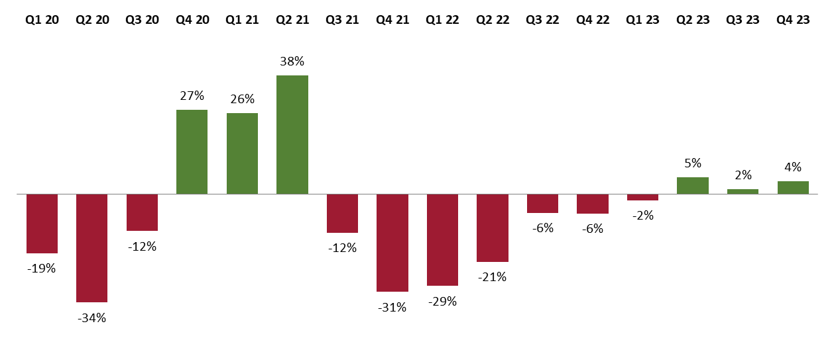

**ABOUT EQUIFAX**

At Equifax (NYSE: EFX), we believe knowledge drives progress. As a global data, analytics, and technology company, we play an essential role in the global economy by helping financial institutions, companies, employers, and government agencies make critical decisions with greater confidence. Our unique blend of differentiated data, analytics, and cloud technology drives insights to power decisions to move people forward. Headquartered in Atlanta and supported by more than 15,000 employees worldwide, Equifax operates or has investments in 24 countries in North America, Central and South America, Europe, and the Asia Pacific region. For more information, visit [www.equifax.co.nz](http://www.equifax.co.nz) or follow the company’s news on [LinkedIn](https://www.linkedin.com/showcase/equifaxnz/).

**FOR MORE INFORMATION**

Annie Hogan | Dentsu

021 725 259

annie.hogan@dentsu.com

**NOTE TO EDITORS**

The Quarterly Consumer Credit Demand Index by Equifax measures the volume of credit card, personal loan applications, and home loan applications that go through the Equifax Consumer Credit Bureau by financial services credit providers in New Zealand. Credit applications represent an intention by consumers to acquire credit and in turn spend; therefore, the index is a lead indicator.

**DISCLAIMER**

Purpose of Equifax media releases:

The information in this release does not constitute legal, accounting or other professional financial advice. The information may change, and Equifax does not guarantee its currency or accuracy. To the extent permitted by law, Equifax specifically excludes all liability or responsibility for any loss or damage arising out of reliance on information in this release and the data in this report, including any consequential or indirect loss, loss of profit, loss of revenue or loss of business opportunity.