Consumer spending growth remains slow,
but Easter spending up on last year
AUCKLAND, 4 April 2024 – Weak spending growth amongst Core Retail merchants in Worldline NZ’s payments network in March suggests Kiwi consumers are still grappling with tight budgets, although they did spend more over Easter this year than last year.

Data released by Worldline NZ today shows consumer spending through Core Retail merchants (excluding Hospitality) in its payments network reached $3.05B in March 2024, which is down -0.2% on March 2023.

Worldline NZ’s Chief Sales Officer, Bruce Proffit, notes the fall in spending during March 2024 simply reflects the fact that March this year included most of the trading-constrained Easter long weekend, whereas March last year did not, when Easter 2023 was entirely in April.

“Spending was up 0.4% on 2023 during the first three weeks of March. It is this figure that is indicative of the underlying consumer spending pattern. This annual growth rate is low and lower than the already slow growth experienced in February, meaning times are still tough for merchants and their customers,” he says.

“Spending was below 2023 over the remaining 10 days of the month but this was due to Easter. Easter spending in 2024 showed a similar daily pattern to last year, despite some reported infringements. Spending was high on Easter Thursday and Easter Saturday but these days do not make up for the lack of sales on Good Friday and Easter Sunday.”

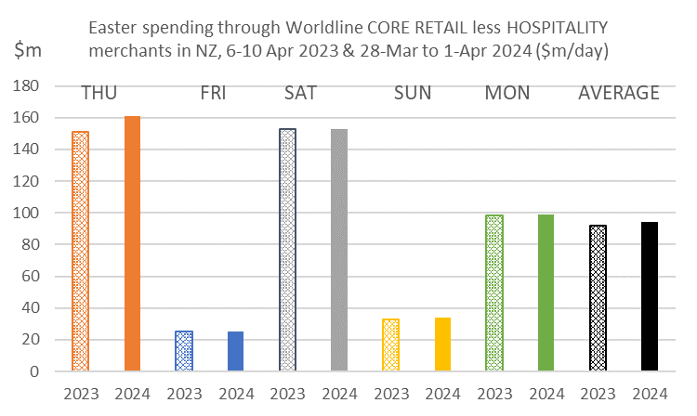
Figure 1: All Cards NZ underlying* spending through Worldline in Easter 2023 and 2024 for core retail excluding hospitality merchants (*Underlying excludes large clients moving to or from Worldline)
“Comparing Easter 2024 versus Easter 2023, spending over the five days was up +2.5%, largely due to the +6.4% jump on Easter Thursday. This also made it the fifth highest spending day of the last 12 months, only behind the few shopping days before Christmas Day,” says Proffit.

“As usual, consumers spent more on groceries on this day and – to a lesser extent – stocked up on books, plants, hardware, sports equipment, and clothes,” he says.

“Spending on Easter Saturday and Easter Monday was also higher than typical for these days of the week, but the annual growth rates were low this year, being unchanged and +0.5% respectively. Due to being public holidays, spending was low on Good Friday and Easter Sunday, with annual spending growth up 0.4% and 3.5% respectively on those days.”

Over the five days of Easter, annual spending growth amongst Core Retail merchants (excluding Hospitality) was highest in Whanganui (+6.8%), Otago (+5.2%), Waikato (+4.7%) and Wellington (+4.2%). Declines occurred in Southland (-8.4%), Bay of Plenty (-2.3%) and Marlborough (-0.4%).

WORLDLINE All Cards underlying* spending for CORE RETAIL less HOSPITALITY merchants for Easter 2024 (versus Easter 2023)
 | Value | Underlying*
Region | transactions $millions | Annual % change on 2023
Auckland/Northland | 175.4 | 2.8%
Waikato | 41.6 | 4.7%
BOP | 33.6 | -2.3%
Gisborne | 4.1 | 3.7%
Taranaki | 11.2 | 1.9%
Hawke's Bay | 18.4 | 1.1%
Whanganui | 6.7 | 6.8%
Palmerston North | 15.0 | 1.3%
Wairarapa | 6.3 | 0.0%
Wellington | 42.4 | 4.2%
Nelson | 9.4 | 3.9%
Marlborough | 6.4 | -0.4%
West Coast | 3.7 | 1.8%
Canterbury | 55.9 | 3.4%
South Canterbury | 7.8 | 1.2%
Otago | 29.9 | 5.2%
Southland | 10.3 | -8.4%
New Zealand | 478.0 | 2.5%
Figure 2: All Cards NZ underlying* spending through Worldline in Easter 2024 (Thursday-Monday) for core retail excluding hospitality merchants, compared to Easter 2023 (* Underlying excludes large clients moving to or from Worldline)
For the month in total, regional annual growth for Core Retail merchants (excluding Hospitality) was highest in West Coast (+6.4%) and Otago (+6.2%), while the largest decline was in Southland (-6.8%).

WORLDLINE All Cards underlying* spending for CORE RETAIL less HOSPITALITY merchants for March 2024
 | Value | Underlying* | Underlying*
Region | transactions $millions | Annual % change on 2023 | Annual % change on 2019
Auckland/Northland | 1,125 | -2.0% | 12.3%
Waikato | 255 | 2.0% | 29.1%
BOP | 201 | -3.9% | 17.9%
Gisborne | 27 | -3.8% | 13.3%
Taranaki | 72 | 0.1% | 31.9%
Hawke's Bay | 115 | 1.7% | 28.5%
Whanganui | 41 | 4.6% | 38.2%
Palmerston North | 93 | -3.4% | 24.2%
Wairarapa | 39 | -0.2% | 30.1%
Wellington | 271 | 1.5% | 13.9%
Nelson | 64 | 0.0% | 20.6%
Marlborough | 41 | 3.5% | 23.0%
West Coast | 25 | 6.4% | 37.0%
Canterbury | 378 | 1.5% | 25.6%
South Canterbury | 55 | 3.3% | 28.9%
Otago | 185 | 6.2% | 22.3%
Southland | 71 | -6.8% | 14.1%
New Zealand | 3,058 | -0.2% | 18.9%
Figure 3: All Cards NZ underlying* spending through Worldline in March 2024 for core retail excluding hospitality merchants (* Underlying excludes large clients moving to or from Worldline)
- ENDS -
Note to editors:
These figures reflect general market trends and should not be taken as a proxy for Worldline‘s market share or company earnings. The figures primarily reflect transactions undertaken within stores but also include some ecommerce transactions. The figures exclude transactions through Worldline undertaken by merchants outside the Core Retail sector (as defined by Statistics NZ).
For more information, contact:
Brendan Boughen
T 027 839 6044
E brendan.boughen.external@worldline.com

ABOUT WORLDLINE IN NEW ZEALAND
We are New Zealand's leading payments innovator. We design, build and deliver payment solutions that help Kiwi business succeed. Whether you’re looking for in store, online or mobile payment solutions or powerful business insights, Worldline is here to help with technology backed by experience. www.worldline.co.nz

About Worldline
Worldline [Euronext: WLN] helps businesses of all shapes and sizes to accelerate their growth journey – quickly, simply, and securely. With advanced payments technology, local expertise and solutions customised for hundreds of markets and industries, Worldline powers the growth of over one million businesses around the world. Worldline generated 4.4 billion euros revenue in 2022. worldline.com
Read our 2022 Integrated Report
Worldline’s corporate purpose (“raison d’être”) is to design and operate leading digital payment and transactional solutions that enable sustainable economic growth and reinforce trust and security in our societies. Worldline makes them environmentally friendly, widely accessible, and supports social transformation.
Press Contact
Hélène Carlander
T +33 7 72 25 96 04
E helene.carlander@worldline.com
Follow us

