Winter spending woes persist for NZ retailers
AUCKLAND, 5 August 2024 –The slow retail environment seen across New Zealand with the onset of winter in June continued throughout July amongst Worldline NZ’s Core Retail merchants, while the Hospitality sector saw a small boost during the school holidays.

Data released by Worldline NZ today shows consumer spending through Core Retail merchants (excluding Hospitality) in its payments network reached $2.82B in July 2024, which is down -2.6% from July 2023.

Worldline NZ’s Chief Sales Officer, Bruce Proffit, says there has been little change in the spending momentum at Kiwi retailers in recent weeks.

“Spending across the country was down on last year in June and continued to be down in July, although there was a small school holiday effect bump seen within the month,” says Proffit.

“The second week of July – the first week of the school holidays – was the best for Hospitality generally across the country, however this was not enough to take spending up to levels seen in the same school holiday period in 2023.”

Proffit says Hospitality sector spending was highest in the major regions (Auckland/Northland, Wellington and Canterbury) and the rest of New Zealand in the second week of the month but was below year ago levels for both regional groups during the week – by 5% and 10% respectively.

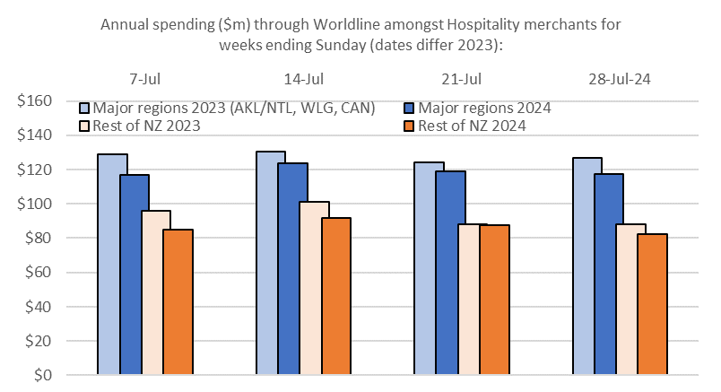
Figure 1: All Cards NZ underlying* spending through Worldline for the 4 weeks ending Sunday in July 2023 and 2024 for Hospitality merchants, grouped by major regions and the rest of NZ (*underlying excludes large clients moving to or from Worldline)

“Beyond the hospitality sector, the third week of July – the second week of the school holidays – was the worst of the month for Core Retail excluding Hospitality merchants in the major regions” he says.

“Some of the major regions’ spending would have moved around – along with holidaymakers – to the rest of the country but this offset was only partial as non-Hospitality spending was below year-ago levels in the major regions and in the rest of the country, by 4% and 0.4% respectively.

“By the last week of the month, the spending decline had reverted to its current momentum – so merchants will be hoping for a positive turning point in August.”
For the month in total, regional annual growth for Core Retail merchants (excluding Hospitality) was highest in Whanganui (+3.7%) and Marlborough (+2.6%).

Spending was down on last year in the remaining areas, with the largest falls being in Southland (-7.1%), Bay of Plenty (-6.3%), South Canterbury (-4.4%) and Auckland/Northland (-3.6%).

WORLDLINE All Cards underlying* spending for CORE RETAIL less HOSPITALITY merchants for July 2024
 | Value | Underlying* | Underlying*
Region | transactions $millions | Annual % change on 2023 | Annual % change on 2019
Auckland/Northland | 1,037 | -3.6% | 10.5%
Waikato | 238 | -0.1% | 27.7%
BOP | 187 | -6.3% | 15.6%
Gisborne | 26 | -2.0% | 10.2%
Taranaki | 69 | -0.8% | 29.2%
Hawke's Bay | 105 | -0.2% | 26.7%
Whanganui | 41 | 3.7% | 34.4%
Palmerston North | 90 | -0.5% | 25.6%
Wairarapa | 37 | -1.1% | 28.6%
Wellington | 249 | -2.7% | 11.6%
Nelson | 56 | -0.7% | 17.7%
Marlborough | 37 | 2.6% | 25.3%
West Coast | 21 | 2.1% | 31.6%
Canterbury | 349 | -1.9% | 23.3%
South Canterbury | 49 | -4.4% | 20.8%
Otago | 166 | -1.2% | 17.4%
Southland | 64 | -7.1% | 12.3%
New Zealand | 2,819 | -2.6% | 16.8%
Figure 2: All Cards NZ underlying* spending through Worldline in July 2024 for core retail excluding hospitality merchants (* Underlying excludes large clients moving to or from Worldline)
- ENDS -
Note to editors:
These figures reflect general market trends and should not be taken as a proxy for Worldline‘s market share or company earnings. The figures primarily reflect transactions undertaken within stores but also include some ecommerce transactions. The figures exclude transactions through Worldline undertaken by merchants outside the Core Retail sector (as defined by Statistics NZ).
For more information, contact:
Brendan Boughen
T 027 839 6044
E brendan.boughen.external@worldline.com

ABOUT WORLDLINE IN NEW ZEALAND
We are New Zealand's leading payments innovator. We design, build and deliver payment solutions that help Kiwi business succeed. Whether you’re looking for in store, online or mobile payment solutions or powerful business insights, Worldline is here to help with technology backed by experience. www.worldline.co.nz

About Worldline
Worldline [Euronext: WLN] helps businesses of all shapes and sizes to accelerate their growth journey – quickly, simply, and securely. With advanced payments technology, local expertise and solutions customised for hundreds of markets and industries, Worldline powers the growth of over one million businesses around the world. Worldline generated a 4.6 billion euros revenue in 2023. worldline.com
Worldline’s corporate purpose (“raison d’être”) is to design and operate leading digital payment and transactional solutions that enable sustainable economic growth and reinforce trust and security in our societies. Worldline makes them environmentally friendly, widely accessible, and supports social transformation.
Press Contact
Hélène Carlander
T +33 7 72 25 96 04
E helene.carlander@worldline.com
Follow us

