School holidays and long weekends change regional spending patterns in April
AUCKLAND, 5 May 2025 – Nationwide consumer spending in April was slightly above the levels seen in the same month last year, according to figures released today by Worldline NZ, with the extra spending occurring mostly outside the major centres.

Consumer spending through all Core Retail merchants in Worldline NZ’s payments network in April 2025 reached $3.74B, which is up +0.9% on April 2024, following adjustments for merchants coming and going from the network.
Worldline NZ’s Chief Sales Officer, Bruce Proffit says a key influence on consumer spending patterns in the month was the Easter public holidays, which fell fully within April this year, and also within the April school holiday period.
“It does appear that many people journeyed out of the major centres over the school, Easter, and Anzac Day holidays this year. This inference follows from the monthly spending declines we saw in the major centres and higher growth in the regions, and from the spending patterns around the Easter long weekend,” he says.
Proffit says the spending pattern over Easter was similar to last year, when Easter spanned March and April, with the traditional peaks on occurring on Easter Thursday and Easter Sunday.
“The average spend per day between Thursday and Monday was $119.2m, which was down 2.4% on Easter 2024. However, the extra spending near the start of the school holidays suggests more people went away this year than in 2024.”
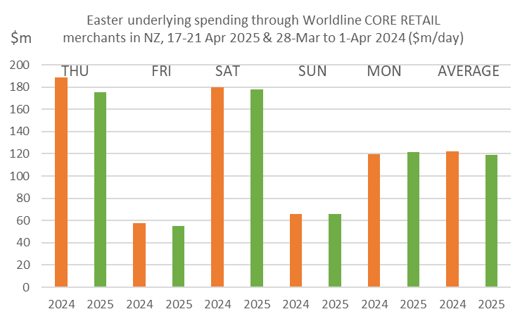
Figure 1: All Cards NZ underlying* spending through Worldline in Easter 2024 and 2025 for core retail merchants (*Underlying excludes large clients moving to or from Worldline). Includes some transactions reported Friday and Sunday that occurred on Thursday and Saturday).
The average underlying Core Retail spending per day between Thursday 10th April and Wednesday 16th April 2025 was $129.3m, up 6.6% on average over Thursday 11th April to Wednesday 17th April 2024 ($121.2m).
Notably, annual regional Core Retail spending growth for the full month of April was highest in West Coast (+8.1%), Whanganui (+7.5%), Otago (+6.1%), Taranaki (+5.0%) and Waikato (+4.7%), while monthly spending declined in Auckland/Northland (-1.5%) and Wellington (-2.2%) and was unchanged from last year in Canterbury (0.0%).

WORLDLINE All Cards underlying* spending for CORE RETAIL merchants for April 2025
 | Value | Underlying value*
Region | transactions $millions | Annual % change on 2024
Auckland/Northland | 1,361 | -1.5%
Waikato | 316 | 4.7%
BOP | 265 | 1.9%
Gisborne | 35 | 3.1%
Taranaki | 90 | 5.0%
Hawke's Bay | 136 | 1.9%
Whanganui | 52 | 7.5%
Palmerston North | 114 | 1.5%
Wairarapa | 44 | 4.2%
Wellington | 316 | -2.2%
Nelson | 79 | 3.3%
Marlborough | 52 | 1.7%
West Coast | 32 | 8.1%
Canterbury | 448 | 0.0%
South Canterbury | 61 | 2.3%
Otago | 245 | 6.1%
Southland | 96 | 3.5%
New Zealand | 3,745 | 0.9%
Figure 2: All Cards NZ underlying* spending through Worldline in April 2025 for core retail merchants (* Underlying excludes large clients moving to or from Worldline)
- ENDS -

Note to editors:
These figures reflect general market trends and should not be taken as a proxy for Worldline‘s market share or company earnings. The figures primarily reflect transactions undertaken within stores but also include some ecommerce transactions. The figures exclude transactions through Worldline undertaken by merchants outside the Core Retail sector (as defined by Statistics NZ).

For more information, contact:
Brendan Boughen
T 027 839 6044
E brendan.boughen.external@worldline.com

ABOUT WORLDLINE IN NEW ZEALAND
We are New Zealand's leading payments innovator. We design, build and deliver payment solutions that help Kiwi business succeed. Whether you’re looking for in store, online or mobile payment solutions or powerful business insights, Worldline is here to help with technology backed by experience. www.worldline.co.nz

About Worldline
Worldline [Euronext: WLN] helps businesses of all shapes and sizes to accelerate their growth journey – quickly, simply, and securely. With advanced payments technology, local expertise and solutions customised for hundreds of markets and industries, Worldline powers the growth of over one million businesses around the world. Worldline generated a 4.6 billion euros revenue in 2024. worldline.com
Worldline’s corporate purpose (“raison d’être”) is to design and operate leading digital payment and transactional solutions that enable sustainable economic growth and reinforce trust and security in our societies. Worldline makes them environmentally friendly, widely accessible, and supports social transformation.
Press Contact
Hélène Carlander
T +33 7 72 25 96 04
E helene.carlander@worldline.com
Follow us

