Spending growth edges up nationwide and stops falling in the Auckland/Northland region
AUCKLAND, 5 June 2025 – Consumer spending nationwide continued its recent modest upward trend in May, with the Auckland/Northland region seeing a year-on-year lift in spending for the first time in nine months, which persisted over the King’s Birthday long weekend.

Consumer spending through all Core Retail merchants in Worldline NZ’s payments network in May 2025 reached $3.80B, which is up +1.8% on May 2024, following adjustments for merchants coming and going from the network.

Worldline NZ’s Chief Sales Officer, Bruce Proffit says while the national consumer spending growth rate remains modest, it was encouraging to see the month start with generally positive figures.
“This was especially the case in the Auckland/Northland region where spending has been weak since early 2024. Spending growth in the region basically came to a halt in early 2024 and had declined on year-ago levels in the previous eight months before rising +1.1% above May 2024,” says Proffit.
“While this spending uptick is not large – and was in part due to a favourable fall of days in May – it is at least a positive sign,” he says.
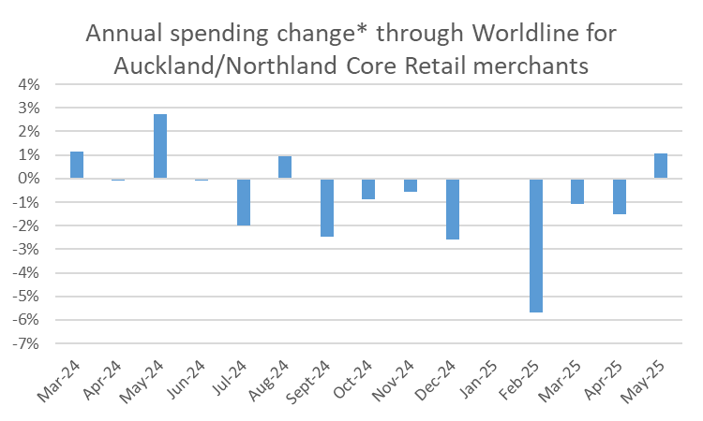
Figure 1: All Cards NZ underlying* spending annual growth through Worldline in recent months for Auckland/Northland core retail merchants (*Underlying excludes large clients moving to or from Worldline).

Proffit says the retail sectors that showed the most year-on-year growth within the overall spend included Food & Beverage, Clothing, Chemists, and Hospitality, which includes cafes, restaurants and Accommodation.
The slight, but positive, growth rate has also continued into June, with, consumer spending through all Core Retail merchants in Worldline NZ’s payments network over the three days of the King’s Birthday long weekend (31 May to 2 June) reaching $0.39B, up +1.0% on the King’s Birthday long weekend in 2024, following adjustments for merchants coming and going from the network.
The annual growth rate for the King’s Birthday long weekend in Auckland/Northland was +0.8%, while the highest growth rate was in Nelson (+6.8%) and the lowest was in Bay of Plenty (-1.1%).

WORLDLINE All Cards underlying* spending for CORE RETAIL merchants for King's Birthday weekend 2025 (versus same weekend 2024)
 | Value | Underlying*
Region | transactions $millions | Annual % change on 2024
Auckland/Northland | 152.0 | 0.8%
Waikato | 32.6 | 1.2%
BOP | 27.8 | -1.1%
Gisborne | 3.3 | 1.7%
Taranaki | 8.7 | 1.0%
Hawke's Bay | 13.5 | 1.5%
Whanganui | 5.1 | 3.0%
Palmerston North | 12.1 | 0.3%
Wairarapa | 4.4 | 3.9%
Wellington | 35.5 | -0.7%
Nelson | 7.2 | 6.8%
Marlborough | 4.9 | 3.0%
West Coast | 2.4 | -0.7%
Canterbury | 48.5 | 2.8%
South Canterbury | 5.7 | 2.9%
Otago | 22.6 | 0.0%
Southland | 8.4 | 0.3%
New Zealand | 395.1 | 1.0%
Figure 2: All Cards NZ underlying* spending through Worldline between Saturday 31-May and Monday 2-Jun 2025 for core retail merchants, versus King’s Birthday weekend 2024 (* Underlying excludes large clients moving to or from Worldline)
Meanwhile, across the regions, Core Retail spending growth for the full month of May was highest in Whanganui (+6.9%), Otago (+4.6%) and Nelson (+4.1%), while spending is still declining in Wellington (-1.3%).

WORLDLINE All Cards underlying* spending for CORE RETAIL merchants for May 2025
 | Value | Underlying value*
Region | transactions $millions | Annual % change on 2024
Auckland/Northland | 1,439 | 1.1%
Waikato | 315 | 3.9%
BOP | 256 | 1.9%
Gisborne | 35 | 3.0%
Taranaki | 90 | 3.7%
Hawke's Bay | 136 | 2.6%
Whanganui | 52 | 6.9%
Palmerston North | 119 | 2.9%
Wairarapa | 44 | 2.6%
Wellington | 331 | -1.3%
Nelson | 76 | 4.1%
Marlborough | 47 | 0.0%
West Coast | 27 | 1.3%
Canterbury | 460 | 1.4%
South Canterbury | 60 | 2.3%
Otago | 222 | 4.6%
Southland | 90 | 2.2%
New Zealand | 3,801 | 1.8%
Figure 3: All Cards NZ underlying* spending through Worldline in May 2025 for core retail merchants (* Underlying excludes large clients moving to or from Worldline)

- ENDS -

Note to editors:
These figures reflect general market trends and should not be taken as a proxy for Worldline‘s market share or company earnings. The figures primarily reflect transactions undertaken within stores but also include some ecommerce transactions. The figures exclude transactions through Worldline undertaken by merchants outside the Core Retail sector (as defined by Statistics NZ).

For more information, contact:
Brendan Boughen
T 027 839 6044
E brendan.boughen.external@worldline.com

ABOUT WORLDLINE IN NEW ZEALAND
We are New Zealand's leading payments innovator. We design, build and deliver payment solutions that help Kiwi business succeed. Whether you’re looking for in store, online or mobile payment solutions or powerful business insights, Worldline is here to help with technology backed by experience. www.worldline.co.nz

About Worldline
Worldline [Euronext: WLN] helps businesses of all shapes and sizes to accelerate their growth journey – quickly, simply, and securely. With advanced payments technology, local expertise and solutions customised for hundreds of markets and industries, Worldline powers the growth of over one million businesses around the world. Worldline generated a 4.6 billion euros revenue in 2024. worldline.com
Worldline’s corporate purpose (“raison d’être”) is to design and operate leading digital payment and transactional solutions that enable sustainable economic growth and reinforce trust and security in our societies. Worldline makes them environmentally friendly, widely accessible, and supports social transformation.
Press Contact
Hélène Carlander
T +33 7 72 25 96 04
E helene.carlander@worldline.com
Follow us

