Kiwis spent more on food but less on other consumer products and services in July
AUCKLAND, 6 August 2025 – Consumer spending increased again in July 2025, although data released by Worldline NZ point to higher prices as a large influence.

Figures released today show consumer spending recorded through all Core Retail merchants in Worldline NZ’s payments network in July 2025 reached $3.72B, which is up +2.4% on July 2024, following adjustments for merchants coming and going from the network.
Worldline NZ’s Chief Sales Officer, Bruce Proffit says July 2025 marks the fourth month in a row that Worldline has recorded consumer spending at levels above those of a year ago.
“Higher spending is generally welcomed by consumers and merchants alike. However, the caveat on the current pattern is that the growth is largely amongst merchants selling food, including the likes of grocery stores, takeaway outlets and cafes,” says Proffit.
“This correlates with recent price rises seen on many food products, which suggests this is the most likely factor driving the overall lift in spending.
“In previous months there was a lift in spending seen amongst other merchant sectors, insomuch as the annual decline in spending had halted in May and June. This was not the case in July, although the annual decline was modest.”
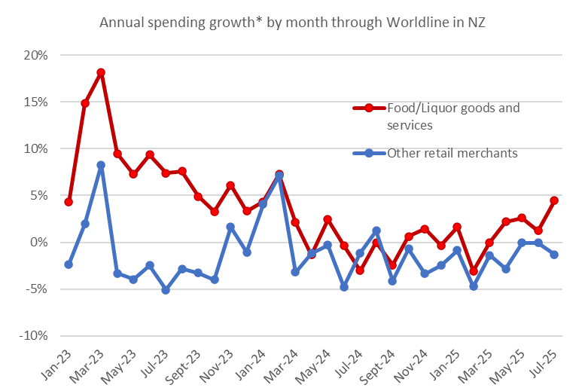
Figure 1: All Cards NZ underlying* spending annual growth through Worldline in recent months for NZ core retail merchants, broken down by Food and Liquor goods and services merchants and the rest (*Underlying excludes large clients moving to or from Worldline).
Looking at regional spending across the combined Core Retail sector shows annual spending growth for July was highest in South Canterbury (+6.0%), Waikato (+5.8%) and Whanganui (+5.8%), while spending declined on July last year in Marlborough (-2.8%).
Meanwhile, spending growth in the three largest regions – Auckland/Northland, Wellington and Canterbury – remain amongst the weakest nationally at +1.6%, +2.2% and +3.4% respectively.
WORLDLINE All Cards underlying* spending for CORE RETAIL merchants for July 2025
 | Value | Underlying value*
Region | transactions $millions | Annual % change on 2024
Auckland/Northland | 1,378 | 1.6%
Waikato | 311 | 5.8%
BOP | 251 | 1.2%
Gisborne | 34 | 2.0%
Taranaki | 89 | 4.4%
Hawke's Bay | 131 | 4.4%
Whanganui | 53 | 5.8%
Palmerston North | 117 | 4.4%
Wairarapa | 43 | 5.1%
Wellington | 323 | 2.2%
Nelson | 73 | 5.2%
Marlborough | 46 | -2.8%
West Coast | 26 | 3.6%
Canterbury | 450 | 3.4%
South Canterbury | 61 | 6.0%
Otago | 239 | 4.2%
Southland | 88 | 1.1%
New Zealand | 3,717 | 2.9%
Figure 2: All Cards NZ underlying* spending through Worldline in July 2025 for core retail merchants (* Underlying excludes large clients moving to or from Worldline)
- ENDS -
Note to editors:
These figures reflect general market trends and should not be taken as a proxy for Worldline‘s market share or company earnings. The figures primarily reflect transactions undertaken within stores but also include some ecommerce transactions. The figures exclude transactions through Worldline undertaken by merchants outside the Core Retail sector (as defined by Statistics NZ).

For more information, contact:
Brendan Boughen
M: 027 839 6044
E: brendan.boughen.external@worldline.com

ABOUT WORLDLINE IN NEW ZEALAND
We are New Zealand's leading payments innovator. We design, build and deliver payment solutions that help Kiwi business succeed. Whether you’re looking for in store, online or mobile payment solutions or powerful business insights, Worldline is here to help with technology backed by experience. www.worldline.co.nz

About Worldline
Worldline [Euronext: WLN] helps businesses of all shapes and sizes to accelerate their growth journey – quickly, simply, and securely. With advanced payments technology, local expertise and solutions customised for hundreds of markets and industries, Worldline powers the growth of over one million businesses around the world. Worldline generated a 4.6 billion euros revenue in 2024. worldline.com
Worldline’s corporate purpose (“raison d’être”) is to design and operate leading digital payment and transactional solutions that enable sustainable economic growth and reinforce trust and security in our societies. Worldline makes them environmentally friendly, widely accessible, and supports social transformation.
Press Contact
Hélène Carlander
T +33 7 72 25 96 04
E helene.carlander@worldline.com
Follow us

