Consumer spending lifts again as winter wanes, but summer will be true test of wider pickup
AUCKLAND, 3 September 2025 – Nationwide consumer spending again nudged above year ago levels in August, but lower interest rates and an increasing tourism rebound may finally see that trend lift higher in the coming spring and summer months, says Worldline NZ.

Figures released today show consumer spending through all Core Retail merchants in Worldline NZ’s payments network in August 2025 reached $3.77B, which is up +2.0% on August 2024, following adjustments for merchants coming and going from the network.
Worldline NZ’s Chief Sales Officer, Bruce Proffit says while there is little change of note in the August spending patterns, annual growth rates remain positive, albeit modest.
“Spending through Core Retail merchants was up on last year for the fifth month in a row, and while the growth is low, it is at least positive overall. Also, as has been seen in recent months, the spending growth appears largely related to higher food prices and a slight pickup across a wider set of merchants outside of the major urban centres.”
Proffit says the key thing to watch from here will be consumer demand as New Zealand retailers approach the busier spring and summer spending months of the year.

“As is usual for this time of year, we should see a steady rise in spending in the months approaching Christmas. However, of greater interest will be whether wider forces will also add to demand, including declining interest rates and a further tourism rebound.”

“We will look closer at a couple of merchants groups in the months ahead for signs of a wider pickup. They are not there yet as spending at housing-related merchants – such as hardware, furniture and appliance stores – were down -1.5% from August last year and hospitality merchants were only up +0.5%,” says Proffit.
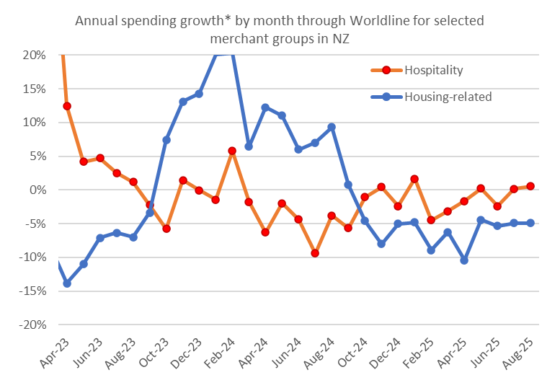
Figure 1: All Cards NZ underlying* spending annual growth through Worldline in recent months for selected NZ core retail merchants – Hospitality and Housing-related (*Underlying excludes large clients moving to or from Worldline).
“But lower interest rates should at some stage feed through to larger big-ticket sales and hence more spending at these housing-related merchants. And more tourists would be a welcome boost to the hospitality sector this summer. These will certainly be trends worth watching.”

Meanwhile in the regions, Core Retail annual spending growth for August was highest in Nelson (+7.3%), Whanganui (+6.4%), West Coast (+4.9%) and Taranaki (+4.1%), while spending declined on the same month last year in Gisborne (-1.4%), Marlborough (-0.5%) and Wellington (-0.3%).

WORLDLINE All Cards underlying* spending for CORE RETAIL merchants for August 2025
 | Value | Underlying value*
Region | transactions $millions | Annual % change on 2024
Auckland/Northland | 1,412 | 1.2%
Waikato | 312 | 3.8%
BOP | 253 | 2.1%
Gisborne | 33 | -1.4%
Taranaki | 88 | 4.1%
Hawke's Bay | 130 | 2.2%
Whanganui | 53 | 6.4%
Palmerston North | 118 | 3.5%
Wairarapa | 42 | 1.6%
Wellington | 324 | -0.3%
Nelson | 75 | 7.3%
Marlborough | 46 | -0.5%
West Coast | 26 | 4.9%
Canterbury | 453 | 1.8%
South Canterbury | 61 | 3.3%
Otago | 246 | 3.2%
Southland | 89 | 0.4%
New Zealand | 3,768 | 2.0%
Figure 2: All Cards NZ underlying* spending through Worldline in August 2025 for core retail merchants (* Underlying excludes large clients moving to or from Worldline)
- ENDS -
Note to editors:
These figures reflect general market trends and should not be taken as a proxy for Worldline‘s market share or company earnings. The figures primarily reflect transactions undertaken within stores but also include some ecommerce transactions. The figures exclude transactions through Worldline undertaken by merchants outside the Core Retail sector (as defined by Statistics NZ).

For more information, contact:
Brendan Boughen
T 027 839 6044
E brendan.boughen.external@worldline.com

ABOUT WORLDLINE IN NEW ZEALAND
We are New Zealand's leading payments innovator. We design, build and deliver payment solutions that help Kiwi business succeed. Whether you’re looking for in store, online or mobile payment solutions or powerful business insights, Worldline is here to help with technology backed by experience. www.worldline.co.nz

About Worldline
Worldline [Euronext: WLN] helps businesses of all shapes and sizes to accelerate their growth journey – quickly, simply, and securely. With advanced payments technology, local expertise and solutions customised for hundreds of markets and industries, Worldline powers the growth of over one million businesses around the world. Worldline generated a 4.6 billion euros revenue in 2024. worldline.com
Worldline’s corporate purpose (“raison d’être”) is to design and operate leading digital payment and transactional solutions that enable sustainable economic growth and reinforce trust and security in our societies. Worldline makes them environmentally friendly, widely accessible, and supports social transformation.
Press Contact
Hélène Carlander
T +33 7 72 25 96 04
E helene.carlander@worldline.com
Follow us

