September sees subdued start to the traditional end-of-year lift in consumer spending
AUCKLAND, 6 October 2025 – Consumer spending in September overall was up slightly on the same month last year, according to figures released today by Worldline NZ, but drops in key retail sectors show current conditions are still tough.

Figures released today show consumer spending recorded through all Core Retail merchants in Worldline NZ’s payments network in September 2025 reached $3.65B, which is up +1.1% on September 2024 following adjustments for merchants coming and going from the network.
Worldline NZ’s Chief Sales Officer, Bruce Proffit says while this small lift in annual growth is a positive, it masks underlying weaknesses.
“Kiwi consumers typically step up their spending in each of the last four months of the year, culminating in December as the busiest month of the year. It is early days yet so little can be said about the seasonal spend to come but we can report what is not happening yet,” he says.
“Last month we noted we would be watching housing-relating merchants and hospitality merchants for any signs that the usual seasonal pick-ups were coming in greater than usual, which would indicate a turnaround in national economic growth.
“Unfortunately, both retail sectors failed to match the month-on-month spending upticks of last September, so annual growth rates declined rather than improved. Housing-related spending – including hardware, furniture and appliance stores – was down -7.0% on last September and hospitality spending was down -1.9%,” says Proffit. (See graph below.)
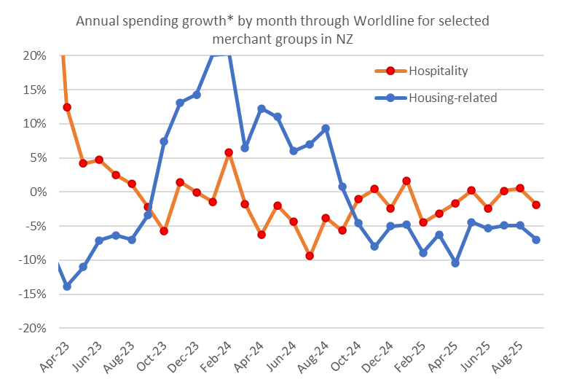
Figure 1: All Cards NZ underlying* spending annual growth through Worldline in recent months for selected NZ core retail merchants – Hospitality and Housing-related (*Underlying excludes large clients moving to or from Worldline).
“The seasonal pick-up in housing-related spending runs from August through to a December peak, so these figures show a slow start to this seasonal trading, suggesting lower interest rates have not yet influenced consumer spending.”
Proffit says the seasonal step-up in hospitality sector spending runs from October through to a December peak, with high spending then extending through to March/April.
“September precedes the international tourism season, so recent data offer little insight into what will happen next. But weak hospitality spending over the month, including in the last few days of September, suggests tourists will be welcomed more than usual by hospitality merchants this year,” he says.
Regionally, Core Retail annual spending growth for September was highest in Whanganui (+7.2%), Nelson (+4.4%) and West Coast (+4.0%), while spending declined in Gisborne (-0.5%) and Canterbury (-0.5%). Core Retail spending in the other two largest regions of Auckland/Northland (+0.0% rounded) and Wellington (+0.1%) was barely above year-ago levels.

WORLDLINE All Cards underlying* spending for CORE RETAIL merchants for September 2025
 | Value | Underlying value*
Region | transactions $millions | Annual % change on 2024
Auckland/Northland | 1,361 | 0.0%
Waikato | 306 | 3.3%
BOP | 248 | 1.1%
Gisborne | 33 | -0.5%
Taranaki | 83 | 1.4%
Hawke's Bay | 128 | 3.3%
Whanganui | 51 | 7.2%
Palmerston North | 113 | 2.4%
Wairarapa | 41 | 2.0%
Wellington | 316 | 0.1%
Nelson | 73 | 4.4%
Marlborough | 47 | 1.4%
West Coast | 26 | 4.0%
Canterbury | 443 | -0.5%
South Canterbury | 59 | 3.2%
Otago | 230 | 3.5%
Southland | 86 | 0.6%
New Zealand | 3,649 | 1.1%
Figure 2: All Cards NZ underlying* spending through Worldline in September 2025 for core retail merchants (* Underlying excludes large clients moving to or from Worldline)
- ENDS -
Note to editors:
These figures reflect general market trends and should not be taken as a proxy for Worldline‘s market share or company earnings. The figures primarily reflect transactions undertaken within stores but also include some ecommerce transactions. The figures exclude transactions through Worldline undertaken by merchants outside the Core Retail sector (as defined by Statistics NZ).

For more information, contact:
Brendan Boughen
T 027 839 6044
E brendan.boughen.external@worldline.com

ABOUT WORLDLINE IN NEW ZEALAND
We are New Zealand's leading payments innovator. We design, build and deliver payment solutions that help Kiwi business succeed. Whether you’re looking for in store, online or mobile payment solutions or powerful business insights, Worldline is here to help with technology backed by experience. www.worldline.co.nz

About Worldline
Worldline [Euronext: WLN] helps businesses of all shapes and sizes to accelerate their growth journey – quickly, simply, and securely. With advanced payments technology, local expertise and solutions customised for hundreds of markets and industries, Worldline powers the growth of over one million businesses around the world. Worldline generated a 4.6 billion euros revenue in 2024. worldline.com
Worldline’s corporate purpose (“raison d’être”) is to design and operate leading digital payment and transactional solutions that enable sustainable economic growth and reinforce trust and security in our societies. Worldline makes them environmentally friendly, widely accessible, and supports social transformation.
Press Contact
Hélène Carlander
T +33 7 72 25 96 04
E helene.carlander@worldline.com
Follow us

