Weekly consumer spending patterns are mixed heading into pre-Christmas shopping season
AUCKLAND, 6 November 2025 – As consumer spending in October 2025 rose slightly on the same month last year, figures released today by Worldline NZ show the weekly and regional patterns are mixed for retailers heading into the all-important Christmas shopping season.

Data released today show consumer spending recorded through all Core Retail merchants in Worldline NZ’s payments network in October 2025 reached $3.91B, which is up +0.3% on October 2024 following adjustments for merchants coming and going from the network.
However, Bruce Proffit, Worldline NZ’s Chief Sales Officer, says the spending patterns providing the most significant insights into retail trends at this time of year are those occurring on a weekly basis within this national monthly total.
“The weekly pattern becomes important as we head into the pre-Christmas shopping season, and it differs by groups of Core Retail merchants – and so far, those patterns are mixed.”
The graphs below show the average daily spending data for three Core Retail merchant groups using Worldline NZ’s payments network – 1) Food & Liquor, 2) Hospitality, and 3) all other Core Retail merchants – in the weeks leading up to Christmas Day in 2024, and for the same time period in 2025 so far.
“These graphs show Food & Liquor stores, including supermarkets, can likely expect a shopping frenzy in the last few days before Christmas Day, whereas the Hospitality merchants – cafés, bars, restaurants and accommodation – will likely see sales increase each week from now on, with a peak around the week before Christmas Day,” says Proffit.
“Other retail stores – where most Christmas present shopping typically happens – can expect a Black Friday sales rush at the end of November before the big spend-up in the last 7-10 days before Christmas Day,” he says.
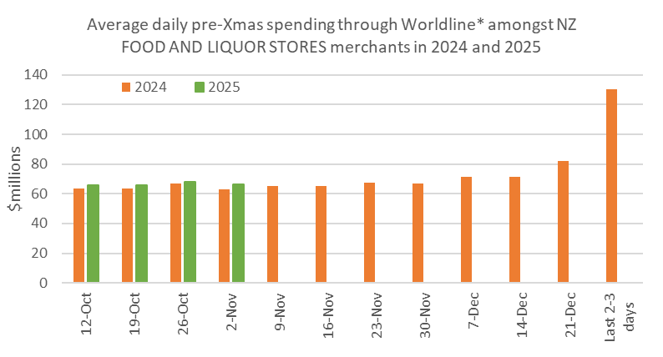
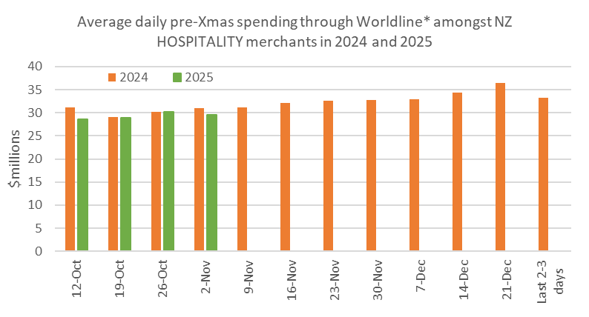
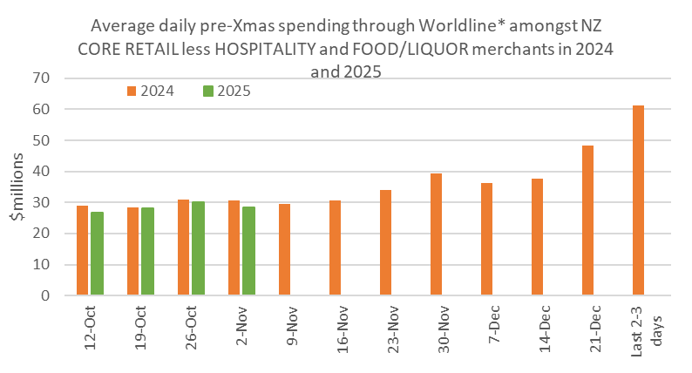
Figure 1: All Cards NZ underlying* spending annual growth through Worldline pre-Christmas for subsets of NZ core retail merchants (*Underlying excludes large clients moving to or from Worldline).
Proffit says the figures for the last four weeks show spending at Food & Liquor stores ran above year-ago levels, while Hospitality was below year-ago levels in two weeks and above in the other two weeks.
“The rest – the Core Retail merchants excluding Food & Liquor and Hospitality – have been running below year-ago levels each week,” he says.
“Weather patterns in October did have an affect on spending on a daily basis in some regions, especially on Thursday 23rd October, but stormy weather does not appear to be the major reason for the recent mixed spending patterns overall.”
Looking at the monthly figures overall shows the regional pattern was also mixed.
Annual growth of Core Retail spending in October was highest in Nelson (+4.1%) and Otago (+3.8%), while spending declined in nine regions including Wellington (-3.7%), Wairarapa (-2.7%) and Gisborne (-2.0%).
/ continues…
WORLDLINE All Cards underlying* spending for CORE RETAIL merchants for October 2025
 | Value | Underlying value*
Region | transactions $millions | Annual % change on 2024
Auckland/Northland | 1,461 | -0.1%
Waikato | 333 | 1.7%
BOP | 271 | -0.6%
Gisborne | 36 | -2.0%
Taranaki | 90 | -1.1%
Hawke's Bay | 140 | 2.9%
Whanganui | 53 | 2.3%
Palmerston North | 120 | -0.7%
Wairarapa | 44 | -2.7%
Wellington | 328 | -3.7%
Nelson | 80 | 4.1%
Marlborough | 50 | 1.4%
West Coast | 29 | -1.6%
Canterbury | 480 | 0.6%
South Canterbury | 63 | 2.3%
Otago | 237 | 3.8%
Southland | 92 | -0.1%
New Zealand | 3,911 | 0.3%
Figure 2: All Cards NZ underlying* spending through Worldline in October 2025 for core retail merchants (* Underlying excludes large clients moving to or from Worldline)
- ENDS -
Note to editors:
These figures reflect general market trends and should not be taken as a proxy for Worldline‘s market share or company earnings. The figures primarily reflect transactions undertaken within stores but also include some ecommerce transactions. The figures exclude transactions through Worldline undertaken by merchants outside the Core Retail sector (as defined by Statistics NZ).

For more information, contact:
Brendan Boughen
T 027 839 6044
E brendan.boughen.external@worldline.com

ABOUT WORLDLINE IN NEW ZEALAND
We are New Zealand's leading payments innovator. We design, build and deliver payment solutions that help Kiwi business succeed. Whether you’re looking for in store, online or mobile payment solutions or powerful business insights, Worldline is here to help with technology backed by experience. www.worldline.co.nz

About Worldline
Worldline [Euronext: WLN] helps businesses of all shapes and sizes to accelerate their growth journey – quickly, simply, and securely. With advanced payments technology, local expertise and solutions customised for hundreds of markets and industries, Worldline powers the growth of over one million businesses around the world. Worldline generated a 4.6 billion euros revenue in 2024. worldline.com
Worldline’s corporate purpose (“raison d’être”) is to design and operate leading digital payment and transactional solutions that enable sustainable economic growth and reinforce trust and security in our societies. Worldline makes them environmentally friendly, widely accessible, and supports social transformation.
Press Contact
Hélène Carlander
T +33 7 72 25 96 04
E helene.carlander@worldline.com
Follow us

