Black Friday was busy but not up on last year
AUCKLAND, 2 December 2025 – Black Friday, 28 November, was the busiest shopping day so far this year for non-food retailers transacting on Worldline NZ’s payments network, but spending on the day itself was below last year, according to figures released today.

Data released today show consumer spending recorded through the Core Retail merchants selling non-food goods in Worldline NZ’s payments network reached $55.6m on Black Friday 2025, surpassing the previous high this year of $49.1m on Easter Saturday.
However, non-food goods spending on Black Friday was -6.2% below the level of last year and was down -4.6% on last year over the three-day weekend. (Both percentages are calculated after adjusting for merchants coming and going from Worldline’s network throughout the intervening 12 months.)
Worldline NZ’s Chief Sales Officer, Bruce Proffit, says while Black Friday sales brought out many shoppers, the pattern across the weekend was consistent with spending on non-food goods, which ran below year-ago levels over other weeks of November.
“It appears that consumer budgets are still constrained at this end of the year. Clothing merchants experienced higher spending than Black Friday 2024 over the weekend but spending elsewhere was generally down,” he says.
“Across the three groups we are tracking weekly, the pattern over the month continues to show more spending at Food & Liquor stores but less at Hospitality providers and less amongst the general category of Core Retail merchants excluding Food & Liquor and Hospitality, collectively referred to as the ‘non-food goods’ retailers.
“Merchants will no doubt be hopeful for spending growth in the busier few weeks remaining before Christmas,” says Proffit.
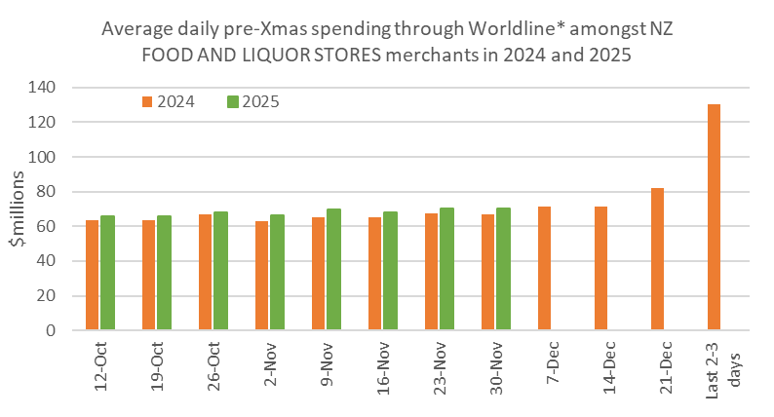
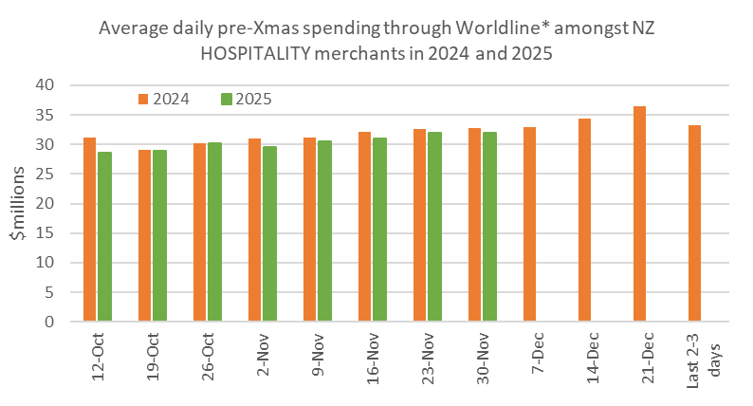
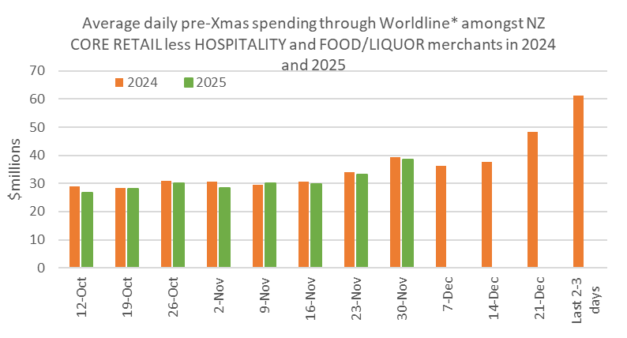
Figure 1: All Cards NZ underlying* spending per day through Worldline pre-Christmas for subsets of NZ core retail merchants (*Underlying excludes large clients moving to or from Worldline).
Across all Core Retail merchants, spending through Worldline reached $4.09B in November, which is up +1.1% on November 2024, following adjustments for merchants coming and going from the Worldline NZ payments network.
Annual growth of Core Retail spending was highest in West Coast (+6.3%), Whanganui (+5.4%) and Otago (+5.0%), while spending declined in Auckland/Northland (-0.3%), Wellington (-1.0%) and Gisborne (-1.8%).
WORLDLINE All Cards underlying* spending for CORE RETAIL merchants for November 2025
 | Value | Underlying value*
Region | transactions $millions | Annual % change on 2024
Auckland/Northland | 1,535 | -0.3%
Waikato | 343 | 3.8%
BOP | 277 | 0.2%
Gisborne | 37 | -1.8%
Taranaki | 95 | 1.9%
Hawke's Bay | 145 | 2.1%
Whanganui | 55 | 5.4%
Palmerston North | 122 | 1.9%
Wairarapa | 46 | 1.4%
Wellington | 344 | -1.0%
Nelson | 85 | 2.4%
Marlborough | 54 | 1.8%
West Coast | 32 | 6.3%
Canterbury | 502 | 1.2%
South Canterbury | 64 | 1.4%
Otago | 254 | 5.0%
Southland | 100 | 1.3%
New Zealand | 4,092 | 1.1%
Figure 2: All Cards NZ underlying* spending through Worldline in November 2025 for core retail merchants (* Underlying excludes large clients moving to or from Worldline)
- ENDS -
Note to editors:
These figures reflect general market trends and should not be taken as a proxy for Worldline‘s market share or company earnings. The figures primarily reflect transactions undertaken within stores but also include some ecommerce transactions. The figures exclude transactions through Worldline undertaken by merchants outside the Core Retail sector (as defined by Statistics NZ).

For more information, contact:
Brendan Boughen
T 027 839 6044
E brendan.boughen.external@worldline.com

ABOUT WORLDLINE IN NEW ZEALAND
We are New Zealand's leading payments innovator. We design, build and deliver payment solutions that help Kiwi business succeed. Whether you’re looking for in store, online or mobile payment solutions or powerful business insights, Worldline is here to help with technology backed by experience. www.worldline.co.nz

About Worldline
Worldline [Euronext: WLN] helps businesses of all shapes and sizes to accelerate their growth journey – quickly, simply, and securely. With advanced payments technology, local expertise and solutions customised for hundreds of markets and industries, Worldline powers the growth of over one million businesses around the world. Worldline generated a 4.6 billion euros revenue in 2024. worldline.com
Worldline’s corporate purpose (“raison d’être”) is to design and operate leading digital payment and transactional solutions that enable sustainable economic growth and reinforce trust and security in our societies. Worldline makes them environmentally friendly, widely accessible, and supports social transformation.
Press Contact
Hélène Carlander
T +33 7 72 25 96 04
E helene.carlander@worldline.com
Follow us

