Consumer spending patterns mixed as retailers approach peak pre-Christmas shopping days
AUCKLAND, 16 December 2025 – Consumer spending through the Worldline NZ’s payment network has tracked slightly below year-ago levels in the first half of December but is set to peak in the coming days – traditionally the busiest of the year – ahead of Christmas Day.

Consumer spending processed through all Core Retail merchants in Worldline NZ’s payments network during the first 14 days of December reached $2.049B, which is down -0.3% on the first 14 days of December 2024 (following adjustments for merchants coming and going from the network.)
Worldline NZ’s Chief Sales Officer, Bruce Proffit, says the busy pre-Christmas spending season has continued to show mixed growth patterns across retail sectors and regions.
“Food and Liquor stores saw more transactions and slightly higher average transaction value across almost all regions in New Zealand, apart from Marlborough, but this is expected to increase even further in the coming days as shoppers prepare for Christmas Day festivities,” he says.
“Hospitality sector spending was mixed meanwhile, with spending generally more positive outside the major centres in the first half of December. Hospitality spending is also expected to rise further this week with the likely peak day occurring on Saturday.”
Proffit says the broader group of merchants selling non-food goods are still experiencing spending in total that is below the same time last year.
Spending at Core Retail (less Hospitality and Food & Liquor) merchants totaled $0.549B in the first 14 days of December, down -5.7% from the first 14 days of December 2024 (following adjustments for merchants coming and going from the network.)
“Notably, some merchant sectors surpassed their Black Friday weekend spending peak last Saturday, including Gift stores, Toy and Games retailers, Bookshops, Marine stores, Florists and Jewelry stores,” says Proffit.
“However, almost all merchants within this group are anticipated to reach new highs for the year in the remaining days before Christmas, although spending at Clothing stores generally peaks on 26 December amidst the usual Boxing Day sales.”
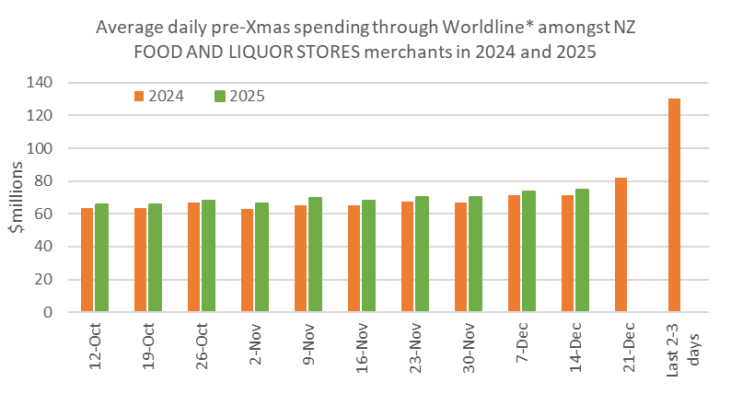
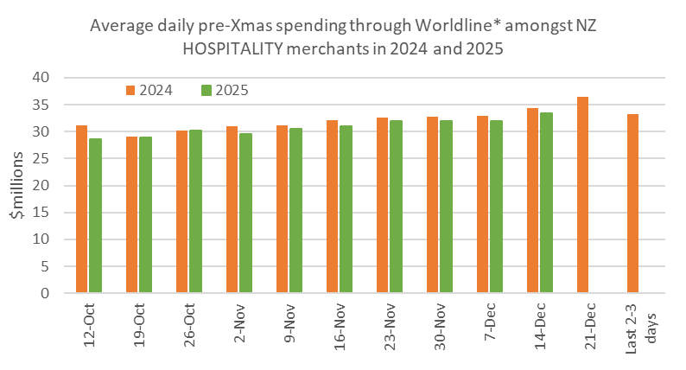
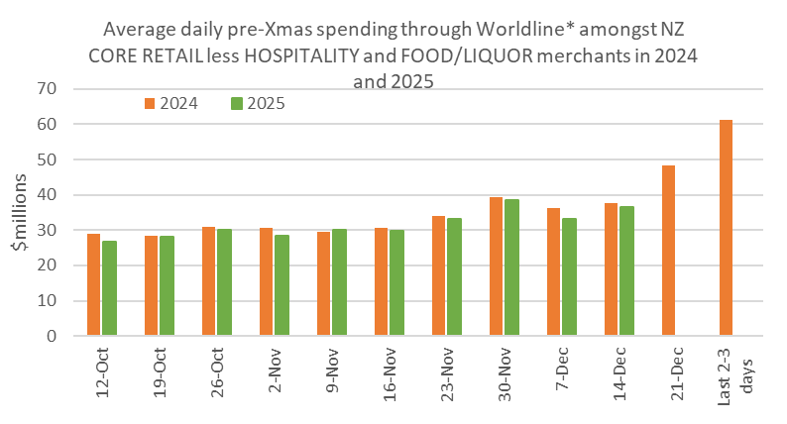
Figure 1: All Cards NZ underlying* spending per day through Worldline pre-Christmas for subsets of NZ core retail merchants (*Underlying excludes large clients moving to or from Worldline).
“As is traditional, we are expecting the peak day for total Core Retail transactions this year to be Christmas Eve, but we’ll see if that hold up in the ongoing challenging economic environment.”
Annual growth of spending at all three combined Core Retail merchant groups through Worldline NZ’s payments network in the first 14 days of December was highest in West Coast (+3.9%), Whanganui (+3.3%) and Otago (+2.9%), while spending declines were largest in percentage terms in Wellington (-4.0%) and Bay of Plenty (-2.4%).
WORLDLINE All Cards spending for all CORE RETAIL merchants for 1-14th December 2025
 | Value | Underlying*
Region | transactions $millions | Annual % change on 2024
Auckland/Northland | 771.0 | -0.2%
Waikato | 173.8 | 1.8%
BOP | 139.3 | -2.4%
Gisborne | 19.1 | -1.4%
Taranaki | 47.2 | 0.4%
Hawke's Bay | 73.6 | 0.4%
Whanganui | 28.5 | 3.3%
Palmerston North | 62.3 | 0.2%
Wairarapa | 23.0 | -1.9%
Wellington | 171.8 | -4.0%
Nelson | 42.9 | 1.3%
Marlborough | 26.8 | -1.9%
West Coast | 15.3 | 3.9%
Canterbury | 245.8 | -1.1%
South Canterbury | 32.3 | -1.1%
Otago | 125.5 | 2.9%
Southland | 49.8 | 0.1%
New Zealand | 2,049.6 | -0.3%
Figure 2: All Cards NZ underlying* spending through Worldline in 1-14th December 2025 for core retail merchants (* Underlying excludes large clients moving to or from Worldline)
- ENDS -
Note to editors:
These figures reflect general market trends and should not be taken as a proxy for Worldline‘s market share or company earnings. The figures primarily reflect transactions undertaken within stores but also include some ecommerce transactions. The figures exclude transactions through Worldline undertaken by merchants outside the Core Retail sector (as defined by Statistics NZ).

For more information, contact:
Brendan Boughen
T 027 839 6044
E brendan.boughen.external@worldline.com

ABOUT WORLDLINE IN NEW ZEALAND
We are New Zealand's leading payments innovator. We design, build and deliver payment solutions that help Kiwi business succeed. Whether you’re looking for in store, online or mobile payment solutions or powerful business insights, Worldline is here to help with technology backed by experience. www.worldline.co.nz

About Worldline
Worldline [Euronext: WLN] helps businesses of all shapes and sizes to accelerate their growth journey – quickly, simply, and securely. With advanced payments technology, local expertise and solutions customised for hundreds of markets and industries, Worldline powers the growth of over one million businesses around the world. Worldline generated a 4.6 billion euros revenue in 2024. worldline.com
Worldline’s corporate purpose (“raison d’être”) is to design and operate leading digital payment and transactional solutions that enable sustainable economic growth and reinforce trust and security in our societies. Worldline makes them environmentally friendly, widely accessible, and supports social transformation.
Press Contact
Hélène Carlander
T +33 7 72 25 96 04
E helene.carlander@worldline.com
Follow us

