Consumer spending increases again in February, as Auckland sees highest growth lift in two years
AUCKLAND, 5 March 2026 – The modest but positive consumer spending growth that was seen in January was repeated across New Zealand in the second month of 2026, according to figures released today by Worldline NZ, while the Auckland/Northland region saw its largest lift in annual spending growth in 24 months.

Consumer spending processed through all Core Retail merchants in Worldline NZ’s payments network during February 2026 reached $3.686B, which is up +2.2% on February 2025, following adjustments for merchants coming and going from the network.
As part of this, the Auckland/Northland region registered a lift of +2.8% in spending in February 2026 compared to February 2025 – the most year-on-year growth that the region has seen in a single month in nearly two years.
Worldline NZ’s Chief Sales Officer, Bruce Proffit, says it is encouraging to see the positive consumer spending trend that began at the start of the year continuing into February.
“While the annual growth rate is relatively low and spending did not increase across all sectors and regions, it’s still heartening to see that total spending is up at this point of the year, and, most notably, up in New Zealand’s largest region,” he says.
Proffit notes the spending pattern during 2025 was generally one of modest growth in the South Island and outside of the major cities in the North Island, while – conversely – spending in the Auckland/Northland (-0.5%) and Wellington (-1.8%) regions declined in February last year.
“Noticeably so far this year, the South Island pattern remains similar, although Wellington spending is still below year-ago levels. Waikato remains one of the fastest growth regions and its spending level surpassed that of Wellington – not by much, but for the third month in a row.”
Annual growth rates for Core Retail spending through Worldline NZ’s payments network in February 2026 was highest in Palmerston North (+4.5%), Otago (+3.8%) and Waikato (+3.7%), while spending declines from last February were highest percentage-wise in Wairarapa (-2.3%) and Gisborne (-1.7%).
WORLDLINE All Cards underlying* spending for CORE RETAIL merchants for February 2026
 | Value | Underlying value*
Region | transactions $millions | Annual % change on 2025
Auckland/Northland | 1,346 | 2.8%
Waikato | 307 | 3.7%
BOP | 250 | 0.3%
Gisborne | 32 | -1.7%
Taranaki | 85 | -1.0%
Hawke's Bay | 132 | 2.7%
Whanganui | 49 | 0.1%
Palmerston North | 110 | 4.5%
Wairarapa | 41 | -2.3%
Wellington | 303 | -0.5%
Nelson | 83 | 3.4%
Marlborough | 52 | -0.6%
West Coast | 35 | 2.4%
Canterbury | 450 | 2.6%
South Canterbury | 59 | 1.7%
Otago | 252 | 3.8%
Southland | 96 | 2.2%
New Zealand | 3,686 | 2.2%
Figure 1: All Cards NZ underlying* spending through Worldline in February 2026 for core retail merchants (* Underlying excludes large clients moving to or from Worldline)
Meanwhile, as happens in February every year, consumer spending on flowers and jewellery spiked in the days before and including Valentine’s Day although overall spending was down on last year, with wet weather likely a factor in dampening romantic retail spirits across the nation.
Total spending through florist and watch/jewellery merchants in Worldline NZ’s payments network was $4.8m over the two days ending Saturday 14th February, which was down -14.5% on the same two days in February 2025.
The following graph showing the regional growth split for these merchants suggests Southland and Palmerston North were the regions with most love in the air – or money in the tills, comparatively – around Valentine’s Day 2026.
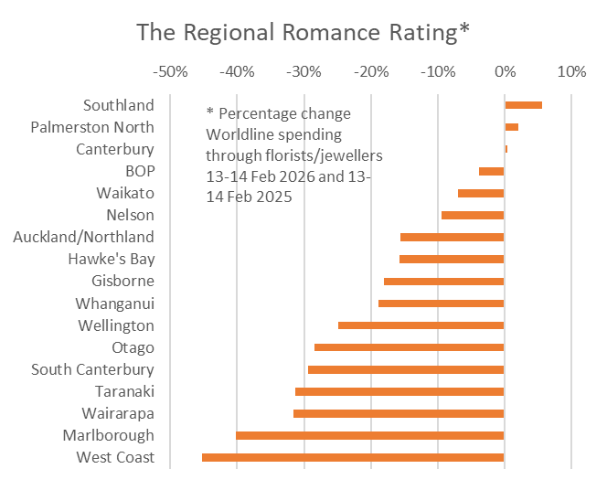
Figure 2: All Cards NZ underlying* spending through Worldline 13-14th February 2026 versus 13-14th 2025 for florist and watch/jewellery merchants (* Underlying excludes large clients moving to or from Worldline)
- ENDS -
Note to editors:
These figures reflect general market trends and should not be taken as a proxy for Worldline‘s market share or company earnings. The figures primarily reflect transactions undertaken within stores but also include some ecommerce transactions. The figures exclude transactions through Worldline undertaken by merchants outside the Core Retail sector (as defined by Statistics NZ).

For more information, contact:
Brendan Boughen
T 027 839 6044
E brendan.boughen.external@worldline.com

ABOUT WORLDLINE IN NEW ZEALAND
We are New Zealand's leading payments innovator. We design, build and deliver payment solutions that help Kiwi business succeed. Whether you’re looking for in store, online or mobile payment solutions or powerful business insights, Worldline is here to help with technology backed by experience. www.worldline.co.nz
ABOUT WORLDLINE
Worldline [Euronext: WLN] is Europe's leading operator of critical infrastructure and payment services. With a presence across the entire value chain, the Group offers its customers unique expertise in processing and securing their payments, thereby promoting their growth. Worldline is leveraging its 2030 strategic plan and its technological innovation capabilities to build the European reference payment partner for merchants and financial institutions. With over 1.2 million customers, Worldline achieved €4bn in revenue in 2025. worldline.com
Worldline’s corporate purpose (“raison d’être”) is to design and operate leading digital payment and transactional solutions that enable sustainable economic growth and reinforce trust and security in our societies. Worldline makes them environmentally friendly, widely accessible, and supports social transformation.
Press Contact
Virginie Bonnet
T: +33 6 18 70 72 12
E: virginie.bonnet@worldline.com
or teamworldline@taddeo.fr

Follow us

