9 December 2013

Mission Statement
To help Kiwi businesspeople and householders make informed financial decisions by discussing the economy in a language they can understand.
Subscribe here.
http://feedback.bnz.co.nz/forms/lFdYSs5FGEq4kAjP95uzTA

Good Optimism And Spending Intentions

Our monthly BNZ-Nine Rewards Consumer Trends Survey has found a continued high level of optimism about the economy going forward and firm spending intentions in what is probably a seasonal jump. A net 30% of the 550 respondents are optimistic about the economy, little changed from 35% last month and 29% in October. A net 47% plan boosting spending in the coming month. This sounds strong, but of course heading into Christmas it is only natural that consumers will plan to spend more than they spent in November. Therefore this month we asked a special question.

Do you plan spending more or less on Christmas presents than last year?

Of the 550 responses 86 said More, 177 Less, and 287 Same, making a net 17% planning to spend less this Christmas shopping period than last year. This result suggests that retailers need to be cautious in their expectations for sales this year and especially take care when listening to daily or weekly reports on electronic transactions numbers and values as December progresses. These data have a historical tendency to over-state what is really happening.

Do You Expect The Economy To Be In Better Or Worse Shape In A Year’s Time?

There has been a slight decline in sentiment this month to a net 30% optimistic about the economy from 35% last month. The result to this question has moved in a tight range since we introduced it in July and we interpret this as meaning consumers have not received either large negative or positive shocks to their sentiment in recent times. The theme has been one of things getting better essentially.
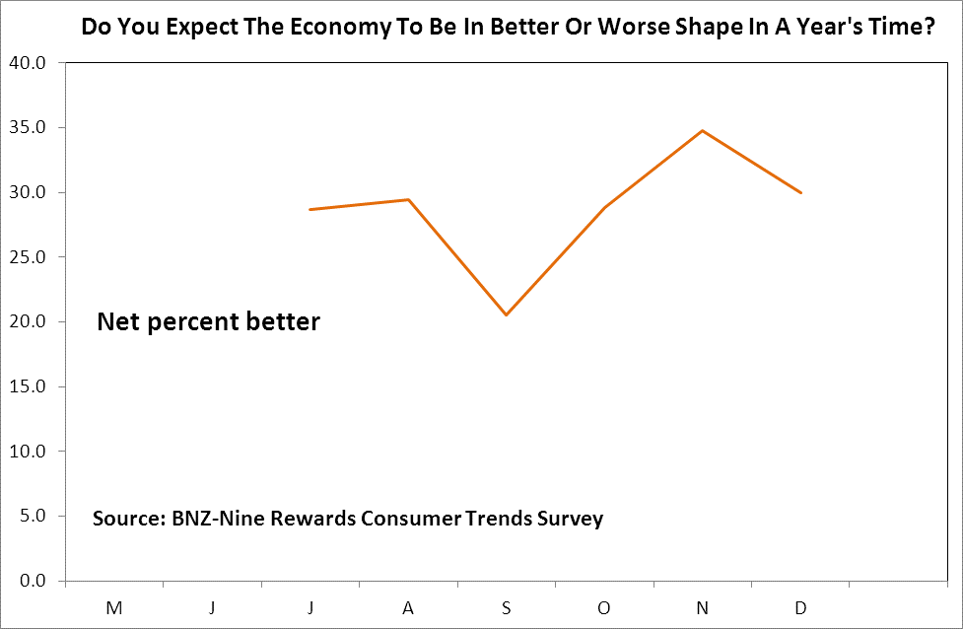

In The Coming Month Do You Think You Will Spend More or Less Than Usual?

A clear seasonal effect is at work in the response to our main question regarding whether people intend spending more or less. A net 47% of the 550 respondents say they plan spending more than usual. But given that the answer to the question above regarding whether people intend spending more or less than last Christmas is a firm negative, one suspects people are comparing planned December spending with spending in November. At least the net 47% response tells retailers their sales will be up this month!
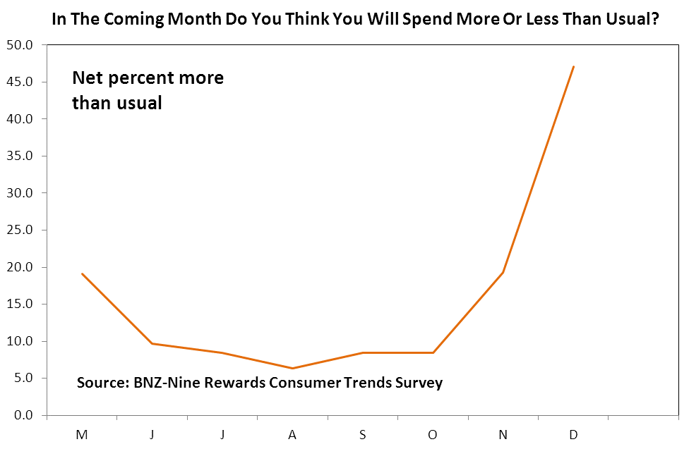

Are you thinking about buying a new car within the next 3 months?

A net 15.3% of respondents plan buying a car soon. This response is little changed from earlier months and says that while people may be lifting spending for Christmas they are not going to be splashing out on cars for their loved ones.
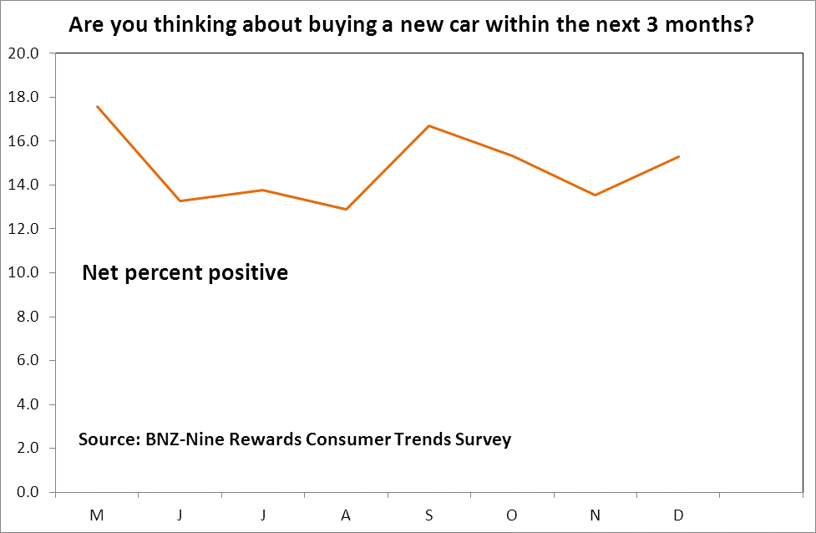

Are you thinking about buying new furniture and/or appliances within the next 3 months?

The response to this question has been trending upward since July and this is the sort of thing we economists look at to see whether people are truly confident about the future. When they are then spending on durable goods such as appliances goes up. If people are quite hesitant and don’t lift such spending then we question how strong overall growth will be. The responses to this question boost our confidence about NZ domestic growth accelerating next year.
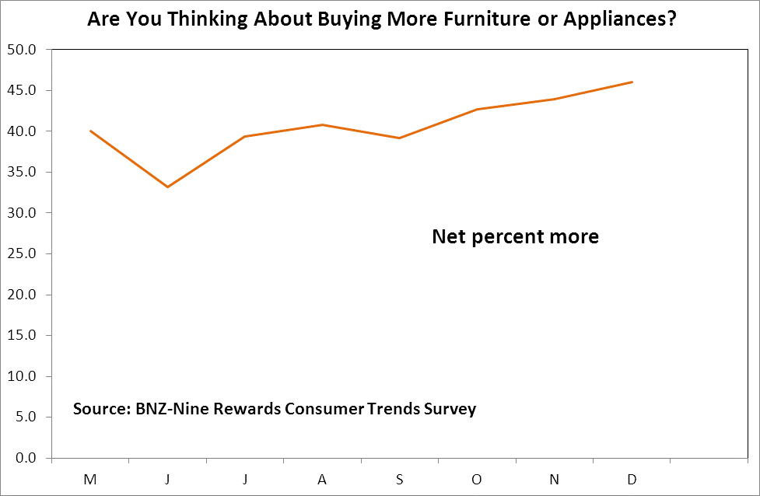

Are you planning to take an overseas holiday in the coming year?

The response to this question has been amazingly steady at a net 44%-45% positive since July.
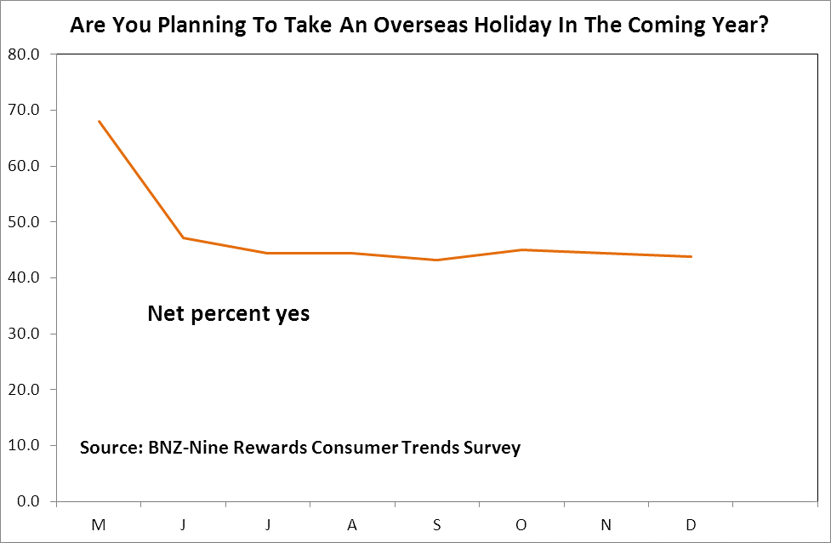

Are you thinking about buying more clothing and accessories within the next 3 months?

A net 80% of respondents plan buying more clothing and accessories in the next three months. There is a mild upward trend in this measure.
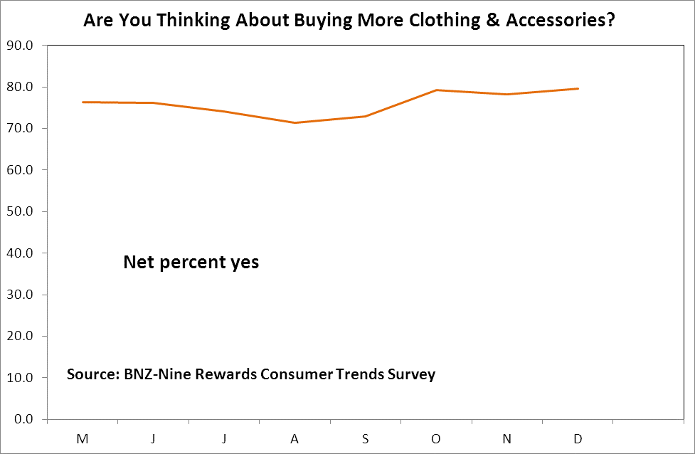

What do you think you will be doing with your debt in the next six months?

Consumers are still planning to reduce their debt levels but there is no trend toward easing off or lifting the pace of debt reduction.
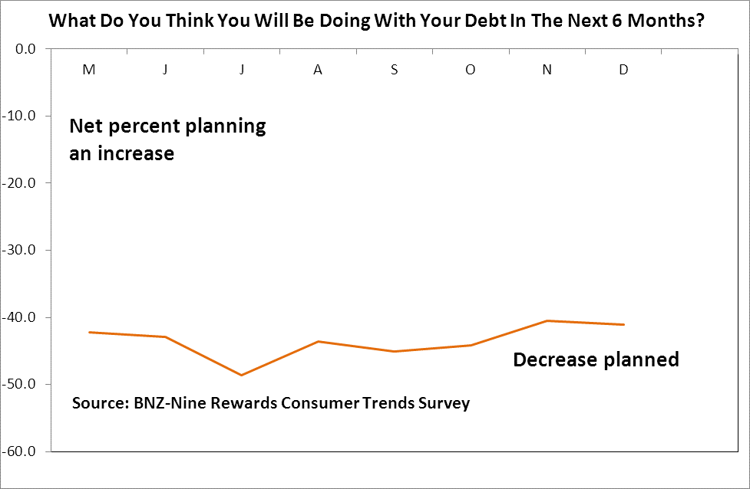

Are you thinking about buying an investment property within the next 3 months?

A net 5.6% of survey respondents are thinking about buying an investment property. The important result we take from the complete absence of any trend in this measure is that the Reserve Bank’s loan to value ratio rule has not caused an obvious large backing off of investors – or attracted a new lot in.
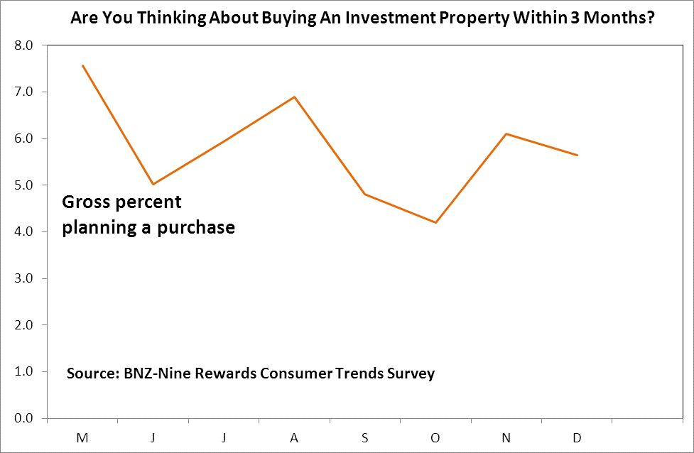

In what direction do you think house prices in your area will move in the next 12 months?

A net 55% of respondents expect house price rises. This is down slightly from 57% in November and 65% in October. Maybe this then is some evidence of price expectations easing extremely slightly at best following introduction of the LVR rule.
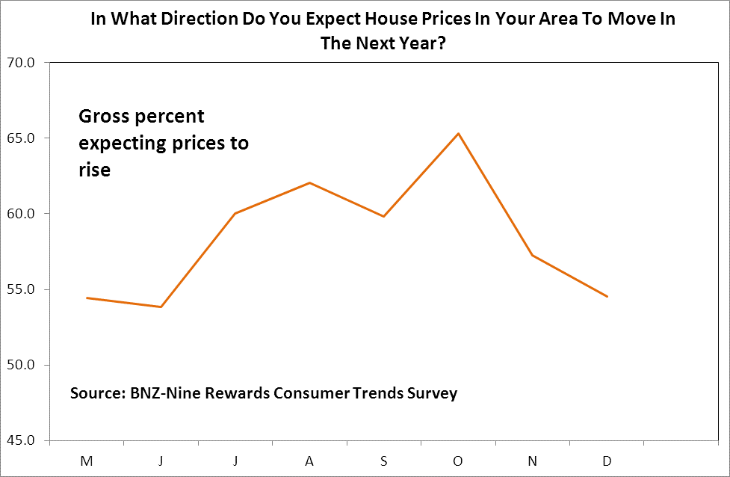

How much do you think house prices will rise by in your area in the next 12 months?
-Answer from those expecting prices to rise.

The average price rise expected is 4.3% and statistically-speaking the responses look essentially the same since we started our survey in May. There is a hint though of a slight backing off in this month’s survey as for the first time expectations have eased for two months in a row rather than just going up and down in a regular saw-tooth fashion.

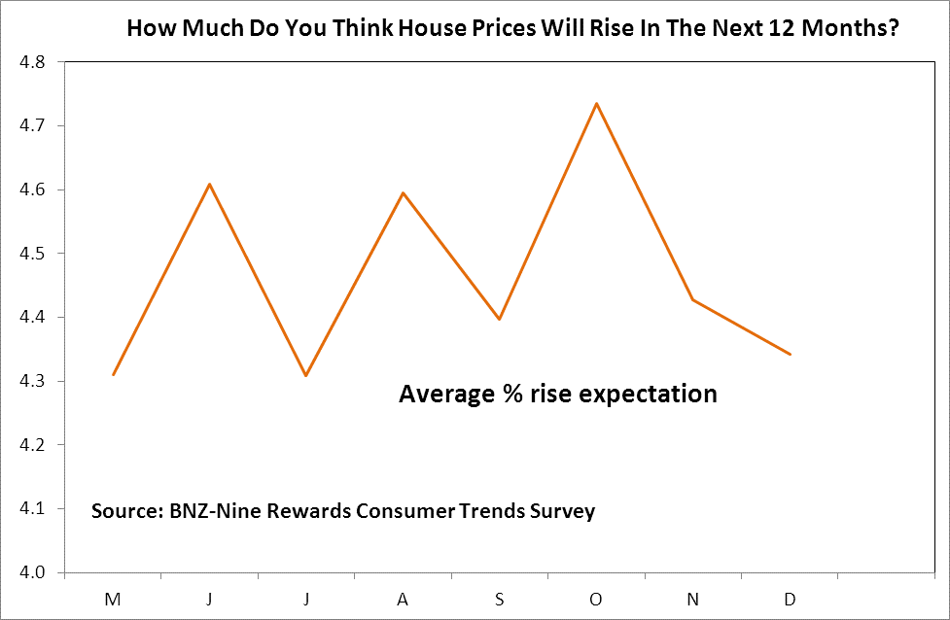

How much do you think house prices will fall by in your area in the next 12 months?
-Answer from those expecting prices to fall.

42 people expect house prices to fall and their average expectation is 3.8%.
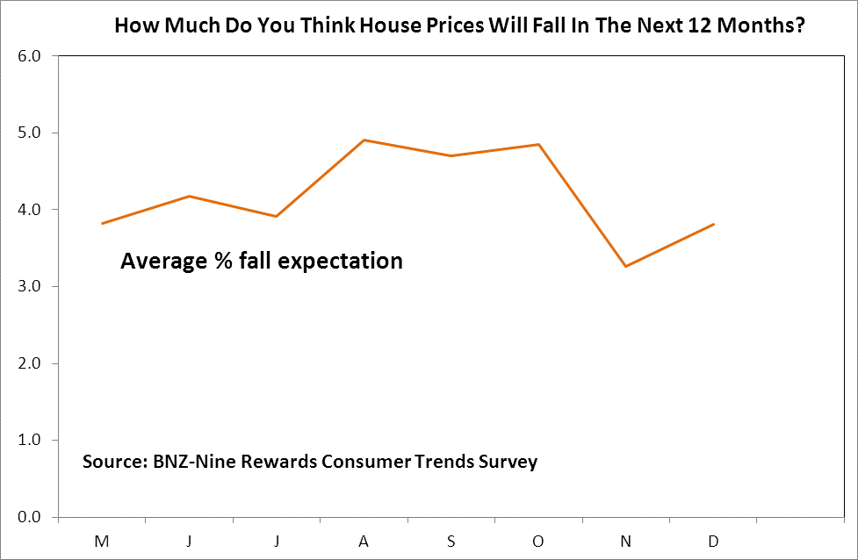

Would you like to earn more money by working more hours each week?

There is no trend rise or fall underway in the proportion of people wanting to get more work. This measure will be interesting to watch next year as the unemployment rate drops. Will more people enter the workforce to accept the jobs employers will be increasingly offering?

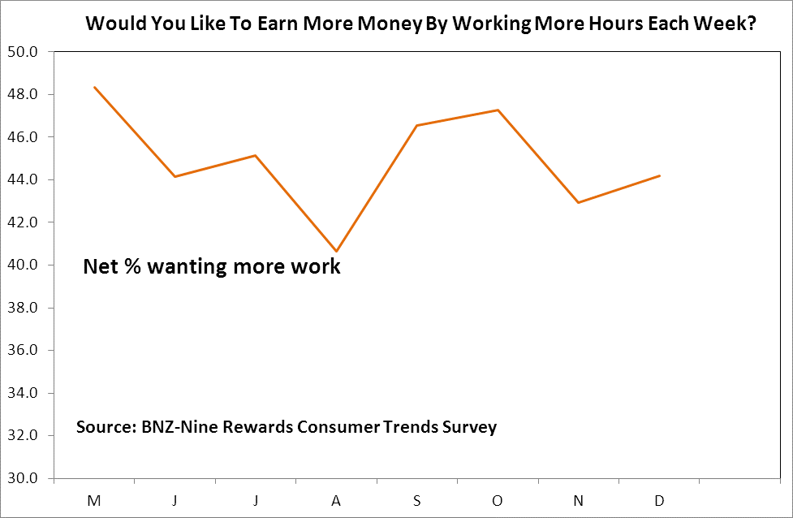

Are you finding jobs or extra hours of work becoming more or less readily available?

A net 24% of survey respondents say that they are finding work less readily available. This is a deterioration from a net 20% in November and our interpretation of this measure is that the labour market is not yet improving by enough for most people to notice it.
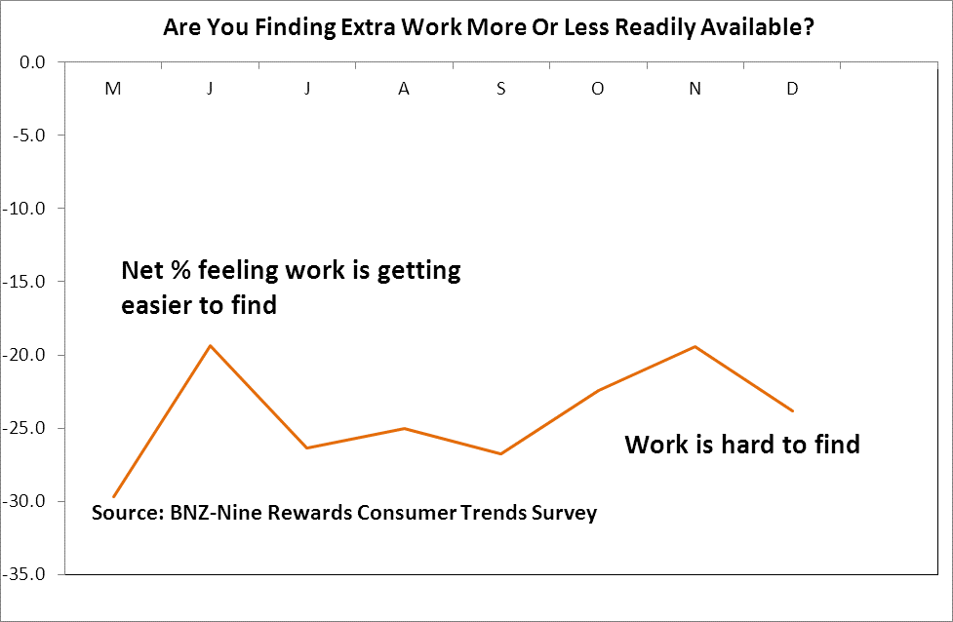

Are you thinking about shifting overseas within the next 12 months?

We are hoping that this measure will give us early warning of the turning in the migration cycle between New Zealand and Australia. The number of Kiwis going across the ditch has been declining since September last year but at some stage the attractions of Australia will again loom large in people’s minds and numbers leaving will cycle back the other way. For now we see no trend change in this measure of people’s intention to leave NZ and live anywhere overseas.
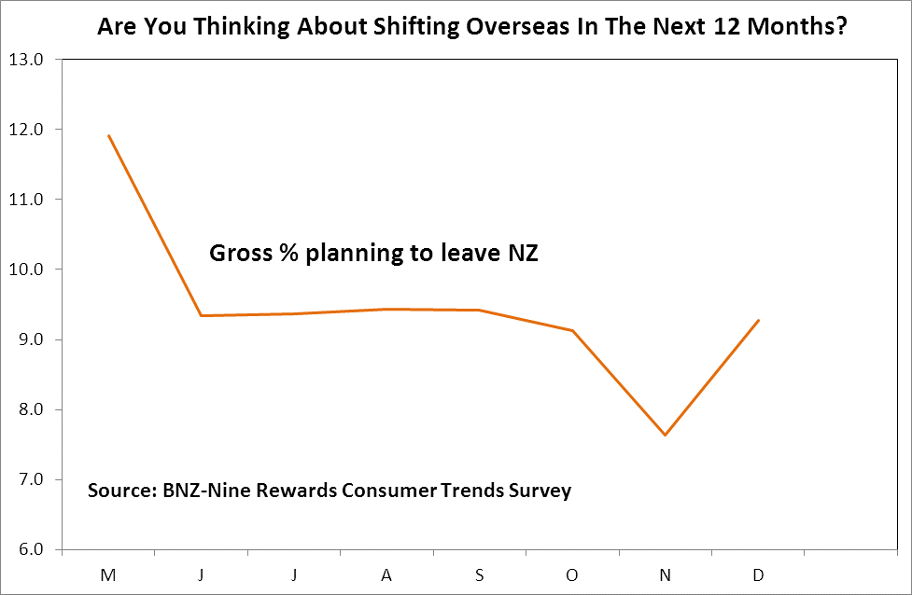

Data Table

Sample A B C D E F G H I J K L M N
size Net Spend Car Furniture Travel Clothing Debt Invest House % rise % fall Work Jobs Leave
Optimism Prices around NZ
May 530 19 18 40 68 76 -42 8 54 4 4 48 -30 12
June 557 10 13 33 47 76 -43 5 54 5 4 44 -19 9
July 523 29 8 14 39 44 74 -49 6 60 4 4 45 -26 9
August 551 29 6 13 41 44 71 -44 7 62 5 5 41 -25 9
September 521 21 8 17 39 43 73 -45 5 60 4 5 47 -27 9
October 548 29 8 15 43 45 79 -44 4 65 5 5 47 -22 9
November 524 35 19 14 44 44 78 -40 6 57 4 3 43 -19 8
December 550 30 47 15 46 44 80 -41 6 55 4 4 44 -24 9

A Do you expect the economy to be in a better or worse shape in a year’s time?
B In the coming month do you think you will spend more or less than usual?
C Are you thinking about buying a new car within the next 3 months?
D Are you thinking about buying new furniture and/or appliances within the next 3 months?
E Are you planning to take an overseas holiday in the coming year?
F Are you thinking about buying more clothing and accessories within the next 3 months?
G What do you think you will be doing with your debt in the next six months?
H Are you thinking about buying an investment property within the next 3 months?
I In what direction do you think house prices in your area will move in the next 12 months?
J How much do you think house prices will rise by in your area in the next 12 months?
K How much do you think house prices will fall by in your area in the next 12 months?
L Would you like to earn more money by working more hours each week?
M Are you finding jobs or extra hours of work becoming more or less readily available?
N Are you thinking about shifting overseas within the next 12 months?

Results By Region

Regions supplying fewer than 20 respondents are not reported. Optimism is low in the Bay of Plenty with a high net 53% of respondents reporting that they are seeing fewer job opportunities but interestingly a far smaller percentage of people planning to repay debt than in other regions. A net 69% of Aucklanders expect house prices to rise as do a net 72% of Cantabrians.

Sample A B C D E F G H I J K L M N
size Net Spend Car Furniture Travel Clothing Debt Invest House % rise % fall Work Jobs Leave
Optimism Prices around NZ
Auckland 159 33 60 18 53 50 81 -41 8 69 5 3 50 -18 9
Bay of Plenty 19 11 42 26 42 47 74 -11 5 26 3 3 53 -53 5
Canterbury 96 22 41 11 46 42 82 -40 3 72 5 3 31 -16 8
Gisborne 3
Hawkes Bay 20 10 45 20 15 40 60 -65 5 50 4 1 40 -35 5
Manawatu-W 30 33 53 17 47 47 80 -50 3 47 3 5 40 -37 3
Marlborough 3
Nelson 5
Northland 12
Otago 16
Southland 7
Taranaki 11
Tasman 1
Waikato 43 37 51 14 47 44 86 -53 12 26 3 6 42 -35 14
Wellington 123 38 41 18 46 45 80 -38 3 46 3 4 49 -24 12
West Coast 2
All NZ 550 30 47 15 46 44 80 -41 6 55 4 4 44 -24 9

With regard to the question regarding whether people plan spending more or less than last Christmas, the results are Auckland -18%, Bay of Plenty -16%, Canterbury -14%, Hawkes Bay 0%, Manawatu-Wanganui -17%, Waikato -9%, Wellington -22%. The results to note are greater than average plans to cut spending in Wellington but plans to spend as much as last year in Hawkes Bay.

Results By Gender

December Survey
Sample A B C D E F G H I J K L M N
Size Net Spend Car Furniture Travel Debt Invest House % rise % fall Work Jobs Leave
Optimism Clothing Prices around NZ
Male 270 42 42 17 48 44 76 -40 6 55 4 4 43 -12 10
Female 280 19 52 13 44 43 84 -43 6 54 4 4 45 -35 9
ALL 550 30 47 15 46 44 80 -41 6 55 4 4 44 -24 9

Do you plan spending more or less on Christmas presents than last year? Males -8%, females -17%. Females are planning far greater Christmas restraint than males.

November Survey
Sample A B C D E F G H I J K L M N
Size Net Spend Car Furniture Travel Debt Invest House % rise % fall Work Jobs Leave
Optimism Clothing Prices around NZ
Male 264 49 17 14 46 48 74 -42 6 61 4 3 43 -7 8
Female 260 20 22 13 42 41 83 -39 6 53 4 3 43 -32 7
ALL 524 35 19 14 44 44 78 -40 6 57 4 3 43 -19 8

Results By Age

December survey
Sample A B C D E F G H I J K L M N
size Net Spend Car Furniture Travel Clothing Debt Invest House % rise % fall Work Jobs Leave
Optimism Prices around NZ
18-24 39 38 44 41 64 46 90 -21 5 62 3 3 82 -44 18
25-29 48 29 60 19 56 42 85 -46 6 40 4 2 63 -40 23
30-34 61 48 52 16 51 56 92 -46 7 56 4 3 51 -16 11
35-39 57 14 68 19 47 47 89 -56 9 51 4 5 47 -21 12
40-44 64 38 58 17 58 31 78 -38 3 63 4 3 48 -22 14
45-49 62 -3 18 10 40 47 81 -58 3 45 5 2 31 -11 5
50-54 72 21 47 11 43 44 76 -40 13 63 5 6 36 -22 7
55-59 37 27 41 11 35 30 81 -41 11 57 5 4 46 -41 5
60-64 56 39 41 9 36 46 73 -39 0 50 5 8 34 -32 0
65yrs+ 54 56 41 7 31 44 54 -19 0 59 4 5 20 -6 0
All 550 30 47 15 46 44 80 -41 6 55 4 4 44 -24 9

November survey
Sample A B C D E F G H I J K L M N
size Net Spend Car Furniture Travel Clothing Debt Invest House % rise % fall Work Jobs Leave
Optimism Prices around NZ
18-24 52 29 21 15 44 40 94 -6 4 67 4 16 87 -38 13
25-29 44 30 32 30 59 55 93 -32 7 50 4 4 59 -25 16
30-34 50 54 30 22 54 64 82 -58 14 56 4 3 44 -20 18
35-39 39 8 21 8 36 31 77 -51 3 74 5 1 41 -31 8
40-44 69 33 28 17 48 26 78 -35 6 52 4 2 43 -23 7
45-49 59 36 12 2 39 41 76 -58 10 59 5 2 32 -14 2
50-54 68 34 21 12 47 47 75 -50 6 44 4 3 32 -19 4
55-59 38 32 21 11 37 45 71 -55 8 71 6 1 37 -16 8
60-64 50 44 10 8 40 50 74 -42 2 48 4 4 38 -4 2
65yrs+ 55 42 0 13 33 51 64 -22 2 62 5 3 22 -7 2
All 524 35 19 14 44 44 78 -40 6 57 4 3 43 -19 8

Do you plan spending more or less on Christmas presents than last year?

18-24 -8%
25-29 -35
30-34 -8
35-39 -26
40-44 -19
45-49 -21
50-54 -14
55-59 -27
60-64 -7
65yrs+ -4
All -17

For further information contact Tony Alexander, Chief Economist, tony.alexander@bnz.co.nz www.tonyalexander.co.nz 04 474-6744, 029 609-8960

The BNZ-Nine Rewards Consumer Trends Survey is run in the last week of each month.

Real People, Real Insights
Nine Rewards is an online market research panel that provides wide coverage and depth of sample across Australia and New Zealand. Large, active panels – 75,000 members in New Zealand (est. 2011) and 1.4 million in Australia (est. 2007) – and a unique multi-channel recruitment source ensures diverse coverage of all demographic groups and interests and limited cross-over with other panels.

For more information visit our website – www.ninerewards.com or email for a quote on your next project - diana.marini@ninerewards.com

This publication has been provided for general information only. Although every effort has been made to ensure this publication is accurate the contents should not be relied upon or used as a basis for entering into any products described in this publication. To the extent that any information or recommendations in this publication constitute financial advice, they do not take into account any person’s particular financial situation or goals. Bank of New Zealand strongly recommends readers seek independent legal/financial advice prior to acting in relation to any of the matters discussed in this publication. Neither Bank of New Zealand nor any person involved in this publication accepts any liability for any loss or damage whatsoever which may directly or indirectly result from any advice, opinion, information, representation or omission, whether negligent or otherwise, contained in this publication.

