14 October 2013

Mission Statement
To help Kiwi businesspeople and householders make informed financial decisions by discussing the economy in a language they can understand.

LVR Rules Slam First Home Buyers But Investors Less Affected

There has been a substantial change in sentiment recorded in our monthly BNZ-REINZ Residential Market Survey. Almost all measures have registered substantial declines including the proportion of agents noticing more first home buyers in the market. This has fallen to a net 41% saying fewer are around which is the first neative result for this series, down from a net 24% noticing more first home buyers in September, and well below the average of 31%.
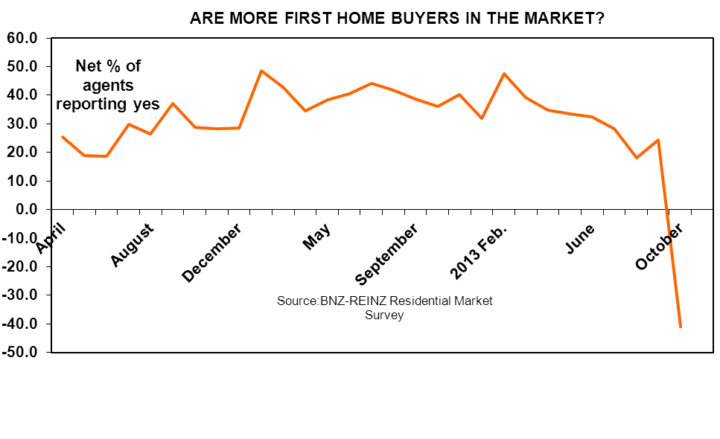
The net percent of agents noticing more investors has remained positive but fallen to 9% from 26% in September. Clearly the minimum deposit rules introduced by the Reserve Bank have had an impact mainly on first home buyers – but nonetheless a net 41% of agents still perceive that prices are rising. The average for this reading is 32% and September’s result was 51%.

A net 11% of agents feel that it remains a seller’s market, down from 30% last month but still above the 8% average.

Our survey results from this month’s 420 respondents shows that the residential real estate market has lost momentum. The question now is how quickly it will regain it.

Is the number of people going through Open Homes increasing or decreasing?

Weakest recorded

A net 16% of responding agents this month said they they are seeing fewer people going through Open Homes. This is a strong sign of cooling activity and the weakest result on record. But as for the other measures we will comment on below the question is really how much of this is a knee-jerk response to the LVR changes, quick bank alterations to pre-approvals, increases in low equity premiums etc., and how much will be sustained?

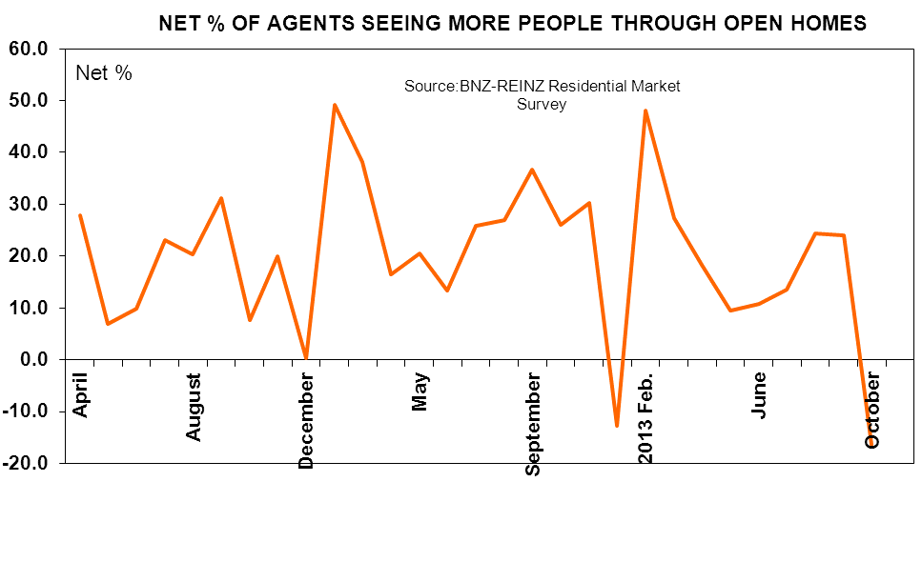
Is the proportion of Written Sales going unconditional increasing or decreasing?

Down

Only a net 9% of agents report that more sales are going Unconditional. This is still a positive result though the weakest since May 2011.

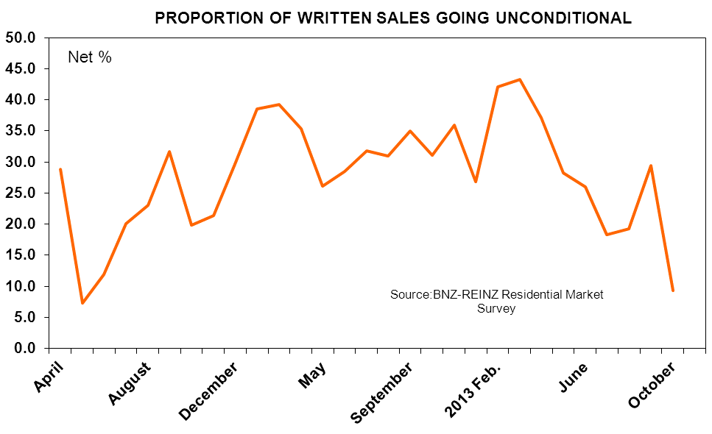

Are auction clearance rates increasing or decreasing?

Weak clearance

A net 2% of responding agents say they auction clearance rates have declined – thus somewhat calling into question the claims that cashed up Chinese have been huge buyers at auctions. Were that the case then changes to LVR rules would have had no noticeable effect on auction clearance rates.

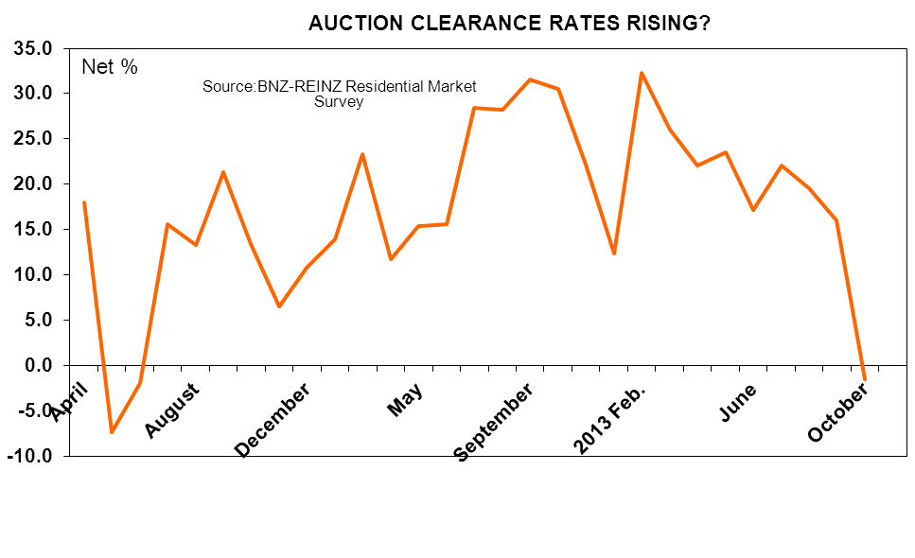

Are requests for appraisals increasing or decreasing?

Down a tad

A net 12% of respondents report that they have received more requests for appraisals. This is down slightly from September’s net 21% but not as much of a decrease as recorded for our demand-side focussed measures.

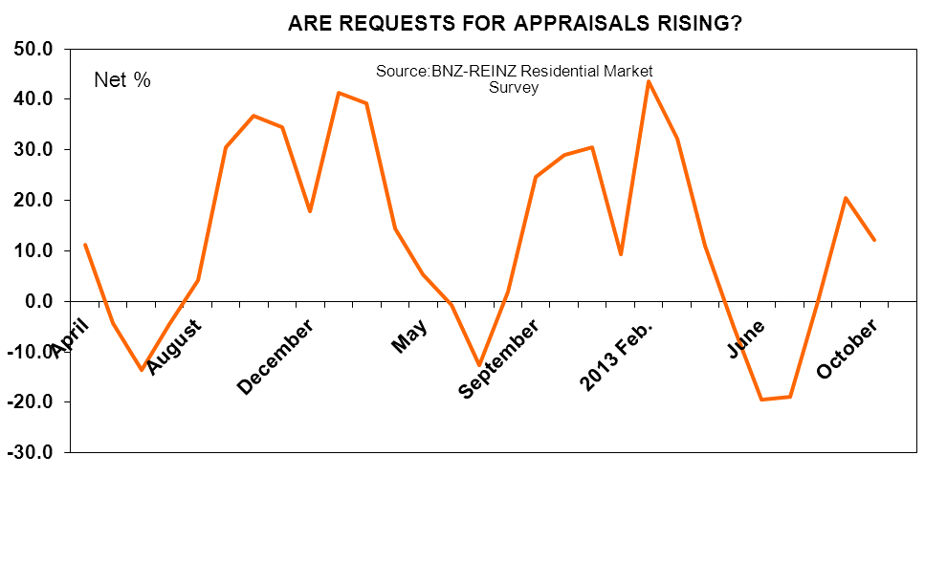
Is the number of investors looking to buy increasing or decreasing?

Down but not out

Some investors have clearly pulled back from the market with a net 9% of agents this month noting they are seeing more in the marketplace compared with a net 26% in September. The decline is much less than for first-home buyers.

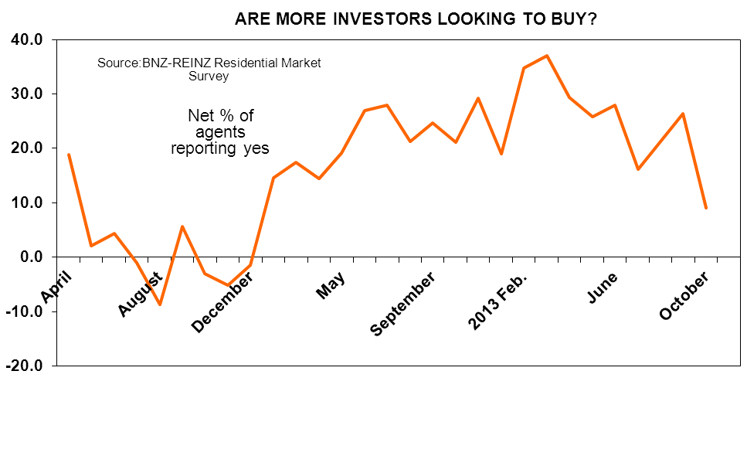
Is the number of first home buyers increasing or decreasing?

Collapse

This measure has plummeted. This month a net 41% of agents say that they are seeing fewer first-home buyers in the market compared with a net 24% who last month said that they were seeing more. This is the weakest and only negative result since our survey started in April 2011. Will it be sustained? Probably not once first-home buyers get used to the new rules, as each month makes more qualify for the new minimum deposit rules, as more and more find alternative finance sources each month, and as some shift their purchasing focus to parts of New Zealand other than Christchurch and Auckland.

Do prices appear to increasing, flat or decreasing?

Minor change

If the Reserve bank had been hoping that the LVR rule canges would have a substantial impact on house price expectations then they will be very disappointed. While our demand measures have fallen sharply there has been only a minor reduction in agent perceptions of where prices are going to a net 41% seeing prices rising this month from 51% in September. The average reading is 32%. Price rises are seen as continuing.

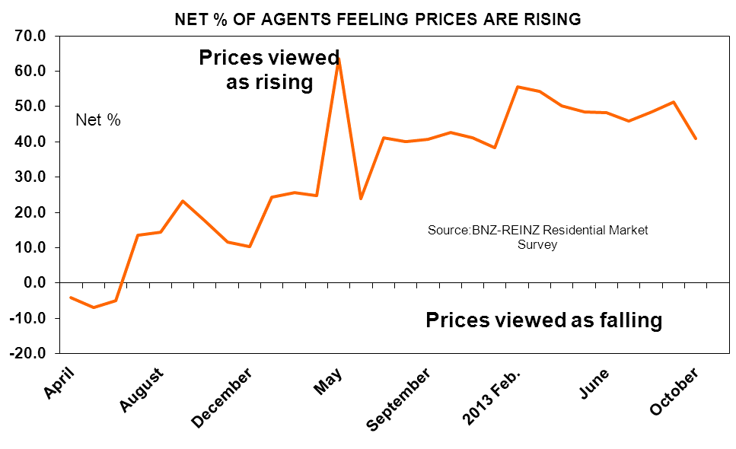

Who appear more motivated to transact – the buyers or the sellers?

Seller’s market persists

A net 11% of agents report that they feel buyers are more motivated to transact than sellers. This is down from 30% in September but still above the 8% average.

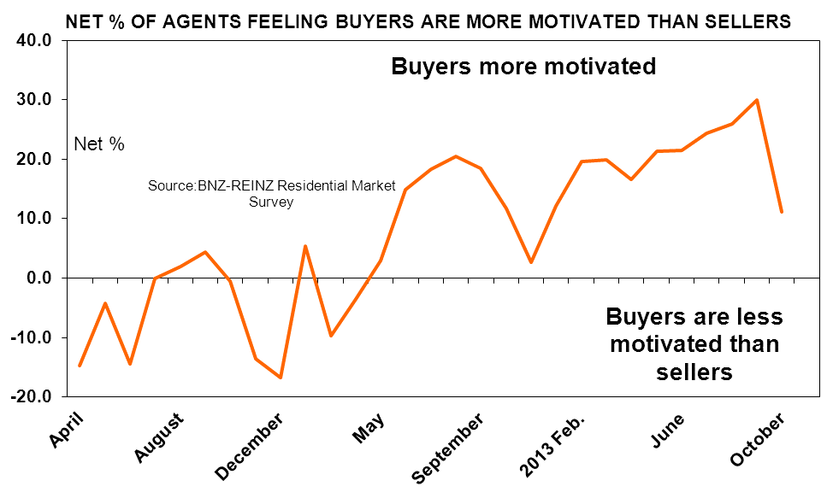
If you operate outside Auckland, are you finding the number of buyers shifting from Auckland increasing or decreasing?

Evidence of buyers looking outside Auckland

There has been a slight rise in the net percent of agents outside Auckland who say they are seeing more buyers coming in from our biggest city. But at 39.3% the result is in line with those of recent months including September’s 38.8%.

DATA TABLE
# of . # of people % of Written Auction Requests Investors First Prices Buyers more Akld
Responses through Sales Clearance for buying home motivated? Buyers?
Open Unconditional rate Appraisals buyers
Homes
April 2011 312 27.9 28.8 17.9 11.2 18.9 25.3 -4.1 -14.7
May 190 6.8 7.4 -7.4 -4.2 2.1 18.9 -6.8 -4.2
June 635 9.8 11.9 -1.9 -13.6 4.4 18.7 -4.9 -14.5
July 742 23.0 20.1 15.6 -4.4 -0.9 29.8 13.5 -0.1
August 498 20.2 23.0 13.3 4.2 -8.6 26.5 14.4 2.0
September 561 31.2 31.7 21.4 30.5 5.7 37.1 23.2 4.5
October 600 7.7 19.8 13.4 36.8 -3.0 28.8 17.7 -0.5
November 486 20.0 21.4 6.5 34.6 -5.1 28.2 11.5 -13.6
December 435 0.2 29.7 10.7 17.9 -1.4 28.5 10.3 -16.8
2012 Feb. 392 49.2 38.5 13.9 41.3 14.5 48.5 24.2 5.4
March 362 38.1 39.2 23.3 39.2 17.4 42.8 25.7 -9.7
April 339 16.5 35.4 11.7 14.5 14.5 34.5 24.8 -3.5
May 414 20.5 26.1 15.4 5.3 19.1 38.4 63.6 2.9
June 256 13.3 28.5 15.5 -0.8 27.0 40.6 23.8 14.8
July 333 25.8 31.8 28.4 -12.6 27.9 44.1 41.1 18.3
August 485 27.0 30.9 28.3 1.9 21.2 41.9 40.0 20.4
September 429 36.6 35.0 31.6 24.7 24.7 38.7 40.8 18.4
October 289 26.0 31.1 30.6 29.1 21.1 36.0 42.6 11.8
November 367 30.2 36.0 22.1 30.5 29.2 40.3 41.1 2.7
December 421 -12.8 26.8 12.4 9.3 19.0 31.8 38.2 12.1
2013 Feb. 572 48.0 42.1 32.3 43.6 34.7 47.5 55.5 19.5
March 355 27.2 43.3 26.0 32.3 37.1 39.3 54.2 19.9
April 500 18.2 37.1 22.1 11.0 29.4 34.8 50.2 16.6
May 549 9.5 28.2 23.5 -5.1 25.9 33.5 48.5 21.3
June 439 10.7 26.0 17.2 -19.4 28.0 32.3 48.3 21.4
July 377 13.5 18.3 22.1 -18.8 16.2 28.4 45.9 24.4 42.4
August 253 24.4 19.3 19.5 0.0 21.3 18.1 48.4 26.0 35.3
September 418 23.9 29.4 16.0 20.6 26.3 24.4 51.2 29.9 38.8
October 420 -16.4 9.3 -1.5 12.1 9.0 -41.0 41.0 11.2 39.3

REGIONAL RESULTS

We report results where at least 20 responses (almost) have been received for a region. Interest from first home buyers has fallen sharply in all regions we have reported on below. Investor demand is still firm in Canterbury and Waikato. Prices are widely perceived to be rising.

# of . # of people % of Written Auction Requests Investors First Prices Buyers more Akld
Responses through Sales Clearance for buying home motivated? Buyers?
Open Unconditional rate Appraisals buyers
Homes
Northland 19 11 11 -6 26 16 -37 32 -16 53
Auckland 164 -28 7 -10 19 15 -43 51 29
Waikato 38 -3 13 19 16 24 -34 45 16 63
Bay of Plenty 35 -23 17 7 3 -6 -57 26 3 47
Hawkes Bay/Gisborne 16
Taranaki 11
Manawatu/Wanganui 17
Wellington 41 2 0 -5 5 -10 -49 39 -24 21
Nelson/Marl. W. Coast 15
Canterbury 37 -22 -3 32 8 24 -35 65 14 8
Otago 21 -10 19 0 -10 14 -38 33 38 14
Southland 6
All 420 -16.4 9.3 -1.5 12.1 9.0 -41.0 41.0 11.2 39.3

For further information contact Tony Alexander, Chief Economist, tony.alexander@bnz.co.nz www.tonyalexander.co.nz

The BNZ-REINZ Market Survey is run (usually) on the first Tuesday of the month after the first Thursday. In the email sent to REINZ member email addresses respondents are asked to click on a URL which takes them to a survey site. Respondents are asked if they feel various measures of real estate market activity are increasing or decreasing and to identify various factors in play influencing buyer and vendor behaviour. Results are collated within 2-3 days and this report is distributed to all BNZ Weekly Overview recipients, REINZ members, and the media.

This publication has been provided for general information only. Although every effort has been made to ensure this publication is accurate the contents should not be relied upon or used as a basis for entering into any products described in this publication. To the extent that any information or recommendations in this publication constitute financial advice, they do not take into account any person’s particular financial situation or goals. Bank of New Zealand strongly recommends readers seek independent legal/financial advice prior to acting in relation to any of the matters discussed in this publication. Neither Bank of New Zealand nor any person involved in this publication accepts any liability for any loss or damage whatsoever which may directly or indirectly result from any advice, opinion, information, representation or omission, whether negligent or otherwise, contained in this publication..

