Media Release

Embargoed until 5:00am Tuesday 9 February 2021

Property market continues to sizzle over summer

**Monday 8 February 2020**

The QV House Price Index data has just been released showing the average value increased 6.27% nationally over the past three-month period, up from the 5.35% quarterly growth we saw in December, with the average value now sitting at $838,826. This represents an increase of 15.11% year-on-year, an increase from annual growth of 11.24% last month.

QV General Manager David Nagel said: “The major urban centres continue to show strong gains in value over the past three months, with Tauranga and Palmerston North leading the way with 10.46% and 9.19% growth respectively.”

“The larger centres were generally first to show the rapid value growth and this was primarily driven by both first-home buyers and investors competing for the very limited supply of entry-level housing stock. But the market strength has now spread to the higher value locations in the major centres as confidence returns in the post-lockdown economic recovery,” he says.

“The rapid and sustained residential value growth has compounded affordability problems, making it difficult for first-home buyers to put together a deposit in the bigger cities. This appears to be the main impediment for first-home buyers entering the market,” he says.

“With the return of LVR speed limits in March this year, we may see a gradual cooling of the market in the second half of 2021, particularly in the entry-level locations as property investors reach their credit limits and first-home buyers struggle to raise a deposit. But with the long-term forecast for housing demand in New Zealand looking positive, it is difficult to see the market take a significant turn for the worse any time soon,” says Mr Nagel.

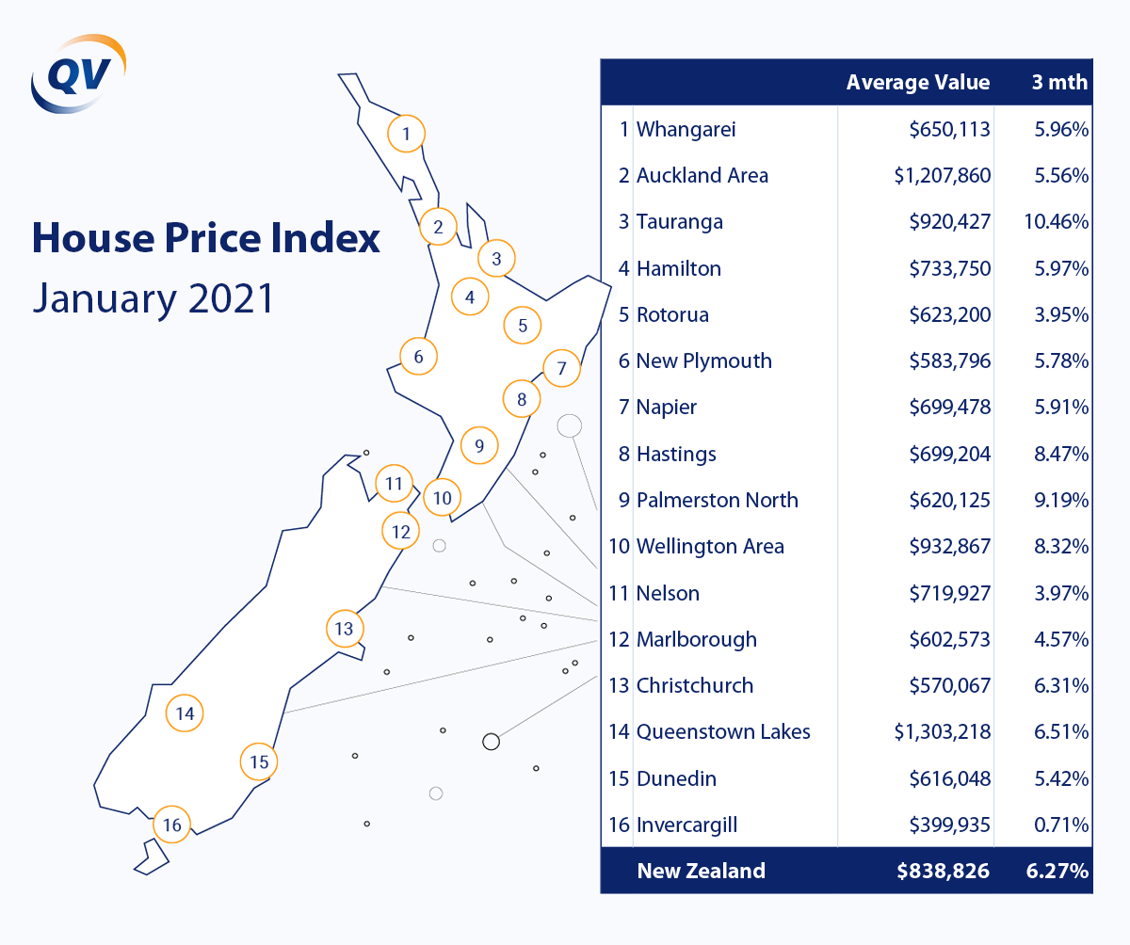

**Auckland**

Auckland residential property prices have picked back up from where they left off last year, posting a rise of 2.1% in January 2021 and an increase of 5.56% for the quarter. The average value for the region is now $1,207,860.

The biggest gains this quarter were made over on the North Shore, where prices have shot up 6.15% in three months to a new average of $1,380,811. It was followed by Auckland central (5.99%), Manukau (5.63%), Rodney (5.47%), and Franklin (5.45%).

Only Franklin ($774,789), Papakura ($817,699), and Waitakere ($961,841) currently have average residential property values below $1m. Auckland city has the highest average residential property price at $1,423,833, followed by North Shore ($1,380,811), Rodney ($1,096,822) and Manukau ($1,061,285).

QV senior consultant Rupert Yortt commented: “We are seeing good levels of value growth across the entire market with the amount of demand favouring sellers heavily at present.”

“Auckland investors are also continuing to make their presence felt − although the LVRs may stem this throughout 2021. In more rural and semi-rural locations, such as Huapai and Kumeu, the market is a bit more steady with many listings being by negotiation, rather than auction, which is dominating the central areas.”

“At the lower end of the market, we are seeing auctions being brought forward and very short listing periods,” Mr Yortt added.

Meanwhile, Auckland properties with development potential continue to be snapped up at a rapid rate, with the Te Atatu Peninsula currently being a hot spot for redevelopment sites.

**Whangarei**

The average house value in New Zealand’s northernmost city is now $650,113 − up 5.96% for the quarter and 2.27% in one month alone.

QV property consultant Jeff Robinson said the Whangarei market had gotten even hotter in December and January with a marked increase in property values for every suburb. “This was the result of lack of available listings coupled with heavy demand for all types of residential and lifestyle properties. Until the number of listings increases, I expect values to continue to increase.

“Likewise, the rental market has also seen vastly increased demand coupled with a lack of available houses and flats to rent. This has resulted in a marked increase in rent.”

**Tauranga**

The Christmas holidays took little or no steam out of Tauranga’s hot residential property market. House prices here have shot up a whopping 10.46% this quarter to a new average price of $920,427.

Property consultant Derek Turnwald said there continued to be a large presence of first-home buyers in the market. With low stock and prices rising rapidly, these buyers are having to compromise on location and the condition of the dwelling to get into the market.

“There is still a sentiment of FOMO (fear of missing out) which is creating very strong demand in all value ranges and in all suburbs,” he said. “Auctions and open homes continue to be very well attended and bids or offers are well above vendor expectations.”

Mr Turnwald said section prices in Papamoa and Pyes Pa were rising rapidly, with some people paying for a place on a priority list for home builds. “Builders cannot bring house-and-land packages to the market fast enough as demand outstrips supply.”

Fortunately, he said the number of consents for new builds was “well above previous years”. Building work would likely continue to “boom” in Tauranga as a result.

**Hamilton**

Residential property prices continue to rise rapidly in Hamilton, where the average house value has climbed 5.97% over the past three months to $733,750.

At 6.83% growth for the quarter, house prices in South West Hamilton have risen the most, followed by the North West (6.63%) and South East (5.71%). Interestingly, value growth has been considerably lower in central Hamilton (2.98%) − less than half as much as in the North West.

The average house price remains highest in the North East ($837,102), followed by Hamilton central ($728,348). The lowest average house price value is $614,103 in the South West.

Property consultant Jarrod Hedley commented: “Values continue to increase throughout the region with agents reporting good turnouts at open homes and multiple offers being tabled on a high majority of applicable properties. There is also strong demand for development properties that are in central locations.”

Looking ahead, he said the market showed no signs of cooling down during the early part of 2021. “We’re currently seeing no signs of the market slowing. While current market conditions persist, continued demand will outweigh any possible slowing of the market.”

**Rotorua**

Much was made of Rotorua’s stark prospects as a result of Covid-19 related border closures, and yet the city’s residential property prices have soared 15.52% over the past 12 months, including a substantial 3.95% for the quarter.

Rotorua’s average house price crossed the $600,000 mark for the first time in January, reaching $623,200. “It wasn’t that long ago that many were predicting the market would drop – now we’re looking at double-figure annual growth and an average price of more than $600,000,” said local property consultant Derek Turnwald.

“All the key drivers of the residential market over the past six months or more are still present – low interest rates, FOMO, and a shortage of stock – so therefore that the market will not likely be too different to 2020. The Government has signalled a desire to cool the residential market, so we’ll have to wait and see what it has in mind.”

**New Plymouth**

New Zealand’s red-hot residential property market shows no signs of slowing down in New Plymouth, where prices have shot up 15.31% over the past 12 months and 5.78% this quarter. The new average value of a home here is $583,796.

QV property consultant Andrew Jaques said the local residential property market was very active in New Plymouth, Stratford, and in South Taranaki. “Agents, mortgage brokers and bank lenders in the region all report to be very busy. There is a shortage of listings in new Plymouth currently, and as a result agents are experiencing a very fast turnaround time of just a few days from listing to sale.”

**Hawke’s Bay**

House prices have surged across the Hawke’s Bay region over the past 12 months. In Hastings, the average house price increased by 21.04% in 12 months and 8.47% this quarter to $699,204; in Napier, it went up 15.66% in 12 months and 5.91% this quarter to $699,478.

At its current trajectory, it looks as though Hastings will soon overtake Napier. Local QV property consultant Nicola Waldon commented: “Hastings has certainly picked up in comparison to Napier. That lower end of the market has moved significantly and it’s hard to find much under $500k.”

“The market here is hot − although it’s been a bit quieter through January, which is typical of the holiday period. There still seems to be plenty of demand and no sign of prices falling off with such low supply levels.”

**Palmerston North**

Residential property investors will likely be pleased to note that house prices have shot up 23.13% over the past 12 months in Palmerston North. First-home buyers, on the other hand, will be less impressed with a new average house price of $620,125 and 9.19% growth this quarter alone.

Property consultant Olivia Roberts commented: “The local market is going from strength to strength and is showing no signs of slowing in the short term. Real estate agents are reporting increased demand with multiple offers being received, and some properties being listed on the market for only a week before selling.”

However, she warned that prices could still be affected by a range of factors, including further restrictions on lending, regulations or economic conditions related to Covid-19.

**Wellington**

The residential property market remains hot in the Wellington region, where QV’s latest house price index shows property prices have increased by 8.32% this quarter and a whopping 21.26% over the last 12 months.

The average house price across the region is $932,867 − though the average value is obviously higher in Wellington City ($1,044,244), where house prices climbed 7.59% this quarter. The biggest gains, however, were in Porirua (10.49%), Hutt City (9.14%), and Upper Hutt (8.18%).

Senior consultant David Cornford said the Wellington market’s strong finish to 2020 had continued on through the early part of 2021. “There is an extreme shortage of property on the market right now and those properties that do get listed are selling quickly. In Lower Hutt, for instance, it takes around 20 days to sell, down from an average of 30 days or more.”

“In a rising market like we’re experiencing right now, home owners are more reluctant to place their property on the market as there is potential to miss out on future capital gains; this is one factor contributing to the low number of listings throughout the region.”

With strong buyer demand throughout the region, Mr Cornford said value increases would likely continue in the first quarter of 2021.

**Nelson**

Nelson has seen strong lifts in values over the past 12 months with low interest rates, lack of supply and returning Kiwis all helping to put upward pressure on residential property prices. The average price of a home is now $719,927 – that’s 3.97% higher than it was three months ago, and 9.46% higher than it was the year before.

QV senior property consultant Craig Russell said the local market was seeing strong demand across the board. “Motueka in particular has seen extremely strong growth, with the greatest demand being for central properties on larger family sections in the $500,000-650,000 range.

“Entry-level homes in Nelson South and Toi Toi have seen strong competition with first-home buyers and investors competing. This is likely to get even more competitive as investor activity appears to be increasing, fueled by low interest rates and weak term deposit rates.”

Given the amount of competition in the market currently, he said purchasers without pre-approval finance or who stipulate numerous conditions were often missing out to purchasers who could make cash offers.

**Christchurch**

Christchurch residential property values have increased by 11.8% year-on-year to the end of January 2021 and by 6.31% over the past three months.

The average value of a residential property in the Garden City is now $570,067 − though the average value is considerably higher in the city’s northwestern suburbs ($787,756), where house prices have increased by 6.87% this quarter.

But the biggest gain was out on the peninsula, where prices have shot up 10.91% in just three months. The next biggest quarterly increase in the average residential house price occurred in East Christchurch (8.6%), with the smallest occurring in West Christchurch (3.57%).

QV Senior Consultant Kris Rogers commented: “The Christchurch market continues to gain momentum in this past month alone. Agents are reporting record numbers at open homes with many properties selling via auction if they reach their auction date.

“It has been an unprecedented past 12 months and where we go from here is not clear, but if the market continues at this rate, Christchurch will soon lose its status as the country’s most relatively affordable urban centre. Low interest rates continue to fuel the market, with many investors finding it relatively easy to come up with a 30% deposit given the latest period of equity growth.”

Meanwhile, the Waimakariri and Selwyn districts continued to experience good growth this quarter with increases of 4.22% and 4.52% respectively. But Waimate was the strongest performing town in the Canterbury region with 7.24% growth for the quarter.

**Dunedin**

Dunedin’s hot residential property market is showing no signs of slowing down during the early part of 2021. The city’s average house price has increased by 5.42% this quarter to $616,048.

The biggest rise was in Dunedin South, where values have increased by 6.76% this quarter to a new average of $582,312, followed by the peninsula and coast, where the average house price has grown 5.63% to $556,479.

QV area manager Tim Gibson commented: “Dunedin’s red-hot property market is being sustained by a general shortage in housing stock together with low interest rates. High demand and value growth is causing buyers to look for more affordable housing in suburbs and towns further afield. There is high demand for residential land for new dwellings, with more marginal land now being seen as attractive.

“Only time will tell how much steam the reintroduction of loan-to-value ratios (LVRs) will take out of the property market. I suspect it will probably cool things down a little, but we’ll still be left with too much demand and not enough houses, and that should keep upward pressure on prices for the foreseeable future.”

**Queenstown Lakes**

Queenstown’s residential property market seems to have sprung back into life, following a difficult year that saw the closure of New Zealand’s borders to tourists. Its average house value has increased by 9.68% over the last six months and 6.51% this quarter to $1,303,218. The 12-month average is 4.72%.

QV Property Consultant Greg Simpson commented: “The local market has generally rebounded quickly from lockdown with growth in market volume that few commentators were expecting. Property management firms report that the residential tenancy market has now stabilised. Rental levels appear to have also found a stable equilibrium.

“There continues to be varying views and predictions from economic commentators, local government and real estate agencies on how the property market will perform in the coming months. Market conditions are currently subject to higher potential for change and there is significant market uncertainty.”

He said the current low interest rate environment will likely continue to support local and nationally based purchasers. However, any new lending for refinance or new purchases is being strictly assessed by loan managers with income for debt servicing paramount.

**Invercargill**

The average residential house value in New Zealand’s southernmost city climbed just 0.71% this quarter to $399,935 − though property prices remain 9.35% higher than the same time last year.

QV property consultant Andrew Ronald said there had been strong demand for all property types in Invercargill throughout 2020, despite a great deal of uncertainty surrounding Covid-19 and the future of the aluminium smelter at Tiwai Point.

“Buyers have been predominantly locals and first-home buyers – although the latter part of 2020 saw increasing investor activity given favourable returns compared to other parts of the country,” he said. “The highest demand has been for affordable properties within the $250,000 to $450,000 range.”

**Provincial centres, North Island**

Ruapehu leads the provincial centres on the North Island this month, with house prices shooting up 7.05% in January alone. Next was Stratford and Thames-Coromandel, with both areas recording 5.93% growth over the month.

On a macro scale, residential property prices increased by an impressive 32.2% over the last 12 months in South Wairarapa. Ruapehu and Whanganui experienced almost as much growth at 29.6% and 28.48% respectively.

**Provincial centres, South Island**

In the South Island, Gore was top of the charts – the southern town’s average property price surged 6.54% in a single month. Southland District followed close behind on 5.77% for the month. Buller rounds out our top three at 4.67%.

In terms of value growth over a 12-month period, Gore is once again at the top of the list at 20.06%. It’s followed closely by Buller (19.82%), with Clutha in third place at 16.93%.

**Ends**