**Media Release**

**13 May 2015**

**April asking prices jump $25,000 to new record high**

The average asking price for a home in New Zealand soared to $539,750 in the three months to April, more than $25,000 higher than a month ago and the highest month-on-month rise recorded in the past five years.

Average asking prices are now over 35 per cent higher than they were in 2010, according to the Trade Me Property Price Index’s analysis of new listings over the past three months.

Auckland continues to be the powerhouse of the property market with a 16 per cent annual rise in average asking prices, up to yet another all-time high of $740,600.

Head of Trade Me Property Nigel Jeffries said it wasn’t all about Auckland though, with all three major metropolitan regions posted new record highs in asking price: with Wellington (+4.3% to $458,750) and Canterbury (+11.3 per cent to $468,000) joining Auckland.

“Regions outside the largest regions are also picking up steam with Taranaki, Bay of Plenty, Hawke’s Bay, Northland and Canterbury each delivering asking price growth in excess of $30,000 year-on-year,” he said.

The largest rise across the regions was in Taranaki, up 25 per cent ($74,850) in the past 12 months to $380,550 in April. In Hawke’s Bay, asking prices were up by 9 per cent ($34,100) over the past year to $398,050 in April.

Mr Jeffries said there appeared to be an “ever-growing confidence” in vendors’ expectation of price appreciation, with 12 regions showing growth of over 5 per cent in the past year, and only Otago in decline.

Otago continues to be the weakest across the country, down 2.6 per cent over the past year, its third consecutive dip. In the past 12 months the average asking price in the region has fallen by $10,750 from $411,300 to $400,550.

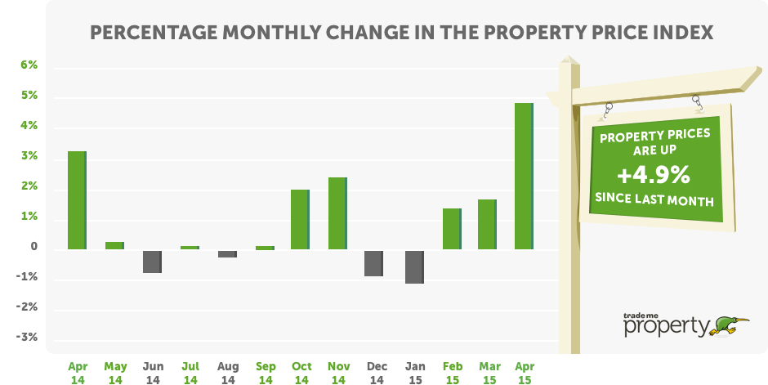

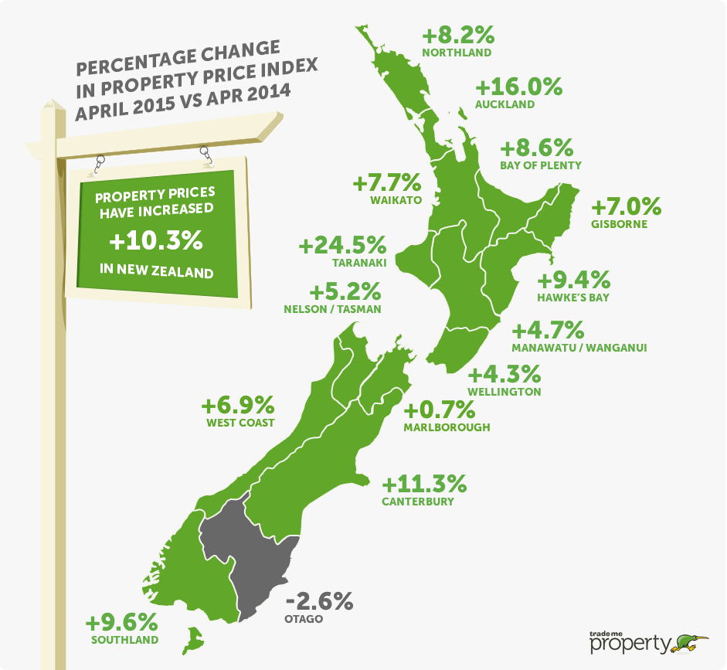

**Price expectation for larger houses takes off**

Medium-sized houses constitute the majority of homes on the market and drive overall market activity. In April, the average asking price for 3-4 bedroom homes again reached a new record high – $545,050, up 9.9 per cent compared to a year ago.

Asking price expectations for larger homes which comprise around 10% of all listings in the past three months have ramped up too. Across the country, the average asking price for one of these homes is now up more than 13 per cent since April 2014 or $112,650.

In Auckland, the asking price for 5+ bedroom homes has risen by $189,150 in the past year, up 19.1 per cent from $988,700 in April 2014 to $1,177,850 in April 2015.

The asking price expectation for smaller homes continues to reflect the strong demand in the property-tight Auckland market, rising 17 per cent in the past year to $569,500 – with price expectations up $82,750 over the past year.

*Table 1: Truncated mean expected sales price by property size & region*

|  |  |  |  |  |
| --- | --- | --- | --- | --- |
|  | New Zealand | Auckland | Wellington | Christchurch |
| Large houses 5+ bedrooms | $955,850 + 13.4% | $1,177,850 + 19.1% | $739,000 + 8.0% | $761,800 - 2.7% |
| Medium houses  3-4 bedrooms | $545,050 + 9.9% | $761,950 + 15.8% | $474,300 + 3.0% | $499,150 + 9.8% |
| Small houses  1-2 bedrooms | $359,300 + 12.2% | $569,500 + 17.0% | $328,350 + 4.4% | $326,150 + 9.7% |
| All property types | **$539,750 + 10.3%** | **$740,600 + 16.0%** | **$458,750 + 4.3%** | **$468,250 + 9.9%** |

**Auckland apartment market delivering more in price appreciation than rents**

Mr Jeffries said the Auckland apartment market continued to “power on”, reflective of a strong supply pipeline of new apartments matched to a healthy demand.

The price expectation for an apartment in Auckland rose by 19 per cent over the past year, up $74,100 to a new record level of $464,800. Over the past two years the asking price of an apartment has risen by $136,200, or 41 per cent. This computes to an average rise of more than $1,300 per week.

Mr Jeffries said that with median rents for Auckland apartments at $440 per week, landlords are seeing notional capital gains at triple the rate of rental income.

Average asking prices for townhouses rose 14 per cent in Wellington, well ahead of the modest overall Wellington increase of just over 4 per cent.

*Table 2: Truncated mean expected sales price by property type & region*

|  |  |  |  |  |
| --- | --- | --- | --- | --- |
|  | New Zealand | Auckland | Wellington | Christchurch |
| Apartments | $459,050 + 16.0% | $464,800 + 19.0% | $437,650 + 13.0% | $461,750 + 20.5% |
| Townhouses | $542,600 + 14.9% | $741,600 + 21.9% | $409,100 + 14.2% | $431,350 + 7.9% |
| Units | $375,300 + 12.8% | $481,600 + 13.2% | $277,400  + 2.2% | $320,000 + 16.0% |
| All property types | **$539,750 + 10.3%** | **$740,600 + 16.0%** | **$458,750 + 4.3%** | **$468,250 + 9.9%** |

-**ends-**

**MORE INFORMATION**

* **About the Trade Me Property Price Index:** 
  + The Trade Me Property Price Index measures trends in the expectations of selling prices for residential property listings added to Trade Me Property by real estate agents and private sellers over the past three months.
  + It provides buyers, sellers and realtors with insights into ‘for sale’ price trends by property type and property size.
  + The Index is produced from data on properties listed on Trade Me Property in the three months leading up to the last day of each period. Each period’s value is a truncated mean of the complete three months’ worth of listings. This is to better reflect trends in property prices rather than month-to-month fluctuations in housing stock.
  + The Index uses an “80% truncated mean” of the expected sale price. This excludes the upper and lower 10% of listings by price, and averages the expected sale prices of the remaining properties.
  + It provides an insight into ‘for sale’ price trends by type and size of property. Other reports aggregate property price data across these various properties.
* **Regional data:** If you are after information for a particular region, please email Jeff Hunkin via [mediaenquiries@trademe.co.nz](mailto:mediaenquiries@trademe.co.nz) and we will see what we can unearth for you. We can also provide the graphs and tables.
* **Contact:** Nigel Jeffries is available for interviews. To tee up a time that suits, please email Jeff Hunkin via [mediaenquiries@trademe.co.nz](mailto:mediaenquiries@trademe.co.nz), or phone (04) 803 2702 or (04) 803 2601.