Media Release
20 May 2015

No let-up in pace of rental market

Median weekly rents continued to grow steadily in the 12 months to April, rising 6.3 per cent to a record-equaling $420 per week.

Head of Trade Me Property Nigel Jeffries said that equated to tenants paying $25 more per week in April 2015 than they were a year ago. “In basic terms, across New Zealand tenants are digging into their bank accounts to pay about $1,300 more per annum to rent a property. Across the country, the rental market has consistently delivered median rental growth north of 7 per cent year-on-year in 2015, accelerating on growth of about 5 per cent over the same period last year.”

He said it was too early to assess the impact of the raft of property and tax changes announced by the Government over recent weeks.

The Rental Price Index measures trends in the expectations of median weekly rents for residential properties on Trade Me Property that have been rented out by real estate property managers and private landlords over the past month. Around 11,000 rental properties are let out via Trade Me Property each month.

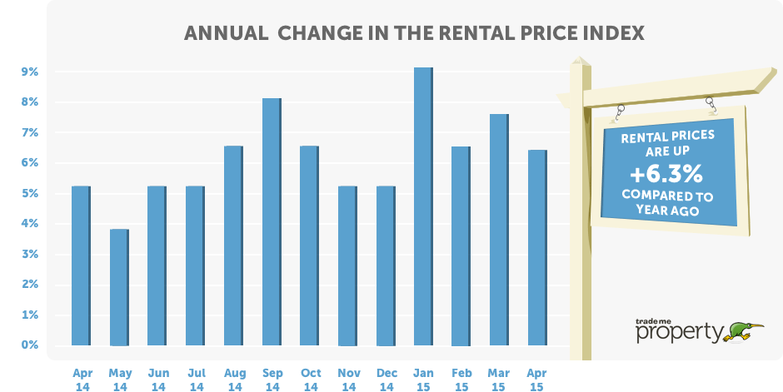

Over the past 5 years, the median weekly rent across New Zealand has risen by 23.5 per cent from $340 per week in April 2010 to $420 per week last month. Mr Jeffries said the majority of this $120 per week increase had occurred since the middle of 2013.
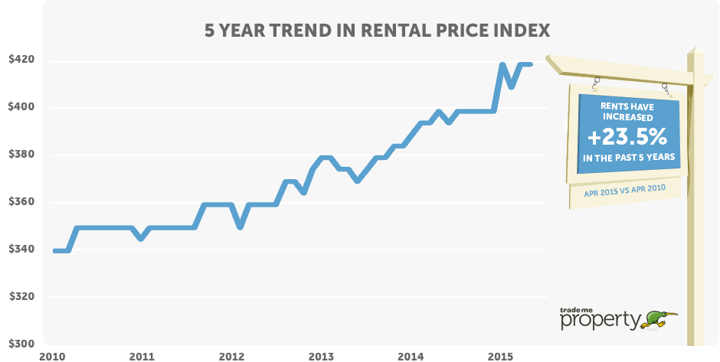

Ups and downs in the regions

Four regions reported double-digit rental growth in the year to April 2015. Leading the way was Gisborne (+20 per cent), followed by Marlborough (+12.3 per cent), Bay of Plenty (+10.9 per cent) and Southland (+10.0 per cent).

Bay of Plenty stood out, reaching a new weekly rental for the fifth consecutive month. The median rent in the region is $355 with rents having risen by 7.5 per cent since Christmas, adding $25 per week to tenants’ outgoings. There are clear signs that the Bay of Plenty is seeing strong demand from Auckland-based investors, based on reports from local agents in the region about heightened interest from out-of-town buyers.

At the other end of the spectrum, the trend in Manawatu and the West Coast is one of declining rents. Over the past year, the median weekly rent for a West Coast property has fallen by 7.4 per cent, and median rents are down 12.3 per cent since April 2010.

Manawatu has fared slightly better, with median weekly rents unchanged year-on-year but declining 4.2 per cent decline over the past 5 years.

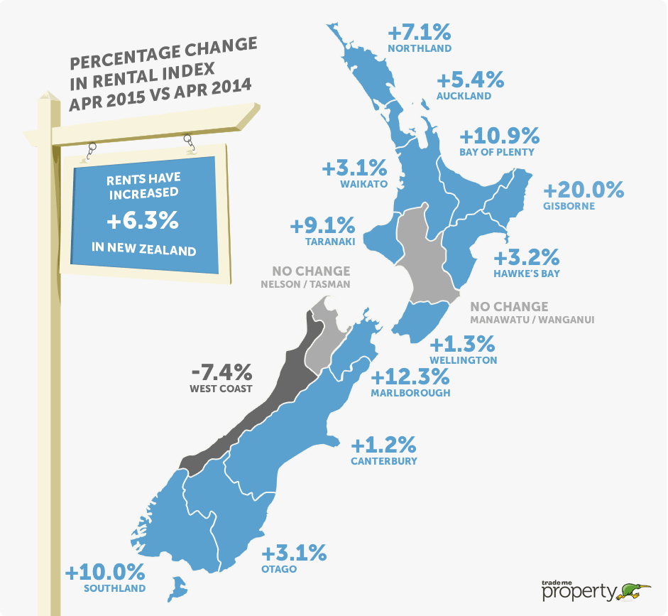

Rents for smaller properties driving the market

Smaller properties (1-2 bedrooms) showed the largest rise in median rents over the past year, up 6.5 per cent or $20 per week over the past year. Smaller homes in Auckland and Wellington saw increases of 5.3 per cent and 4.8 per cent respectively, whilst Christchurch was more subdued as rents only rose 2.1 per cent year-on-year.

The largest rise in rents for smaller properties was in the Bay of Plenty, up 11.5 per cent over the past year to a new record high of $290 per week.

Mr Jeffries said the Christchurch rental market had “changed significantly” over the past year. “In April 2014 we saw rents in the city rising by over 8 per cent per annum – a year later we see median rent is unchanged for the most prevalent medium-sized properties and median rents for large homes have fallen by more than 13 per cent year-on-year.”

Table 1: Median weekly rent by property size & region

 | New Zealand | Auckland | Wellington | Christchurch
Large houses  5+ bedrooms | $665  + 2.3% | $748  + 9.9% | $635  - 2.3% | $650  - 13.3%
Medium houses  3-4 bedrooms | $455  + 4.6% | $550  + 5.8% | $450  + 2.3% | $490  No change
Small houses  1-2 bedrooms | $330  + 6.5% | $400  + 5.3% | $330  + 4.8% | $368  + 2.1%
All property types | $420  + 6.3% | $485  + 5.4% | $395  + 1.3% | $450  No change

Units & apartments continue to show strong demand

Units are primarily a phenomena of the major metropolitan markets, where more than three-quarters of all units are located. Continued demand for these properties is demonstrated by the record weekly rent in April of $335 per week, up $35 per week over the past year. In Auckland weekly rents reached a new record of $395 and were up $30 per week since April 2014.

The Auckland apartment market saw a 5.9 per cent rise in median weekly rent over the past 12 months to a new record high of $450, up from $400 per week two years ago.

Table 2: Median weekly rent by property type & region

 | New Zealand | Auckland | Wellington | Christchurch
Apartments | $410  + 5.1% | $450  + 5.9% | $400  - 1.2% | $385  + 6.9%
Townhouses | $452  + 4.6% | $560  + 12.0% | $420  + 6.3% | $440  - 2.2%
Units | $335  + 11.7% | $395  + 8.2% | $300  + 9.1% | $340  + 0.9%
All property types | $420  + 6.3% | $485  + 5.4% | $395  + 1.3% | $450  No Change

-ends-

NOTES

- About the Trade Me Property Rental Price Index: This is the first report to provide a timely and comprehensive monthly insight into the rental market covering price trends by type and size of property across New Zealand.
The index is produced from Trade Me Property data of properties that have been rented in the month by property managers and private landlords. On average over 14,000 properties are rented each month and the report provides a comprehensive insight into this part of the property market for tenants, landlords and investors.
The index is calculated using the median rent in the month, this being an accurate statistical assessment of the current rent being charged by landlords and property managers.

- More info: For information about the differences between the Trade Me Property data and bond data collected by Tenancy Services, please read this post by Dr Lucy Telfar-Barnard from the University of Otago: http://onetwothreehome.org.nz/2015/05/11/how-high-is-the-rent/

- Regional data: If you are after information for a particular region, please email Jeff Hunkin via mediaenquiries@trademe.co.nz and we will see what we can unearth for you. We can also provide the graphs and tables.

CONTACT

- Nigel Jeffries is available for interviews. To tee up a time that suits, please email Jeff Hunkin via mediaenquiries@trademe.co.nz or phone (04) 803 2601.

